Navigation
Home
Product
- Arcade Games
- VR Games
- AR Games
- Bowling Alley
- Trampoline Park
- Soft Play
- Bumper Cars
- Hypergrid
- Laser tag
- Amusement Park
- Lights
- Sculpture
- Reception Table
- Other Furniture
Project
Resources
- Blog
- ROI
- Safety Standard
About Us
Contact Us

Location wise Pages shows in Footer

Home Page - Sub headings
- Heading - Sub content
- CTA Buttons (Get Quotes/Plan Your Game Zone) (Explore Products)
- Trust signals
- Our Clients
- About Us
- Products
- Industries We Serve
- Process
- Our Projects
- Why Choose Us
- Channel Partners
- Testimonials
- FAQS
- Lead form/Whatsapp Button

About Us Page

- Story / Introduction
- Meet Our Founder
- Our Purpose & Promise — Vision, Mission, Values
- Trust Signals
- Why Winera Stands Out
- Our Clients
- Channel Partners
- Final CTA

Contact Us Page
- Contact Form
- Our Location
- Email Address
- Phone Number
- Google Map
- Business Hours
- WhatsApp Button

Product Page
- Simple Heading
- Product showcase in grid
- Industries we serve
- Why choose Winera International
- Our Process
- CTA

Product Page
- Hero Section
Watch Video/Get Quote
- Features & Specifications
Product highlights,
Technical specs,
- Investment & ROI
- Setup Process
- Our Projects
- Related Products
- Why Choose Us
- Testimonials
- FAQs
- Final CTA

Project Page
Hero Section
Project Categories Filter
- All Projects
Project Listing Grid
- Project Image
- Project Name
- Location
- Area Size
- View Case Study Button

Project Case Study Page
- Hero Section
- Client Requirement
- Our Solution
- Project Highlights
- Project Gallery
- Equipment Installed
- Project Timeline
Results
- Project Outcome
- Successfully launched on schedule
- Increased footfall attraction
- Multiple entertainment zones under one roof
- Optimized visitor flow
- Revenue-focused layout planning
CTA

Project name + City = URL
Reference : https://threeplusgame.com/

1. FizzyFox - Nashik
2. Nenopanda - indore
3. Zaaza Play area - Mumbai
4. Hulaboo - Game zone - Surat
5. Playzonia - Soft play - Surat
6. Funfair - Game zone - Surat
7. Level up - Game zone - Morbi
8. 1 up - Game zone - Guwahati
9. House of People - Soft play- arcade - Kolkata
10. Attitude ball in ball out - Bowling alley - Mumbai
11. Skidz Play Spaces - Soft play
12. Pop - Bowling alley - Ahmedabad
13. Rebounce - Game zone - Surat
14. Happy Hoppers - Soft play - Kolkata
15. Uday Palace - Game zone - Navasari
16. 360 VR Zone - Gandhidham
17. The Fun Factory - Nallasopara west
18. FifthAlley Sport Bowling - Bowling alley - Surat
19. Rajhans Game Zone - Surat
20. Kingsman - Arcade & VR
21. Knpatel school - Soft play - Ahmedabad
22. Fun Houze - Gameznoe - Begusarai
23. Kidzania - Soft play - Ghatkopar West Mumbai

Industry Page - 4 CTAs Add
- Hero Section - 1 Headline and subcontent - 2 CTA
- Trust Signals
- Why It Works
- Problem → Solution
- Recommended Products for Industry
- Investment & Returns - ROI Section
- Why Choose Winera International
- Our Work
- Clients Testimonials
- FAQs
- CTA

Blog Page
- Headling
- Blogs
- Search Bar
- Use the same theme for the image
- Show 2-3 line fixed heading and content also
- Date and name
- Categories

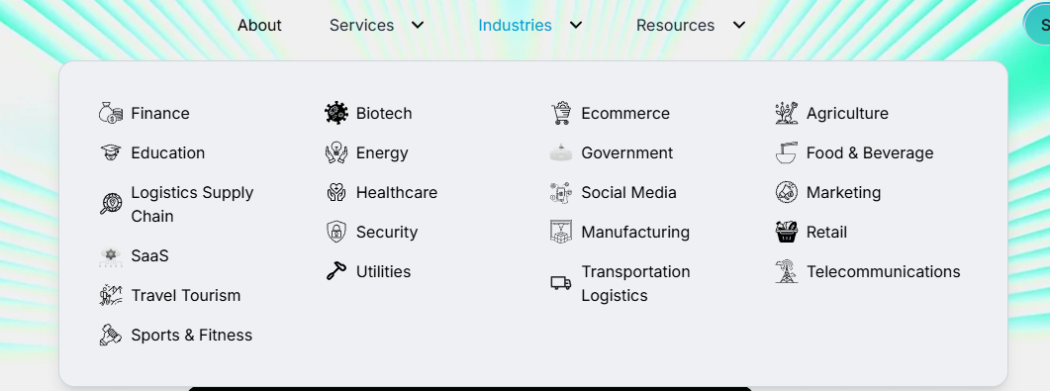

Example for Industry

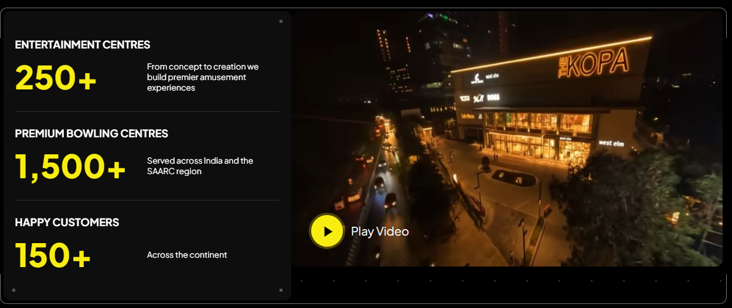

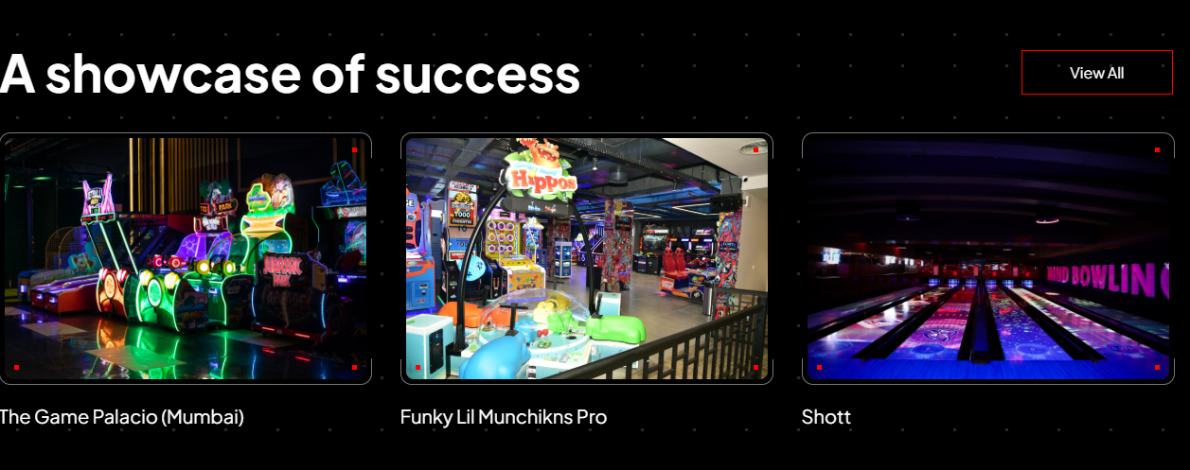

Our Channel Partners



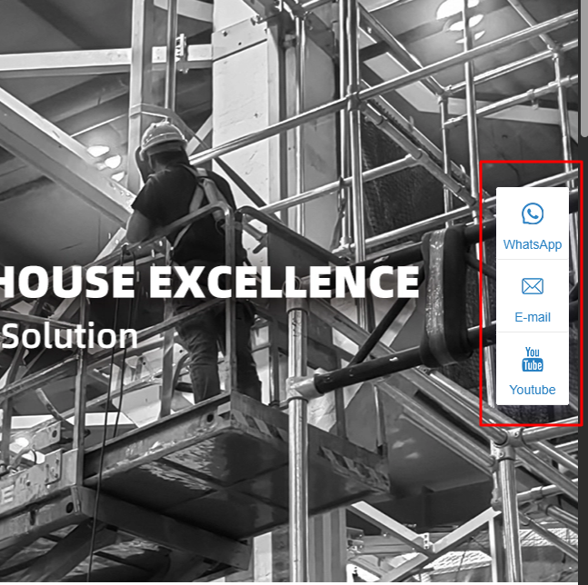

https://www.libengroup.com/category/indoor-playground-equipment

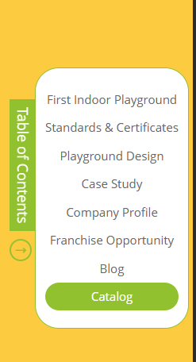


While we click on this button open this box

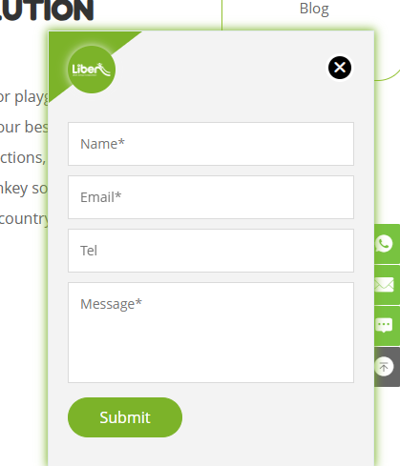
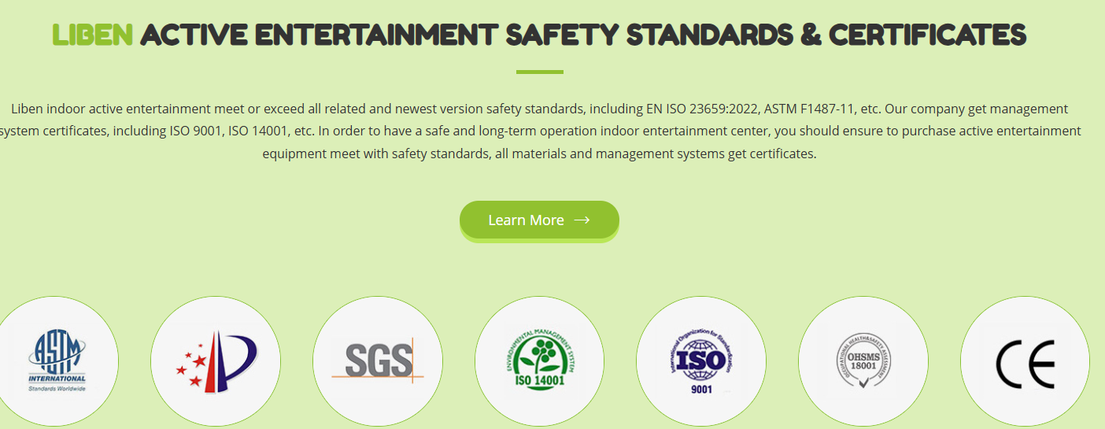

https://www.dreamlandplayground.com/

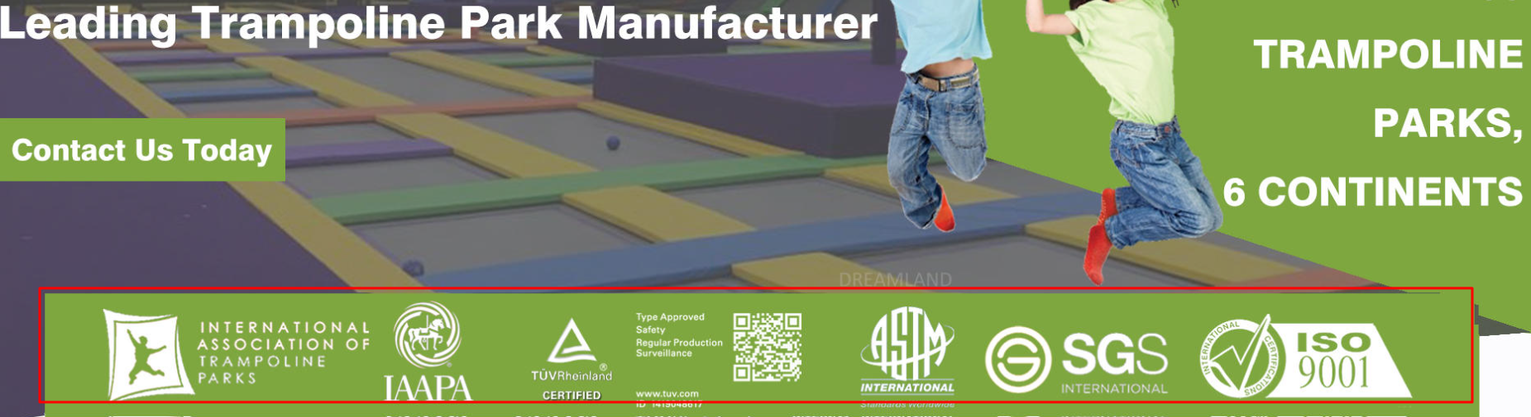

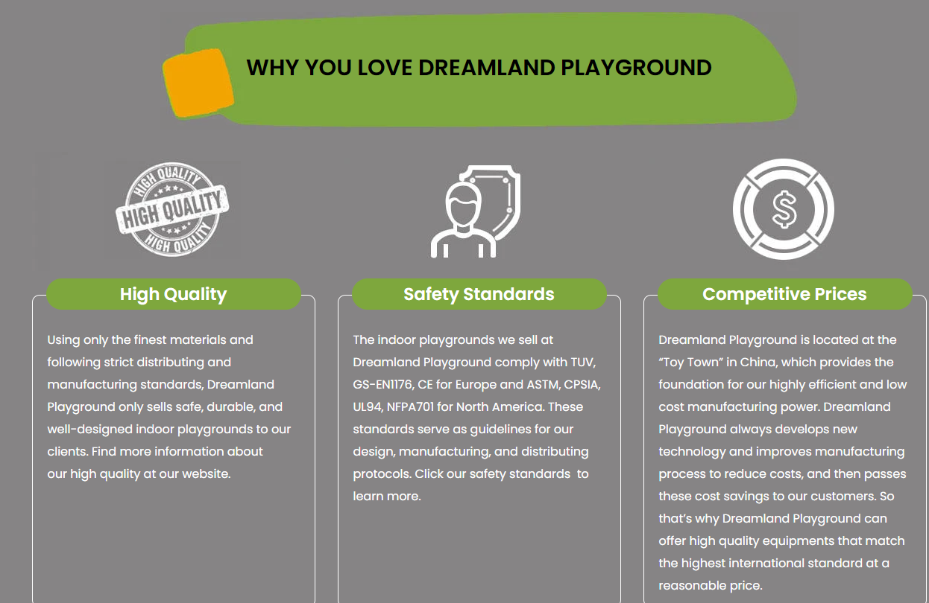

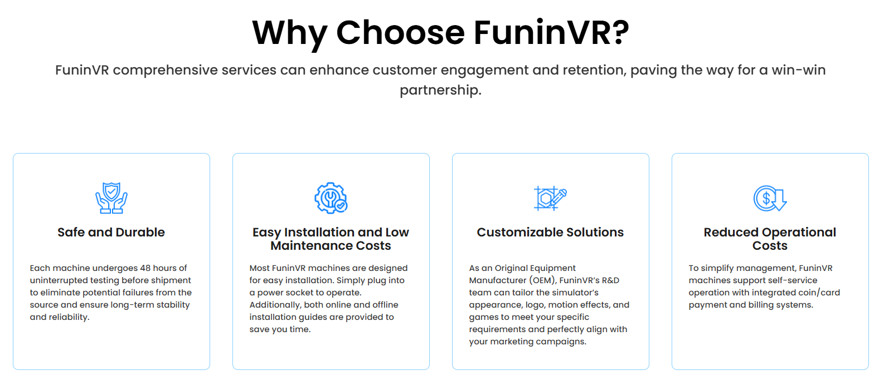

https://www.funin-vr.com/cases/show/post-136.html

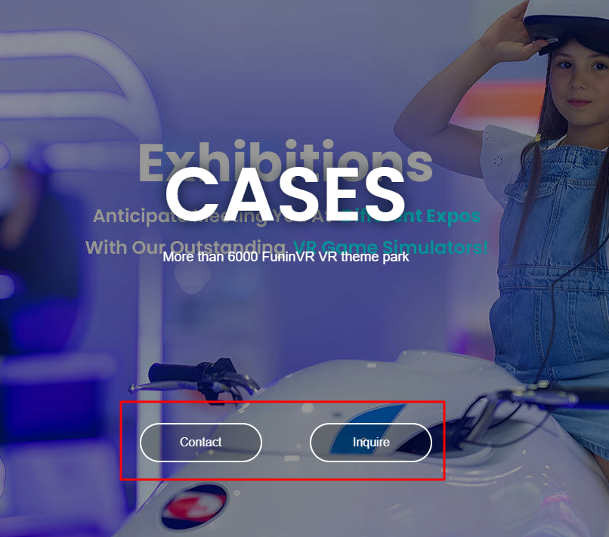

https://www.funin-vr.com/products/show/Tri-Screen-GT.html

WEBSITE STRUCTURE

Homepage
Purpose:
- Explain company
- Build trust
- Generate leads
Content:
- Hero Section
- Product Overview
- Industries Served
- Process
- Projects
- Testimonials
- CTA

MAIN PRODUCT PAGES
These are your biggest lead generators.
- /trampoline-park-manufacturer/
- /bowling-alley-manufacturer/
- /arcade-game-zone-manufacturer/
- /-vr-game-zone-manufacturer/
- /kids-play-area-manufacturer/
- /soft-play-area-manufacturer/
- /family-entertainment-center-manufacturer/
- /-indoor-playground-manufacturer/
- /bumper-car-manufacturer/
- /-adventure-park-manufacturer/
- /game-zone-design-consultation/
- /game-zone-installation-services/

INDUSTRY PAGES
Many businesses skip this.
These pages attract investors.
- Malls
- Hotels
- resorts
- schools
- commercial-spaces
- real-estate-projects
- family-entertainment-centers
Content:
- Why this industry needs game zones
- ROI potential
- Design considerations
- Project examples

LOCATION PAGES
These generate geo leads.
Start with major cities.
- /game-zone-manufacturer-india/
- /game-zone-manufacturer-ahmedabad/
- /game-zone-manufacturer-mumbai/
- /game-zone-manufacturer-delhi/
- /game-zone-manufacturer-bangalore/
- /game-zone-manufacturer-hyderabad/
- /game-zone-manufacturer-pune/
- /game-zone-manufacturer-chennai/
- /game-zone-manufacturer-kolkata/
- /game-zone-manufacturer-surat/

PROJECT SECTION
- Client Problem
- Project Scope
- Design Process
- Installation
- Final Result
- Images
- Video
- CTA

ABOUT SECTION

- Owner Story
- Team
- Process

CONTACT US

BLOG
Business Intent Blogs
Buying Intent Blogs
Educational Blogs

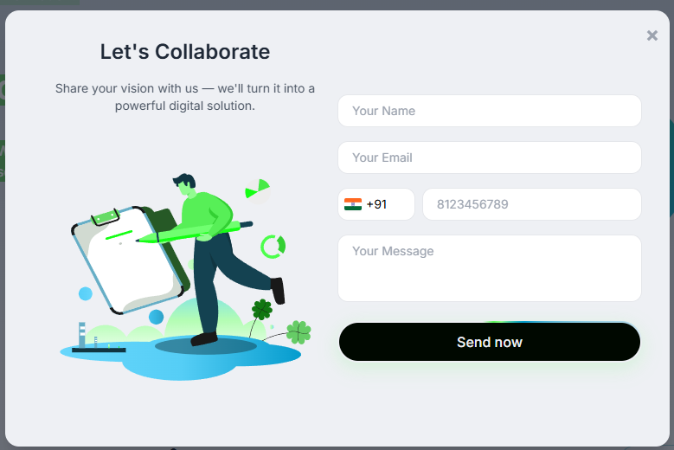
Hero Section
H1:
Headline: Game Zone Equipment Manufacturer & Supplier
Sub-content:
India's ROI-First Game Zone Developer from bowling alleys and trampoline parks to arcade zones and VR gaming & complete indoor amusement park setup, installed by our own team across 50+ cities.
CTA Button:
Plan Your Game Zone - Whatsapp Button

------------------------------------------------------------------------
Trust Of Signals Section

Our Statistics
https://www.wahlap.com/en/product/hot-game.html
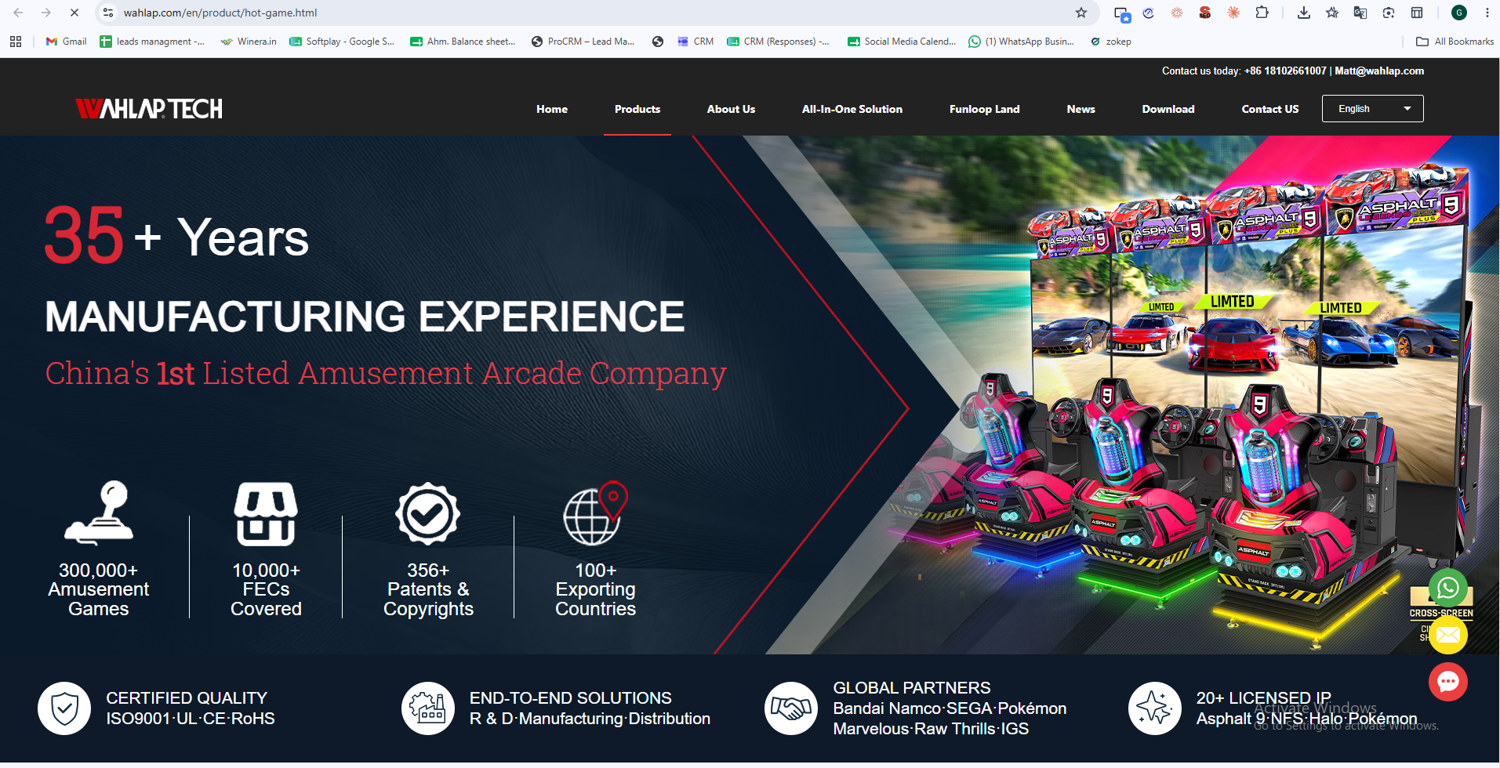
H2: Discover Our Company Stats

- Years of Experience 14+
- Project Completed 200+
- Happy Clients 98%
- Cities Covered 50+
------------------------------------------------------------------------

H2: Our Clients Section

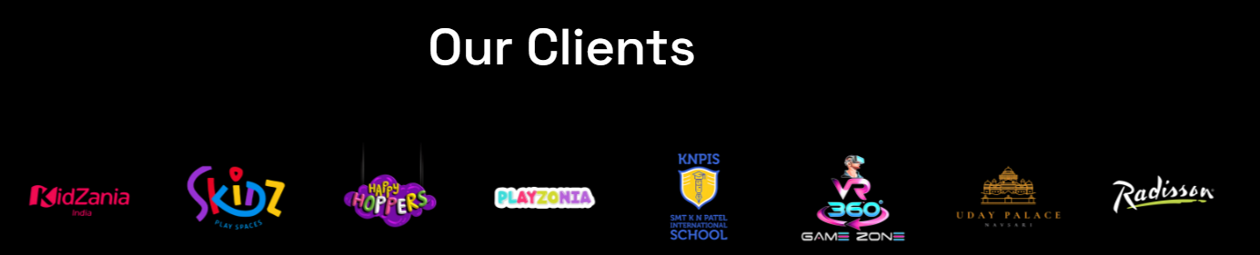

- Added Logos
------------------------------------------------------------------------

About Company
H2: About Winera International
Winera International Pvt. Ltd. is a dynamic force in the gaming and indoor amusement industry, headquartered in Surat, India. Since our establishment in 2014, we have focused exclusively on delivering project-based gaming solutions to the B2B sector nationwide.
Our unwavering commitment to excellence and tailored approach sets us apart. We're dedicated to understanding our client's unique needs and providing the most suitable gaming solutions for each project.
Our team calculates a complete ROI Blueprint for your space, covering projected footfall, revenue potential, and break-even timeline.
At Winera International Pvt. Ltd, we've built a reputation for efficiency and reliability, making us the go-to choice for exceptional gaming experiences in the B2B sector.
CTA: More About Us

- Game Zone Setup
- FEC Equipment & Setup
- Bowling Alley Equipment
- Arcade & Amusement Equipment
- Kids Entertainment Solutions
- VR Gaming Equipment
- Concept to Installation



You can also add this kind of Batch

---------------------------------------------------------------------------------------------------------------------
Channel Partners Section

Our Channel partners

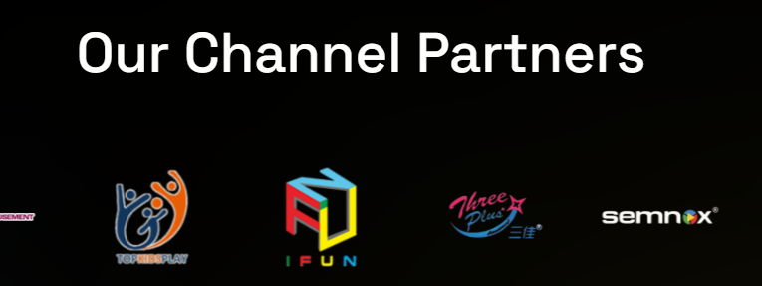
—---------------------------------------------------------------------------------------------------------
Take a look At Our Best Products
H2: Our Complete Game Zone Equipment & Setup Solutions

Arcade Games
Discover endless fun with our innovative indoor arcade games, merging excitement and fitness seamlessly.
CTA: View More Info

VR Games
Immersive commercial VR gaming machines delivering thrilling virtual reality experiences.
CTA: View More Info

AR Games
Interactive AR gaming solutions blending technology and entertainment — sports simulators, immersive experiences, and more.
CTA: View More Info

Bowling Alley
The Brunswick bowling equipment not only has stable mechanical capacity, but also they all are the very popular bowling equipment in the world.
CTA: View More Info

Trampoline Park
This segment has undergone a tremendous change as fun and physical fitness has become requisite.
CTA: View More Info

Soft Play
Indoor playgrounds are designed specifically for children aged 3-15 years of indoor game venues.
CTA: View More Info

Bumper Cars
Our bumper cars are an exhilarating blend of thrilling collisions and smooth handling, designed with a laser focus on safety and durability.
CTA: View More Info

Hypergrid
Interactive LED floor game where players compete across pressure-sensitive glowing tiles for a unique experience.
CTA: View More Info

Laser tag
High-adrenaline commercial laser tag arena setup delivering competitive team battles for malls and entertainment venues.
CTA: View More Info

Amusement Park
Complete amusement park equipment and setup solutions designed to create joy and excitement for every visitor.
CTA: View More Info

Lights

Sculpture

Reception Table

Other Furniture

Product section: https://pin.it/2jAMpIiTS
---------------------------------------------------------------------------------------------------------------------

Your Partner in Building a Profitable Game Zone
Discover how Winera International Pvt. Ltd. helps you plan, build, and launch a successful game zone from free ROI consultation to safety-certified equipment and complete installation support.

Free ROI Consultancy
Before you invest a single rupee, our team consults with you on layout, equipment mix, and budget and hands you a complete ROI report covering projected revenue, footfall, and break-even timeline.
[Explore More]

Safety-Certified Installation
Every product we install meets commercial safety standards tested for high-footfall environments, assembled by our own trained team, and handed over only after a full on-site safety inspection.
[Explore More]
---------------------------------------------------------------------------------------------------------------------
Industries Section
H2: Industries We Serve
We deliver complete game zone setup solutions for businesses across India
- Shopping Malls
- Hotels & Resorts
- Schools & Academies
- Commercial Spaces
- Residential Projects
- Sports Centres
- Entertainment Hubs
- Airports & Terminals
- Hospitals & Clinics
- Food and Beverage
—---------------------------------------------------------------------------------------------------------
Our Working Process
How We Setup Your Game Zone

Step 1 — Free Consultation
- Share your project idea and business goal
- Tell us your space size and budget
- We suggest the best game zone setup for you

Step 2 — Planning & Selection
- We design a complete game zone layout for your space
- Best equipment and activities selected as per your budget
- Detailed project timeline and execution plan prepared

Step 3 — Production & Procurement
- Order confirmed with transparent pricing
- Production process begins and Equipment sourcing
- Quality checks done at every stage

Step 4 — Project Installation
- Complete equipment assembly at your site
- Product installation and setup
- Full equipment inspection after installation

Step 5 — Forever Support
- Technical support whenever you need assistance
- Spare parts and maintenance support available
- Expert guidance to keep operations running smoothly
—---------------------------------------------------------------------------------------------------------
Our Projects

H2: Game Zones We Have Built Across India
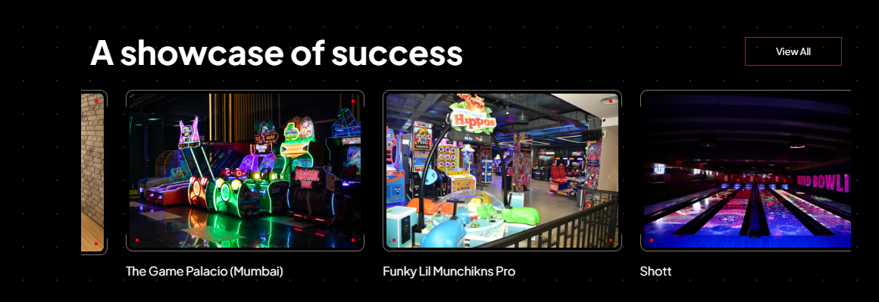
https://csmlgroup.com/
Explore our successfully completed projects delivered across India from small indoor game zones to large family entertainment centers.

Bounce berry blr - Bangalore
Nextgen gaming zone - Raichur
Rock and bowl - Vapi
The fun factory nsp - Nallasopara West
Zaazaa play - Mumbai
Gif gaming is fun - Dehra Dun
Kidzonation - bhopal
Neon Panda - Indore
Fizzy Fox - Nashik
Rumble Zone - Gurugram
Fun Houze - Begusarai
360 - gandhidham
uday palace - navsari
Happy hoppers - Nagpur
Rebounce - Surat
House of pepe - Kolkata
Funfair - Surat
Playzonia - Surat
Hulaboo - Surat
FifthAlley Sport Bowling - Surat

CTA: View All (Redirect to Project Page)

—---------------------------------------------------------------------------------------------------------
Why Choose Us Section

H2: Why Choose Winera International

ROI-Focused, From Day One
We consult on ROI first every client receives a complete report covering footfall, revenue, and payback period before we plan or select equipment.

Largest In-House Technical Team
Our experienced technical team handles installation, testing, training, and after-sales support to ensure your game zone runs smoothly

Complete Turnkey Solutions
We provide end-to-end support from project planning and equipment selection to installation and execution.

Industry Expertise
Our team recommends the right entertainment attractions based on your space, budget, and business goals.

Customized Planning
We create tailored layouts and attraction plans to maximize the potential of your entertainment space.

Pan-India Execution
We support projects across India with professional installation, project management, and execution services.
--------------------------------------------------------------------------------------------------
Testimonials Section

H2: What Our Clients Say
Sub Content:
We are proud to have helped businesses across India build successful game zones. Here's what our clients say about our quality, service, and support.

When we were planning Rebounce we had the space and the budget but no idea how to turn it into a game zone. Winera International Pvt. Ltd. made the entire process effortless. One meeting was enough. We shared our requirements and they handled everything from game selection and layout design to complete installation. The result speaks for itself Rebounce today is a thriving game zone and our customers keep coming back.

— Rebounce Game Zone

Choosing the right gaming zone setup company in India was critical for us given our tight deadline. Winera International Pvt. Ltd. delivered everything as planned and on schedule. Fun Houze opening day went smoothly and the game zone setup was exactly as we discussed.

— Fun Houze

To be honest before starting Hulaboo we had visited multiple game zone setup companies and was confused about who to trust. When we finally met Winera International Pvt. Ltd. the clarity they gave us from day one was different. They explained the entire process, showed us real projects and gave us a transparent quote. That confidence is what made us sign. And they delivered exactly what they promised.

— Hulaboo Game Zone

Most game zone equipment suppliers just deliver and disappear. What surprised us most about Winera International Pvt. Ltd. was that they actually sat with us, understood our space and planned the entire Funfair game zone layout from scratch. That level of involvement made a real difference to our final setup.
— Funfair

Combining soft play and arcade under one roof was our vision but we had no idea how to execute it. We needed a reliable soft play equipment manufacturer in India who could also handle the arcade side. Winera International Pvt. Ltd. designed the House of Pepe layout perfectly; both zones feel different but connected. Customers enjoy both sections equally.

— House of Pepe

Before finalizing we visited Winera International Pvt. Ltd. previous projects in person. The quality we saw there gave us confidence to move forward with Playzonia. They designed our complete soft play layout, selected age-appropriate equipment for children and handled the full installation from start to finish. Kids enjoy it daily and parents feel safe. That is our biggest win.

— Playzonia

Adding a game zone to Uday Palace was a new experiment for us. We were looking for a complete indoor amusement park setup company in India and Winera International Pvt. Ltd. made the entire process simple and stress free. Today our game zone is one of the most enjoyed parts of our venue especially by families.

— Uday Palace

Our space was completely underutilized before the VR gaming zone setup. Winera International Pvt. Ltd. transformed our space into a complete VR gaming zone and the results have been outstanding. Now 360 runs are packed almost every day and the ROI came much faster than we expected.

— 360 VR Zone
Winera International set up our indoor play area, and the whole process was smooth from design to installation. The space is safe, colourful, and the kids absolutely love it. Parents keep coming back, and it's become the highlight of our venue.
— Team Bounce Berry
Winera developed our gaming zone end to end, and their team handled everything professionally. The equipment quality is excellent, and the support after installation has been quick and reliable. A great partner to work with.
— Team Nextgen Gaming Zone
Winera International helped us bring together everything under one roof — bowling, arcade, VR, and kids' play area. The whole project was well managed and finished on time, and honestly the variety is what keeps our guests coming back.
— Team Rock and Bowl
Our soft play area was designed and installed exactly to our space and budget. The build quality is great, it's safe for the children, and thanks to Winera International the response from families has been wonderful.
— Team The Fun Factory
From the first design to the final setup, Winera International made everything easy. They understood our space and delivered a bright, safe play area that kids enjoy every day. Professional team, smooth experience.
— Team Zaazaa Play
Winera built our multi-level soft play area. The climbing frames, slides, and ball pool are all top quality and completely safe for the kids. They handled everything with real professionalism, and children love spending time here. Their team supported us at every step.
— Team Gif Gaming is Fun
Winera International built our kids' play area from start to finish, and the whole process was stress-free. The equipment is safe and well made, and our young visitors have a great time.
— Team Kidzonation
Winera developed our game zone and delivered exactly what we needed. The setup was smooth, the equipment quality is top class, and the after-sales support has been dependable. A pleasure to work with.
— Team Fizzy Fox
From planning to opening day, Winera International handled our game zone setup professionally. Their team understood our space and delivered on time. Our visitors love it, and it's been great for business.
— Team Rumble Zone
The indoor kids play zone Winera built for us has become the highlight of our space. The quality of soft play products, attention to safety, and the overall finish of the installation reflects the expertise their team brings to every project.
— Team Happy Hoppers
Winera International handled our soft play setup from design to installation with complete professionalism. The 3D design process gave us full clarity before anything was built, and the final soft play equipment quality exceeded our expectations. We've had great visitor response since opening.
— Team Playzonia, Surat
Getting a bowling setup right takes real know-how, and that's what Winera brought. From choosing the right equipment to installing it and training our staff, everything was handled properly and the after-sales support has been just as reliable. Our guests love the lanes.
— Team FifthAlley

—---------------------------------------------------------------------------------------------------------Frequently Asked Questions

How do I set up a game zone in India?
Start with a consultation and share your available space, budget, and location with our team. As a trusted gaming zone setup company in India, Winera International handles everything from ROI analysis and layout design to equipment selection, installation, and post-launch support across 50+ cities.

What is the cost of a game zone setup in India?
Game zone setup cost in India totally depends on the size of space, type of attractions, and level of customisation. As a direct game zone equipment supplier, Winera International provides a complete cost breakdown covering equipment, installation, and maintenance before you confirm any project. Contact our team for a quote specific to your venue.

Does Winera handle the complete game zone setup?
Yes. As experienced game zone developers in India, we manage the entire project from concept to completion, space planning, equipment sourcing, layout design, installation, and after-sales support all handled by our own team, not third-party contractors.

Which cities does Winera cover in India?
Winera International installs game zone equipment across 50+ cities in India — covering Tier-1 metros, Tier-2 cities, and emerging Tier-3 markets. Our own installation team reaches wherever your venue is located, without relying on local contractors.

What makes Winera International different from other game zone suppliers?
Before recommending any equipment, we prepare a free ROI Blueprint for your specific venue covering projected footfall, revenue potential, and break-even timeline. Very few game zone suppliers in India offer this as a standard part of their process.

Do you provide after-sales support after installation?
Yes. Our technical team provides ongoing maintenance, spare parts, and on-site support for all equipment we install available directly through our own team, not through agents or third-party service providers.

Can game zone equipment be customised for my venue's theme?
Yes. Every game zone solution we deliver is designed around your specific space, theme, budget, and target audience from layout planning to equipment selection and visual design.

How do I get started with my game zone project?
Contact us via our website's contact form, WhatsApp, or call +91 94289 89488. We're also available on social media.

Can Winera International help me plan my game zone from scratch?
Yes, Winera International offers complete game zone planning support. From space planning and equipment selection to installation and staff training, we manage the entire project. Our “Plan Your Game Zone” service is specially designed for first-time entrepreneurs and existing businesses looking to add an entertainment zone.

=============================================================

Call to action section

Game Zones Are India's Fastest Growing Business Are You In?

Get expert guidance, custom layout design and complete installation support from India's trusted game zone setup company

CTA: Talk to an Expert

---------------------------------------------------------------------------------------------------
Footer

Product
Arcade Games
Bowling Alley
Soft Play
Trampoline Park
VR Games
Bumper Cars
Ninja Courses
Wall Climbing
Amusement Park
Hypergrid
Laser tag

Quick Links
About Us
Contact Us
Privacy Policy
Terms of Use

Resources
Blog
Project
ROI
Safety Standard
Industries

Decorative
Lights
Sculpture
Reception Table
Other Furniture

Social Media Icons
Winera is a professional solution provider and builder specializing in indoor amusement parks and playground equipment.

Get in Touch
+91 94289 89488
+91 95123 56766

Email I’d
info@winera.in

About Us Page Content

About Us Page

Welcome to Winera International
Winera International Pvt. Ltd. is a Surat-based B2B leader in indoor amusement and playground solutions. Since 2014, we have been transforming commercial spaces into world-class entertainment destinations, handling everything from design and manufacturing to installation and after-sales support

Quality Assurance
At Winera International, quality is key. Our lanes, trampolines, soft play, and arcade games are built to last and ensure safety. We don't just build equipment; we build experiences you can trust.

Your Success, Our Commitment
At Winera International, we prioritize your satisfaction. From product exploration to final installation and beyond, our dedicated team walks with you at every step.

CTA: Contact Us Now / Browse Products

14+
Years in Business
200+
Installations
50+
Countries Served
98%
Customer Satisfaction
—---------------------------------------------------------------------------------------------------------
Vision & Mission Section

Our Purpose & Promise

Our Vision
To be India's most trusted partner in building world-class indoor entertainment destinations where every space we touch becomes a thriving hub of joy, play, and business success.

Our Mission
We deliver premium-quality game zone and indoor playground solutions to B2B clients across India combining expert design, international equipment, and seamless project execution to create entertainment spaces that last.

—---------------------------------------------------------------------------------------------------------
Why choose us section

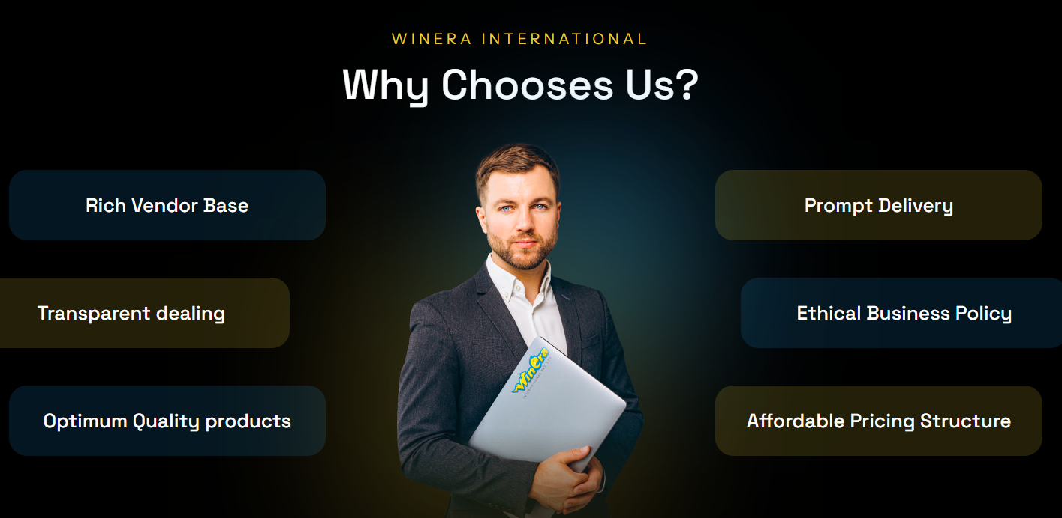

Why Choose Us?
Rich Vendor Base
Transparent Project Pricing
International-Grade Quality Equipment
On-Time Delivery & Installation
End-to-End Project Ownership
Competitive Pricing with High ROI

CTA: Get Started / View Our Products

Sales
From the moment you choose Winera International, our dedicated sales team works closely with you to finalize the right game zone solution for your space and budget. We're an ROI-focused partner. Before any project begins, every client receives a complete ROI report covering projected footfall, revenue potential, and payback period. We handle product selection, project scoping, pricing, and documentation, making your buying experience smooth, transparent, and completely hassle-free.

Service
Our professional installation team takes complete ownership of your project from equipment delivery and assembly to safety testing and final handover. Every game zone we install is set up with precision, care, and zero compromise on quality standards so your entertainment space is ready to welcome visitors from day one.

Satisfaction
At Winera International, a completed project is just the beginning of our relationship. We measure our success by yours whether it's children laughing in our soft play zones, families enjoying our bowling alleys, or teenagers competing on our arcade machines. Your visitors' joy and your business's growth are what drive everything we do.

—---------------------------------------------------------------------------------------------------------

Founder Section

Our Founder
Mr. Unnit Jogani is the Founder & CEO of Winera International Pvt. Ltd. One of India's most trusted game zone equipment manufacturers and indoor amusement park solution providers. Since establishing WinEra in Surat, Gujarat in 2014, Unnit has led the company's growth from a regional startup to a pan-India B2B leader successfully delivering projects across India with an uncompromising focus on quality, safety, and client satisfaction.

Button: Linkedin Profile

—---------------------------------------------------------------------------------------------------------
CTA Section
Ready to Get Started?

Take the Next Step Towards Your

Perfect Game Zone
Our team is ready to help you plan, build, and launch a game zone that drives real revenue.

Book Consultation

Contact Us Page Content

Contact Us

Get in Touch with Winera International

Looking for reliable game zone equipment, soft play solutions, or indoor amusement park installations for your business? Our team is here to help you with product details, project pricing, and complete service support. Connect with us to discuss your space requirements and see how Winera International transforms ordinary spaces into extraordinary entertainment destinations.

Contact Form

Name:

Phone Number:

Email:

Inquiry:

Button: Request Free Consultation
-------------------------------------------------------------------------------------------
Phone No. Email Us
+91 94289 89488 info@winera.in
+91 95123 56766
-------------------------------------------------------------------------------------------
Our 2 Address - Surat and China
-------------------------------------------------------------------------------------------
Lastly shows Map

Headline:

Arcade Game Machines in India
Winera International Pvt. Ltd is a trusted arcade games manufacturer and supplier of premium arcade machines, sourced and serviced end-to-end across 50+ cities. With over 15 years of industry expertise, we source every arcade game machine from established global manufacturers and configure it with modern coin, card, or ticket-based redemption systems to match your venue's requirements.
Before delivery, each unit goes through a commercial-grade durability check built for high-footfall environments like malls, hotels, and entertainment centres, not casual or residential use.
From sourcing to installation and after-sales support, our own team handles the entire arcade game zone setup process, not a third-party contractor.
CTA: [Watch Video(60-90 second installation/ product walkthrough video)] [Get a Quote]


Categories:

- Claw Machine
- Redemption Game
- Kiddy Ride
- Bike Racing Game
- Car Racing Game
- Shooting Games

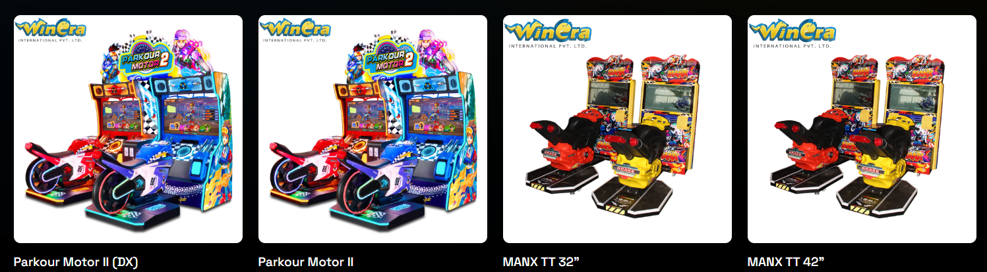
—-------------------------------------------------------------------------------------------------

Built for Commercial Use

Built for Real Commercial Footfall
Arcade machines in Indian malls and entertainment centres often run ten or more hours a day, handled mostly by children. Equipment sourced without that environment in mind tends to fail within weeks of installation.
We at Winera International prioritise machines rated for sustained commercial cycles over units designed for lighter, residential, or occasional use, which is why our installations typically need far less frequent servicing than machines bought through unverified import channels.

What Will Your Arcade Game Zone Actually Earn?
An arcade game zone is not a single machine decision, it is a business decision about which machines, in which combination, at what price point, will generate the strongest return for your specific venue. Most suppliers hand you a catalogue and leave that calculation entirely to you.
Winera International starts there. Before any machine is recommended, our team works out the numbers for your specific floor size, daily footfall, and target visitor age group projected revenue per machine category, daily session estimates, maintenance costs per year, and a realistic break-even timeline. Not a generic percentage claim. Your actual numbers, for your actual venue.
For Winera, this analysis is not a premium add-on. It is the first conversation.
[Talk to an ROI Expert] - Whatsapp Button
---------------------------------------------------------------------------------------------

Why Choose Winera International

15+ Years in the Industry
Supplying and supporting indoor amusement equipment across India

Successful Installations
From malls to resorts, our track record speaks through completed projects, not just promises.

Direct Sourcing
We work straight with global manufacturers — consistent quality, no unnecessary markup.

Pricing That Makes Sense
No hidden costs, no inflated resale pricing — fair rates backed by direct sourcing.

Local Support in 50+ Cities
Our own technicians install and service every machine — no waiting on overseas suppliers.

Easy to Maintain
Equipment rated for heavy daily commercial use — fewer breakdowns, more consistent revenue.

Solutions That Fit Your Space
Every recommendation based on your venue size, footfall, and budget — never one-size-fits-all.
----------------------------------------------------------------------------------------------------

Our Recent Project Section

Our Recent Project
- Add CTA (View All)
- So they redirect to Project Page
- Image
- Add Project Name
- City
- We’ll provide Project info
----------------------------------------------------------------------------------------------------
H2: What Our Clients Say
Sub Content:
We are proud to have helped businesses across India build successful game zones. Here's what our clients say about our quality, service, and support.

When we were planning Rebounce we had the space and the budget but no idea how to turn it into a game zone. Winera International Pvt. Ltd. made the entire process effortless. One meeting was enough. We shared our requirements and they handled everything from game selection and layout design to complete installation. The result speaks for itself Rebounce today is a thriving game zone and our customers keep coming back.

— Rebounce Game Zone

Choosing the right gaming zone setup company in India was critical for us given our tight deadline. Winera International Pvt. Ltd. delivered everything as planned and on schedule. Fun Houze opening day went smoothly and the game zone setup was exactly as we discussed.

— Fun Houze

To be honest before starting Hulaboo we had visited multiple game zone setup companies and was confused about who to trust. When we finally met Winera International Pvt. Ltd. the clarity they gave us from day one was different. They explained the entire process, showed us real projects and gave us a transparent quote. That confidence is what made us sign. And they delivered exactly what they promised.

— Hulaboo Game Zone

Most game zone equipment suppliers just deliver and disappear. What surprised us most about Winera International Pvt. Ltd. was that they actually sat with us, understood our space and planned the entire Funfair game zone layout from scratch. That level of involvement made a real difference to our final setup.

— Funfair

Combining soft play and arcade under one roof was our vision but we had no idea how to execute it. We needed a reliable soft play equipment manufacturer in India who could also handle the arcade side. Winera International Pvt. Ltd. designed the House of Pepe layout perfectly; both zones feel different but connected. Customers enjoy both sections equally.

— House of Pepe

Before finalizing we visited Winera International Pvt. Ltd. previous projects in person. The quality we saw there gave us confidence to move forward with Playzonia. They designed our complete soft play layout, selected age-appropriate equipment for children and handled the full installation from start to finish. Kids enjoy it daily and parents feel safe. That is our biggest win.

— Playzonia

Adding a game zone to Uday Palace was a new experiment for us. We were looking for a complete indoor amusement park setup company in India and Winera International Pvt. Ltd. made the entire process simple and stress free. Today our game zone is one of the most enjoyed parts of our venue especially by families.

— Uday Palace

Our space was completely underutilized before the VR gaming zone setup. Winera International Pvt. Ltd. transformed our space into a complete VR gaming zone and the results have been outstanding. Now 360 runs are packed almost every day and the ROI came much faster than we expected.

— 360 VR Zone
Winera International set up our indoor play area, and the whole process was smooth from design to installation. The space is safe, colourful, and the kids absolutely love it. Parents keep coming back, and it's become the highlight of our venue.
— Team Bounce Berry
Winera developed our gaming zone end to end, and their team handled everything professionally. The equipment quality is excellent, and the support after installation has been quick and reliable. A great partner to work with.
— Team Nextgen Gaming Zone
Winera International helped us bring together everything under one roof — bowling, arcade, VR, and kids' play area. The whole project was well managed and finished on time, and honestly the variety is what keeps our guests coming back.
— Team Rock and Bowl
Our soft play area was designed and installed exactly to our space and budget. The build quality is great, it's safe for the children, and thanks to Winera International the response from families has been wonderful.
— Team The Fun Factory
From the first design to the final setup, Winera International made everything easy. They understood our space and delivered a bright, safe play area that kids enjoy every day. Professional team, smooth experience.
— Team Zaazaa Play
Winera built our multi-level soft play area. The climbing frames, slides, and ball pool are all top quality and completely safe for the kids. They handled everything with real professionalism, and children love spending time here. Their team supported us at every step.
— Team Gif Gaming is Fun
Winera International built our kids' play area from start to finish, and the whole process was stress-free. The equipment is safe and well made, and our young visitors have a great time.
— Team Kidzonation
Winera developed our game zone and delivered exactly what we needed. The setup was smooth, the equipment quality is top class, and the after-sales support has been dependable. A pleasure to work with.
— Team Fizzy Fox
From planning to opening day, Winera International handled our game zone setup professionally. Their team understood our space and delivered on time. Our visitors love it, and it's been great for business.
— Team Rumble Zone
The indoor kids play zone Winera built for us has become the highlight of our space. The quality of soft play products, attention to safety, and the overall finish of the installation reflects the expertise their team brings to every project.
— Team Happy Hoppers
Winera International handled our soft play setup from design to installation with complete professionalism. The 3D design process gave us full clarity before anything was built, and the final soft play equipment quality exceeded our expectations. We've had great visitor response since opening.
— Team Playzonia, Surat
Getting a bowling setup right takes real know-how, and that's what Winera brought. From choosing the right equipment to installing it and training our staff, everything was handled properly and the after-sales support has been just as reliable. Our guests love the lanes.
— Team FifthAlley
----------------------------------------------------------------------------------------------------
Related Products Section

Related Products

- Trampoline Park
- Soft Play
- VR Games
- AR Games
- Bumper Cars
- Bowling Alley
- Amusement Park
- Hypergrid
- Laser tag
---------------------------------------------------------------------------------------------

Frequently Asked Questions

Where can I buy arcade game machines in India?
Winera International is a trusted arcade games manufacturer and supplier in India — supplying claw machines, redemption games, racing simulators, shooting games, and kiddy rides for malls, hotels, FECs, and amusement parks, with complete installation across 50+ cities by our own team.

Do you supply coin operated arcade machines in India?
Yes. Winera International supplies a wide range of coin operated arcade machines in India, card-based systems, and ticket redemption arcade machines, built for commercial environments such as malls, hotels, resorts, and family entertainment centres.

Can Winera International set up a complete arcade game zone setup?
Yes. We handle space planning, machine selection, delivery, installation, and staff training as one connected arcade game zone setup process, not separate transactions with different vendors.

What happens if a machine breaks down after installation?
Our own technicians handle servicing directly, with coverage across 50+ cities in India. You are not waiting on an overseas supplier or a disconnected logistics partner to respond.
- Which businesses typically install arcade game machines in India?
Malls, hotels, resorts, and family entertainment centres are the most common buyers of arcade machines.

How long does it take to install arcade machines?
Installation timelines depend on the number of machines, your venue's readiness, and your location. We share an exact schedule as part of your quote, so you know precisely when your arcade zone will be ready.

What is the price of arcade machines in India?
Arcade machine pricing in India depends on the machine category, payment mechanism, and customisation level. Because Winera International sources directly at scale, our pricing avoids the markup typical of multi-layer resellers.
- How do I get started with ordering arcade machines from Winera?
Contact us via our website's contact form, WhatsApp, or call +91 94289 89488. Our team will recommend the right machine mix for your space and send a quote ASAP.

Which arcade games give the best ROI for FECs and malls in India?
Ticket redemption games, claw machines, and racing simulators consistently deliver the strongest revenue per square foot in Indian FECs and malls. Winera International helps you choose the right arcade game zone machine mix based on your specific footfall, floor size, and visitor demographic — not a generic recommendation.

What is the difference between coin-operated and card-based arcade machines?
Coin-operated arcade machines accept physical tokens and suit venues with casual walk-in visitors. Card-based systems use rechargeable cards — better for revenue tracking, reducing cash handling, and encouraging repeat visits through balance top-ups. Winera supplies both and advises on the right system for your venue.
---------------------------------------------------------------------------------------------
CTA Section
Need Any Consultations ?
We’re Ready to Give Answers to Your Question.
CTA: Get Quote Now

Bowling Alley Manufacturers in India
India's trusted source for refurbished Brunswick bowling equipment — complete setup, installation, and a free ROI report before you invest.

CTA: Get Quote From Expert

Premium Bowling Alley Manufacturer in India
At Winera International Pvt. Ltd., we are proud to be India’s leading bowling alley manufacturer and supplier. With over 15 years of expertise in the industry, we have built a reputation for delivering top-quality bowling alley equipment and exceptional customer service, tailored to fit the unique needs and budgets of our clients.

Free-Fall Bowling: Give the Full Professional Experience
Free-fall bowling is the traditional game you'll find in professional bowling centers worldwide. When the ball hits the pins, they fall freely and naturally, and a pinsetter machine clears and resets them for the next throw. It delivers the true feel of real bowling, the satisfying strike and the competition-grade experience serious players expect.
We specialise in refurbished Brunswick GS98 and GS-X equipment, restored to perform like new and enhanced with the latest Frameworx or Vector scoring systems based on your specific requirements. Our approach is simple — offer the best bowling solutions to match both your budget and venue dimensions, ensuring an outstanding bowling experience. It's the ideal choice for dedicated bowling centers and premium venues where bowling is the main attraction.
CTA: [Watch Video(60-90 second installation/ product walkthrough video)]
Specifications
- Lane length: 89 feet per lane
- Lane width: 6 feet per lane
- Pinsetter type: Free-fall (gravity-based)
- Experience: Professional / competition-grade
- Best for: Dedicated bowling centers, premium venues
CTA: Download Our Brochure

String Bowling Machines: Affordable Bowling Setup for Every Venue
Add a complete, ready-to-play bowling setup to your venue at a lower upfront cost than a traditional free-fall system. We supply and install full string bowling lanes pins, strings, scoring screens, and commissioning so you get a finished attraction, not just a machine.
String systems have fewer moving parts, which means quieter lanes, easier maintenance your own team can handle, and a compact footprint that fits where a full 89 ft lane won't. That's why family entertainment centers, malls, resorts, and cafés choose them. Lower to set up, lower to run, and quick to start earning.

Specifications
Pin reset: Overhead string mechanism
Lane footprint: Shorter than a full 89 ft free-fall lane
Lane width: 6 feet per lane
Maintenance: Low — fewer parts, easy servicing
Best for: FECs, malls, resorts, cafés, gaming zones

Investment & ROI
Setting up a bowling center is a significant investment which is why we don't just sell you equipment and walk away. We're India's ROI-First Game Zone Developer. Before you commit to a project, every client receives a complete report covering product costing, maintenance costs, and projected revenue timeline, so your investment decision is based on real numbers, not estimates.
By choosing our refurbished bowling systems, you can create a high-end bowling center at a cost-effective budget. With reliable machinery that's been expertly restored, you'll enjoy top-tier performance, low maintenance, and durability without the cost of brand-new equipment.
CTA: Talk to an ROI Expert
----------------------------------------------------------------------------------------------------

Why Choose Winera International?
At Winera International, we bring over 15 years of industry experience as a trusted bowling alley manufacturer in India. We are the largest bowling alley supplier in the country, with more than 30 complete setups delivered successfully. Our equipment is sourced from the USA/China, ensuring proven quality. We provide affordable refurbished options along with installation, maintenance, and support across India with low failure rates and easy servicing, tailored to your budget and space.
----------------------------------------------------------------------------------------------------

Our Recent Project Section

Our Recent Project
- We can add here our projects
- Add CTA (Know More)
- So they redirect to Project Page
----------------------------------------------------------------------------------------------------
H2: What Our Clients Say
Sub Content:
We are proud to have helped businesses across India build successful game zones. Here's what our clients say about our quality, service, and support.

When we were planning Rebounce we had the space and the budget but no idea how to turn it into a game zone. Winera International Pvt. Ltd. made the entire process effortless. One meeting was enough. We shared our requirements and they handled everything from game selection and layout design to complete installation. The result speaks for itself Rebounce today is a thriving game zone and our customers keep coming back.

— Rebounce Game Zone

Choosing the right gaming zone setup company in India was critical for us given our tight deadline. Winera International Pvt. Ltd. delivered everything as planned and on schedule. Fun Houze opening day went smoothly and the game zone setup was exactly as we discussed.

— Fun Houze

To be honest before starting Hulaboo we had visited multiple game zone setup companies and was confused about who to trust. When we finally met Winera International Pvt. Ltd. the clarity they gave us from day one was different. They explained the entire process, showed us real projects and gave us a transparent quote. That confidence is what made us sign. And they delivered exactly what they promised.

— Hulaboo Game Zone

Most game zone equipment suppliers just deliver and disappear. What surprised us most about Winera International Pvt. Ltd. was that they actually sat with us, understood our space and planned the entire Funfair game zone layout from scratch. That level of involvement made a real difference to our final setup.
— Funfair

Combining soft play and arcade under one roof was our vision but we had no idea how to execute it. We needed a reliable soft play equipment manufacturer in India who could also handle the arcade side. Winera International Pvt. Ltd. designed the House of Pepe layout perfectly; both zones feel different but connected. Customers enjoy both sections equally.

— House of Pepe

Before finalizing we visited Winera International Pvt. Ltd. previous projects in person. The quality we saw there gave us confidence to move forward with Playzonia. They designed our complete soft play layout, selected age-appropriate equipment for children and handled the full installation from start to finish. Kids enjoy it daily and parents feel safe. That is our biggest win.

— Playzonia

Adding a game zone to Uday Palace was a new experiment for us. We were looking for a complete indoor amusement park setup company in India and Winera International Pvt. Ltd. made the entire process simple and stress free. Today our game zone is one of the most enjoyed parts of our venue especially by families.

— Uday Palace

Our space was completely underutilized before the VR gaming zone setup. Winera International Pvt. Ltd. transformed our space into a complete VR gaming zone and the results have been outstanding. Now 360 runs are packed almost every day and the ROI came much faster than we expected.

— 360 VR Zone
Winera International set up our indoor play area, and the whole process was smooth from design to installation. The space is safe, colourful, and the kids absolutely love it. Parents keep coming back, and it's become the highlight of our venue.
— Team Bounce Berry
Winera developed our gaming zone end to end, and their team handled everything professionally. The equipment quality is excellent, and the support after installation has been quick and reliable. A great partner to work with.
— Team Nextgen Gaming Zone
Winera International helped us bring together everything under one roof — bowling, arcade, VR, and kids' play area. The whole project was well managed and finished on time, and honestly the variety is what keeps our guests coming back.
— Team Rock and Bowl
Our soft play area was designed and installed exactly to our space and budget. The build quality is great, it's safe for the children, and thanks to Winera International the response from families has been wonderful.
— Team The Fun Factory
From the first design to the final setup, Winera International made everything easy. They understood our space and delivered a bright, safe play area that kids enjoy every day. Professional team, smooth experience.
— Team Zaazaa Play
Winera built our multi-level soft play area. The climbing frames, slides, and ball pool are all top quality and completely safe for the kids. They handled everything with real professionalism, and children love spending time here. Their team supported us at every step.
— Team Gif Gaming is Fun
Winera International built our kids' play area from start to finish, and the whole process was stress-free. The equipment is safe and well made, and our young visitors have a great time.
— Team Kidzonation
Winera developed our game zone and delivered exactly what we needed. The setup was smooth, the equipment quality is top class, and the after-sales support has been dependable. A pleasure to work with.
— Team Fizzy Fox
From planning to opening day, Winera International handled our game zone setup professionally. Their team understood our space and delivered on time. Our visitors love it, and it's been great for business.
— Team Rumble Zone
The indoor kids play zone Winera built for us has become the highlight of our space. The quality of soft play products, attention to safety, and the overall finish of the installation reflects the expertise their team brings to every project.
— Team Happy Hoppers
Winera International handled our soft play setup from design to installation with complete professionalism. The 3D design process gave us full clarity before anything was built, and the final soft play equipment quality exceeded our expectations. We've had great visitor response since opening.
— Team Playzonia, Surat
Getting a bowling setup right takes real know-how, and that's what Winera brought. From choosing the right equipment to installing it and training our staff, everything was handled properly and the after-sales support has been just as reliable. Our guests love the lanes.
— Team FifthAlley
---------------------------------------------------------------------------------------------
Other Products Section
- Arcade Games
- Soft Play
- Trampoline Park
- VR Games
- AR Games
- Bumper Cars
- Amusement Park
- Hypergrid
- Laser tag
---------------------------------------------------------------------------------------------
FAQs Section

Frequently Asked Questions

Why Choose Refurbished Brunswick Bowling Alley Equipment?
We offer refurbished Brunswick bowling equipment that is well-known for its long-term reliability and performance. As one of the most preferred brands worldwide, Brunswick is valued for its stable mechanical capacity and low failure rate making it a top choice for bowling alley equipment globally.
One of Brunswick’s standout features is its advanced scoring system that automatically identifies potential issues and provides user-friendly troubleshooting guides. This helps keep your lanes running smoothly with minimal downtime.

How is Brunswick Equipment Refurbished to Perfection?
Our skilled engineers refurbish each set of Brunswick equipment with precision, replacing all worn parts using original Brunswick components. The result? A product that performs like new, at a fraction of the cost.
- Why is the quality of refurbished Brunswick equipment trustworthy?
Many bowling centers in India have shut down in recent years due to shifts in the sport's popularity. However, the equipment from these venues often remains in excellent condition, with many systems being only 2–5 years old. Considering Brunswick equipment is built to last 40–50 years, even lightly used units are still in their prime.

Why Opt for Refurbished Equipment?
By choosing our refurbished Brunswick bowling systems, you can create a high-end bowling center at a cost-effective budget. With reliable machinery that’s been expertly restored, you’ll enjoy top-tier performance, low maintenance, and durability.

What is the Bowling Alley Setup Cost in India?
The bowling alley setup cost in India depends on the number of lanes, equipment condition, and venue size. Winera International provides refurbished Brunswick bowling equipment at a fraction of new equipment cost making it possible to set up a high-end bowling center within a realistic budget. Contact our team for a complete cost-to-revenue report for your specific space.
- What After-Sales Support Does Winera Provide for Bowling Alley Equipment?
Our relationship with clients continues well after installation. We provide comprehensive maintenance, servicing, and support for all Brunswick bowling alley equipment we supply ensuring your lanes run smoothly with minimal downtime for years to come.

How much space is required to set up a bowling alley?
A standard bowling lane requires 89 feet in length and 6 feet in width; a minimum of 2 lanes is recommended for commercial setups. Winera assesses your exact dimensions and provides a complete layout plan along with a free ROI report before confirming any equipment.
- What is the difference between a free-fall bowling system and a string bowling system?
Free-Fall Bowling System:
In this system, the pins fall freely when the bowling ball hits them. It feels just like real bowling played in professional bowling centers.
String Bowling System:
In this system, each pin has a string attached at the top. After the ball hits the pins, the strings lift them back into place. It is easier to maintain and more affordable.
----------------------------------------------------------------------------------------------------
Partner with Winera International, your trusted bowling alley manufacturer in India and reliable bowling alley supplier, to set your centre up for long-term success.
----------------------------------------------------------------------------------------------------
CTA Section
Need Any Consultations?
Invest in our quality bowling equipment and elevate your venue with long-lasting, world-class bowling gear without overspending.
Request a Quote - Whatsapp Button

Looking for a bowling alley manufacturer in India? Winera International supplies premium new and refurbished Brunswick systems, with 15+ years of expertise.
Looking for a bowling alley manufacturer in India? Winera International supplies the best refurbished Brunswick bowling equipment. With 15+ years of expertise, get top-quality products at the best prices with trusted delivery!

Indoor Soft Play Equipment Manufacturer in India
India's trusted soft play equipment manufacturer custom designed, safety certified, and installed by our own team across India.
CTA: Get Quote From Expert

Soft Play Equipment Manufacturer
At Winera International, we are one of India's leading soft play equipment manufacturers, designing and supplying custom indoor play areas for kids across malls, hotels, schools, hospitals, and family entertainment centres since 2014. As a direct soft play manufacturer in India, we ensure every project starts with a detailed 3D design and ends with a fully installed, safety-certified play zone with our own team managing every step from concept to handover.
Whether you are setting up a compact 500 sq ft play corner or a large-scale interactive soft play zone, we deliver indoor kids play zone equipment tailored precisely to your space, budget, and audience, not a pre-packaged, off-the-shelf solution.
CTA: [Watch Video(60-90 second installation/ product walkthrough video)]
----------------------------------------------------------------------------------------------------

Product Specifications
Specification | Details
Target age group | 2–12 years
Minimum space required | 500 sq ft
Maximum height | Customisable to your venue
Construction | Galvanized steel frame, imported LLDPE, soft PVC cover
Safety | Padded surfaces, rounded edges — commercial grade
Customisation | Theme, colour, layout, activities
Customisation | Pan-India by Winera's own team
Expected lifespan | 10+ years with proper maintenance

—------------------------------------------------------------------------------------------------

Materials — Quality That Defines a Trusted Soft Play Manufacturer
Every component in a Winera soft play structure is selected to perform reliably under heavy daily commercial use, not occasional play. Here is what goes into every build:

Plastic Parts
Crafted from high-quality imported LLDPE (Linear Low-Density Polyethylene) anti-UV, anti-static, and impact-resistant. This material maintains its colour and structural integrity even after years of heavy commercial use.

Post Structure
Constructed from national standard galvanized steel pipes providing the structural backbone that keeps every soft play structure stable, safe, and built to last for years.

Metal Components
All metal parts are galvanized to resist corrosion critical for indoor environments where moisture and regular cleaning can degrade lower-grade metals quickly.

Deck, Stair & Bridge
Features a robust wood core padded with high-density sponge and coated with rubber or powder finish — providing comfort underfoot and impact protection for children.

Outer Cover
Finished with a soft PVC covering that is pleasant to touch, easy to clean, and provides an additional protective layer across all play surfaces.
—------------------------------------------------------------------------------------------------
Soft Play We Offer

Types of Soft Play Zones We Design & Install

Themed Soft Play Zones

A fully designed play environment built around a visual theme — jungle, ocean, space, or a custom branded concept tailored to your venue. Every element from colours and structures to signage works together, creating a space visitors photograph, share, and return to. Ideal for malls, hotels, and family entertainment centres looking to build a recognisable, destination-worthy indoor play area for kids.

Toddler & Junior Play Areas

Age-segmented zones designed for children aged 2–5 and 6–12 years separately ensure the right structure height, challenge level, and safety padding for each group. Allows venues serving mixed-age families to keep younger toddlers safe without restricting older children. Popular in hospitals, airports, and hotel recreation zones where the play area must serve a wide visitor demographic.

Multi-Level Play Structures

Vertical installations that use your full ceiling height — slides, climbing walls, rope bridges, tunnels, and elevated platforms across multiple levels. Delivers large play capacity in a smaller floor footprint, making it the preferred format for venues where floor space is limited but ceiling height is available. Commonly installed in malls and standalone soft play centres across India.

Ball Pit & Sensory Zones

Foam-filled ball pits and sensory play areas built for children aged 2–6 years — fully padded, rounded edges, and commercial-grade foam throughout. These zones generate some of the highest dwell times of any soft play equipment category, keeping young visitors engaged while parents relax nearby. Works well as a standalone addition or as part of a larger play zone setup.
CTA: [Download Our Brochure]
----------------------------------------------------------------------------------------------------

Know Your Returns Before You Invest
Most soft play suppliers will quote you a price and ask you to decide. Winera International works differently.
Before any equipment is selected, our team prepares a complete ROI report for your specific venue covering your exact soft play area cost, projected monthly footfall, estimated revenue, maintenance costs, and break-even timeline. Every number is calculated around your space, your city, and your business, not an industry average copied from a brochure.
No other soft play manufacturer or supplier in India currently offers this as a standard part of their process. For Winera, it is not an add-on, it is how every project starts.
CTA: Talk to an ROI Expert - Whatsapp Button
----------------------------------------------------------------------------------------------------

Why Choose Winera International

Expertise
Building commercial soft play zones since 2014, made to survive heavy daily use.

Customized Solutions
Every project starts with a custom 3D design, never an off-the-shelf kit.

Proven Track Record
Trusted by malls, hotels, and schools across 50+ cities in India.

Competitive Pricing
Factory-direct pricing with no distributor markup, plus a free ROI report.

Single Point of Contact
One team from 3D design to installation with no third-party contractors.
—----------------------------------------------------------------------------------------------------------------------------
Our Projects Section

Our Recent Project
- We can add here our projects
- Add CTA (View All)
- So they redirect to Project Page
—----------------------------------------------------------------------------------------------------------------------------
Related Products Section

Related Products

- Trampoline Park
- Soft Play
- VR Games
- AR Games
- Bumper Cars
- Bowling Alley
- Amusement Park
- Hypergrid
- Laser tag
----------------------------------------------------------------------------------------------------
H2: What Our Clients Say
Sub Content:
We are proud to have helped businesses across India build successful game zones. Here's what our clients say about our quality, service, and support.

When we were planning Rebounce we had the space and the budget but no idea how to turn it into a game zone. Winera International Pvt. Ltd. made the entire process effortless. One meeting was enough. We shared our requirements and they handled everything from game selection and layout design to complete installation. The result speaks for itself Rebounce today is a thriving game zone and our customers keep coming back.

— Rebounce Game Zone

Choosing the right gaming zone setup company in India was critical for us given our tight deadline. Winera International Pvt. Ltd. delivered everything as planned and on schedule. Fun Houze opening day went smoothly and the game zone setup was exactly as we discussed.

— Fun Houze

To be honest before starting Hulaboo we had visited multiple game zone setup companies and was confused about who to trust. When we finally met Winera International Pvt. Ltd. the clarity they gave us from day one was different. They explained the entire process, showed us real projects and gave us a transparent quote. That confidence is what made us sign. And they delivered exactly what they promised.

— Hulaboo Game Zone

Most game zone equipment suppliers just deliver and disappear. What surprised us most about Winera International Pvt. Ltd. was that they actually sat with us, understood our space and planned the entire Funfair game zone layout from scratch. That level of involvement made a real difference to our final setup.
— Funfair

Combining soft play and arcade under one roof was our vision but we had no idea how to execute it. We needed a reliable soft play equipment manufacturer in India who could also handle the arcade side. Winera International Pvt. Ltd. designed the House of Pepe layout perfectly; both zones feel different but connected. Customers enjoy both sections equally.

— House of Pepe

Before finalizing we visited Winera International Pvt. Ltd. previous projects in person. The quality we saw there gave us confidence to move forward with Playzonia. They designed our complete soft play layout, selected age-appropriate equipment for children and handled the full installation from start to finish. Kids enjoy it daily and parents feel safe. That is our biggest win.

— Playzonia

Adding a game zone to Uday Palace was a new experiment for us. We were looking for a complete indoor amusement park setup company in India and Winera International Pvt. Ltd. made the entire process simple and stress free. Today our game zone is one of the most enjoyed parts of our venue especially by families.

— Uday Palace

Our space was completely underutilized before the VR gaming zone setup. Winera International Pvt. Ltd. transformed our space into a complete VR gaming zone and the results have been outstanding. Now 360 runs are packed almost every day and the ROI came much faster than we expected.

— 360 VR Zone
Winera International set up our indoor play area, and the whole process was smooth from design to installation. The space is safe, colourful, and the kids absolutely love it. Parents keep coming back, and it's become the highlight of our venue.
— Team Bounce Berry
Winera developed our gaming zone end to end, and their team handled everything professionally. The equipment quality is excellent, and the support after installation has been quick and reliable. A great partner to work with.
— Team Nextgen Gaming Zone
Winera International helped us bring together everything under one roof — bowling, arcade, VR, and kids' play area. The whole project was well managed and finished on time, and honestly the variety is what keeps our guests coming back.
— Team Rock and Bowl
Our soft play area was designed and installed exactly to our space and budget. The build quality is great, it's safe for the children, and thanks to Winera International the response from families has been wonderful.
— Team The Fun Factory
From the first design to the final setup, Winera International made everything easy. They understood our space and delivered a bright, safe play area that kids enjoy every day. Professional team, smooth experience.
— Team Zaazaa Play
Winera built our multi-level soft play area. The climbing frames, slides, and ball pool are all top quality and completely safe for the kids. They handled everything with real professionalism, and children love spending time here. Their team supported us at every step.
— Team Gif Gaming is Fun
Winera International built our kids' play area from start to finish, and the whole process was stress-free. The equipment is safe and well made, and our young visitors have a great time.
— Team Kidzonation
Winera developed our game zone and delivered exactly what we needed. The setup was smooth, the equipment quality is top class, and the after-sales support has been dependable. A pleasure to work with.
— Team Fizzy Fox
From planning to opening day, Winera International handled our game zone setup professionally. Their team understood our space and delivered on time. Our visitors love it, and it's been great for business.
— Team Rumble Zone
The indoor kids play zone Winera built for us has become the highlight of our space. The quality of soft play products, attention to safety, and the overall finish of the installation reflects the expertise their team brings to every project.
— Team Happy Hoppers
Winera International handled our soft play setup from design to installation with complete professionalism. The 3D design process gave us full clarity before anything was built, and the final soft play equipment quality exceeded our expectations. We've had great visitor response since opening.
— Team Playzonia, Surat
Getting a bowling setup right takes real know-how, and that's what Winera brought. From choosing the right equipment to installing it and training our staff, everything was handled properly and the after-sales support has been just as reliable. Our guests love the lanes.
— Team FifthAlley
----------------------------------------------------------------------------------------------------
FAQs Section

Frequently Asked Questions
- Why does Winera International stand out as the best soft play equipment manufacturer in India?
Winera International manufactures every soft play structure in-house, provides a free ROI report before every project, and installs across 50+ cities through our own team, not a third-party contractor. One partner, from 3D design to after-sales support.
- How much does a soft play zone cost in India?
Soft play zone cost in India depends on space size, design complexity, and materials. Winera International provides a complete cost breakdown before project confirmation. Contact our team for a customized quote based on your specific space and budget.
- What businesses should install a soft play zone?
Malls, hotels, schools, hospitals, airports, family entertainment centres, and residential township projects benefit most from soft play zones, any venue that regularly attracts families with children aged 2–12 years.
- Can soft play zones be customized with themes?
Yes. Winera International offers full customisation of jungle, ocean, space, and venue-branded themes with matching colours, structures, and visual elements. Every project includes a detailed 3D visual for client approval before manufacturing begins.

What maintenance does commercial soft play equipment need?
Winera soft play structures are designed for a 10+ year commercial lifespan with standard maintenance. Routine checks include: foam padding condition, PVC cover integrity, structural connection points, and slide surface smoothness — typically quarterly. Daily venue-side maintenance is limited to cleaning and a visual safety check before opening. Winera provides a maintenance schedule and inspection checklist with every installation.

What kind of Soft Play Equipment does Winera International supply?
Winera International manufactures and supplies themed play zones, toddler and junior play areas, multi-level play structures, and ball pit and sensory zones — all custom designed around your space, budget, and target age group, installed by our own team across 50+ cities in India.

How much floor space is needed to install a soft play zone?
A soft play zone can be installed in spaces starting from 500 sq ft. Our design team creates a custom layout around your exact floor dimensions, ensuring every square foot is used effectively — along with a free ROI report before confirming any project.

------------------------------------------------------------------------------------------------------------

Final CTA

Ready to Build Your Soft Play Zone?
Talk to India's trusted soft play manufacturer and get a setup made for your space and budget.
[Get a Quote]

Looking for a soft play manufacturer in India? Winera International designs custom indoor soft play equipment tailored to your space, budget, and venue needs.
As a premier soft play manufacturer in India, Winera International creates custom indoor soft play equipment. We deliver personalized solutions designed to fit your specific space and budget.

Trampoline Park Manufacturer in India
India's trusted trampoline park manufacturer safety-certified equipment, custom-designed layouts, and installed by our own team across India.

CTA: Get Quote From Expert

Custom Trampoline Parks by Winera International
At Winera International, we specialize in creating custom-built trampoline parks tailored to your space, budget, and activity preferences. As a leading trampoline manufacturer in India we ensure top-quality design, safety, and durability in every project. Whether you're envisioning a compact jump zone or a large-scale interactive entertainment center, we are the trampoline park manufacturer that delivers complete turnkey solutions to bring your vision to life. We have been designing and supplying commercial trampoline parks for malls, hotels, schools, resorts, and family entertainment centres since 2014.

Technical Specifications
Specification | Details
Minimum space required | 2,000 sq ft
Ceiling height required | 4.5 m minimum
Weight capacity | 150 kg per mat
Frame | Hot-dip galvanized steel
Jump mats | UV-stabilized polypropylene mesh
Springs | Zinc-coated carbon steel
Expected lifespan | 8–12 years

What is inside a custom trampoline park?
A Winera trampoline park is built around your available space and visitor profile. Below are the zones you can include each can be combined in any configuration based on your floor area and budget.

Free Jump Zones
Free jump zones are open trampoline areas where visitors of all ages jump freely without restrictions. They are the primary attraction of any trampoline park — simple to supervise, high throughput, and effective at keeping visitors active throughout their session. Suitable for all age groups from 3 years upward.

Dunk Hoops
Dunk hoops are basketball hoops mounted above trampolines so visitors can jump and slam-dunk — something impossible at standard court height. A consistently popular zone with teenagers and young adults that extends session time. Low maintenance and easy to integrate into any free jump area.

Zip Line
An indoor zip line where visitors glide from an elevated platform to a foam landing pit. The zip line is an aerial experience that most standard trampoline parks do not include, making it a strong differentiator for venues wanting a premium attraction mix. Suitable for visitors aged 6 and above.

Obstacle Courts
Obstacle courts are connected physical challenge courses built across trampoline surfaces jumping, dodging, climbing, and balancing in a single run. They work particularly well for school group bookings, birthday parties, and corporate team events, where structured activity rather than open jumping is preferred.

Air Bags
Large soft inflatable bags where visitors land after jumping from a height. Safe and exciting visitors can try flips and aerial jumps without worrying about hard landings. Very popular with teenagers.

Climbing Wall
Indoor climbing walls where visitors use fixed grips to climb to the top. Winera International is a trusted Climbing Wall Manufacturer in India — offering options from beginner-friendly bouldering walls to more challenging rope climb routes, suitable for all ages and fitness levels.

Ninja Courses
A set of physical obstacles warped walls, balance beams, hanging bars, rope bridges, and timed speed courses. Winera International is a leading Ninja Course Equipment Manufacturer in India, designing courses for ages 6 and above. Visitors come back again and again to beat their own time and improve their skills.

Foam Cubes
A large pit filled with soft foam cubes where visitors jump in and land safely. One of the most popular attractions is that children especially love it and tend to spend more time here than any other zone.

What Will Your Trampoline Park Actually Earn?
Most trampoline park suppliers in India send a price list and wait for you to decide.

As India's ROI-First Game Zone Developer, Winera International works differently. Before a single design is drawn, our team prepares a complete ROI report for your specific venue covering your exact trampoline park setup cost, projected daily footfall, estimated monthly revenue, maintenance costs, and break-even timeline.

Every figure is calculated around your location, your venue type, and your visitor profile, not an industry average.
Very few indoor trampoline park suppliers in India include this as a standard part of their process. For Winera, the ROI report is not an add-on, it is how every project starts.

CTA: [Talk to an ROI Expert] - Whatsapp Button

—----------------------------------------------------------------------------------------------------------------------------
Why choose us section

Why Choose Winera International

Premium Quality
Commercial-grade materials built to survive years of heavy daily jumping.

Safety First
Foam-padded frames, safety nets, and certified equipment on every build.

Custom Solutions
Layouts and zone mixes designed around your space, budget, and visitors.

Competitive Pricing
Factory-direct pricing with no distributor markup, plus a free ROI report.

Prompt Delivery
Manufactured in-house and installed on schedule by our own team.
—-------------------------------------------------------------------------------
Our Projects Section

Our Recent Project
- We can add here our projects
- Add CTA (Know More)
- So they redirect to Project Page
----------------------------------------------------------------------------------------------------
H2: What Our Clients Say
Sub Content:
We are proud to have helped businesses across India build successful game zones. Here's what our clients say about our quality, service, and support.

When we were planning Rebounce we had the space and the budget but no idea how to turn it into a game zone. Winera International Pvt. Ltd. made the entire process effortless. One meeting was enough. We shared our requirements and they handled everything from game selection and layout design to complete installation. The result speaks for itself Rebounce today is a thriving game zone and our customers keep coming back.

— Rebounce Game Zone

Choosing the right gaming zone setup company in India was critical for us given our tight deadline. Winera International Pvt. Ltd. delivered everything as planned and on schedule. Fun Houze opening day went smoothly and the game zone setup was exactly as we discussed.

— Fun Houze

To be honest before starting Hulaboo we had visited multiple game zone setup companies and was confused about who to trust. When we finally met Winera International Pvt. Ltd. the clarity they gave us from day one was different. They explained the entire process, showed us real projects and gave us a transparent quote. That confidence is what made us sign. And they delivered exactly what they promised.

— Hulaboo Game Zone

Most game zone equipment suppliers just deliver and disappear. What surprised us most about Winera International Pvt. Ltd. was that they actually sat with us, understood our space and planned the entire Funfair game zone layout from scratch. That level of involvement made a real difference to our final setup.
— Funfair

Combining soft play and arcade under one roof was our vision but we had no idea how to execute it. We needed a reliable soft play equipment manufacturer in India who could also handle the arcade side. Winera International Pvt. Ltd. designed the House of Pepe layout perfectly; both zones feel different but connected. Customers enjoy both sections equally.

— House of Pepe

Before finalizing we visited Winera International Pvt. Ltd. previous projects in person. The quality we saw there gave us confidence to move forward with Playzonia. They designed our complete soft play layout, selected age-appropriate equipment for children and handled the full installation from start to finish. Kids enjoy it daily and parents feel safe. That is our biggest win.

— Playzonia

Adding a game zone to Uday Palace was a new experiment for us. We were looking for a complete indoor amusement park setup company in India and Winera International Pvt. Ltd. made the entire process simple and stress free. Today our game zone is one of the most enjoyed parts of our venue especially by families.

— Uday Palace

Our space was completely underutilized before the VR gaming zone setup. Winera International Pvt. Ltd. transformed our space into a complete VR gaming zone and the results have been outstanding. Now 360 runs are packed almost every day and the ROI came much faster than we expected.

— 360 VR Zone
Winera International set up our indoor play area, and the whole process was smooth from design to installation. The space is safe, colourful, and the kids absolutely love it. Parents keep coming back, and it's become the highlight of our venue.
— Team Bounce Berry
Winera developed our gaming zone end to end, and their team handled everything professionally. The equipment quality is excellent, and the support after installation has been quick and reliable. A great partner to work with.
— Team Nextgen Gaming Zone
Winera International helped us bring together everything under one roof — bowling, arcade, VR, and kids' play area. The whole project was well managed and finished on time, and honestly the variety is what keeps our guests coming back.
— Team Rock and Bowl
Our soft play area was designed and installed exactly to our space and budget. The build quality is great, it's safe for the children, and thanks to Winera International the response from families has been wonderful.
— Team The Fun Factory
From the first design to the final setup, Winera International made everything easy. They understood our space and delivered a bright, safe play area that kids enjoy every day. Professional team, smooth experience.
— Team Zaazaa Play
Winera built our multi-level soft play area. The climbing frames, slides, and ball pool are all top quality and completely safe for the kids. They handled everything with real professionalism, and children love spending time here. Their team supported us at every step.
— Team Gif Gaming is Fun
Winera International built our kids' play area from start to finish, and the whole process was stress-free. The equipment is safe and well made, and our young visitors have a great time.
— Team Kidzonation
Winera developed our game zone and delivered exactly what we needed. The setup was smooth, the equipment quality is top class, and the after-sales support has been dependable. A pleasure to work with.
— Team Fizzy Fox
From planning to opening day, Winera International handled our game zone setup professionally. Their team understood our space and delivered on time. Our visitors love it, and it's been great for business.
— Team Rumble Zone
The indoor kids play zone Winera built for us has become the highlight of our space. The quality of soft play products, attention to safety, and the overall finish of the installation reflects the expertise their team brings to every project.
— Team Happy Hoppers
Winera International handled our soft play setup from design to installation with complete professionalism. The 3D design process gave us full clarity before anything was built, and the final soft play equipment quality exceeded our expectations. We've had great visitor response since opening.
— Team Playzonia, Surat
Getting a bowling setup right takes real know-how, and that's what Winera brought. From choosing the right equipment to installing it and training our staff, everything was handled properly and the after-sales support has been just as reliable. Our guests love the lanes.
— Team FifthAlley
----------------------------------------------------------------------------------------------------
Other Products Section
- Arcade Games
- Soft Play
- Bowling Alley
- VR Games
- AR Games
- Bumper Cars
- Amusement Park
- Hypergrid
- Laser tag
----------------------------------------------------------------------------------------------------
FAQs Section

Frequently Asked Questions

Why does Winera International stand out as the best trampoline park manufacturer in India?
Winera International manufactures every trampoline park in-house, offers a free ROI report before every project, and installs across 50+ cities through

What is the trampoline park setup cost in India?
Trampoline park setup cost in India depends on the facility size, number of attractions, and materials selected. Winera provides a complete cost breakdown — equipment, installation, and maintenance — before confirming any project. Contact our team for a quote specific to your space.

Is a trampoline park a profitable business in India?
Yes, when located in a suitable venue with the right zone mix and pricing model. Trampoline parks generate revenue through entry fees, birthday party packages, school group bookings, corporate events, and membership plans. Winera prepares a free ROI report before every project showing your specific venue's projected daily capacity, estimated monthly revenue, and break-even timeline.

What licenses or permissions are required to open a trampoline park in India?
Requirements vary by state and municipality but typically include a trade license, fire safety NOC, building use permission, and public liability insurance. Winera's team can guide you on general requirements based on your city and consult a local legal advisor for state-specific compliance.

What maintenance does a commercial trampoline park require?
Winera trampoline parks are designed for 8–12 years of commercial operation with regular maintenance. Routine checks include: jump mat tension and condition, spring integrity, foam padding wear, safety net inspection, and frame connection points. A standard maintenance schedule and checklist is provided with every installation. Annual professional servicing is recommended.

What is the ideal target audience for a trampoline park in India?
Children aged 5–15 years form the core audience, but modern trampoline parks increasingly serve teenagers, young adults, and corporate groups through ninja courses, dodgeball arenas, and team-building packages — making them viable for a much wider demographic than traditional play zones.
-----------------------------------------------------------------------------------------------------------------------------

CTA Section

Plan your trampoline park with Winera
Our team will assess your venue, prepare a free ROI report, and recommend the right zone mix for your space.

[Get Quote Now] - Whatsapp Button

Bumper Car Manufacturer in India
India's ROI-first bumper car manufacturer electric floor and battery-operated cars, installed by our own team across 50+ cities, with a free ROI report before you invest.
CTA: Get Quote From Expert - WhatsApp Button
Bumper Car Manufacturer
Bumper cars have long held a special place in the hearts of amusement park enthusiasts, and at Winera International, we take immense pride in delivering high-quality options that enhance the overall park experience. As a leading Bumper Car manufacturer in India and trusted Bumper Car manufacturer, our creations are not just rides; they’re an exhilarating blend of thrilling collisions and smooth handling, designed with a laser focus on safety and durability.
The Perfect Blend of Thrill and Safety:
When it comes to bumper cars, safety is paramount. At Winera International, we’ve made it our unwavering commitment to ensure the safety of every rider. Our bumper cars are equipped with state-of-the-art safety features and technology, making the bumper car experience a thrilling yet secure adventure. Visitors can enjoy the excitement of collisions without compromising their well-being.
A Long-Term, Low-Maintenance Investment:
Choosing Winera International’s bumper cars means investing in a long-term, low-maintenance attraction that guarantees maximum fun for your visitors. Our bumper cars are built to withstand the rigors of continuous use, which means less downtime for maintenance and more ride time for your guests. The reliability and durability of our bumper cars ensure that your investment pays off year after year.
Customization Options from India’s Trusted Bumper Car Manufacturer:
We recognize that every amusement park has its own unique theme and ambiance. That’s why we offer a wide array of designs and features for you to choose from. Our customization options allow you to tailor your bumper car attraction to seamlessly align with the overall look and feel of your park. Whether you’re aiming for a classic, nostalgic atmosphere or a modern, futuristic vibe, our range of choices ensures you can create the perfect fit.
Elevating Entertainment and Safety Standards:
At Winera International, we’re dedicated to supplying amusement park products that not only enhance the entertainment factor but also raise the bar for safety standards. Our bumper cars exemplify this commitment, where the pursuit of fun is always in harmony with ensuring the safety and well-being of your guests. By investing in our high-quality bumper cars, you’re not just providing memorable experiences; you’re also guaranteeing a secure environment for all riders.
Contact India’s Leading Bumper Car Manufacturer:
If you’re looking to elevate your amusement park to new heights, Winera International is your partner in making it happen. Our comprehensive range of offerings includes bumper cars designed to capture the hearts of visitors. As a reputed Bumper Car manufacturer in India, we’re ready to assist you in creating an attraction that draws families, friends, and thrill-seekers alike to your park. Contact us today to explore our extensive catalog and discover how our bumper cars can be the highlight of your amusement park.
Technical Specifications
Specification | Details
Drive Type | Electric floor type or battery-powered
Body Material | High-density polyethylene (HDPE) — impact resistant
Power Source | Conductive floor grid (electric) or rechargeable battery
Weight Capacity | Up to 150 kg per car — commercial grade
Minimum Area Required | 400 sq ft
Expected Lifespan | 8–12 years with proper maintenance

CTA: [Download Our Brochure]

—---------------------------------------------------------------------------------------------------------
Types of Bumper Cars

Indoor Bumper Car Options for Your Venue
We supply two drive types for indoor bumper car attractions. The right choice depends on your floor infrastructure, venue flexibility, and operational model.

Electric Floor Bumper Cars
Powered through a conductive floor grid and ceiling contact system. Delivers consistent, uninterrupted power throughout operating hours with zero battery management. Best suited for permanent, fixed installations in amusement parks, large FECs, and dedicated entertainment venues where the infrastructure investment is justified by high daily footfall.

Battery-Operated Bumper Cars
Self-contained rides running on rechargeable batteries — no floor grid or ceiling rig required. Ideal for malls, gaming zones, and temporary event setups where floor modification is not possible or where the operator wants the flexibility to relocate the attraction.
QUICK COMPARISON TABLE
 | Electric floor | Battery-operated
Installation | Conductive floor + ceiling grid | Flat surface only — no modification needed
Power management | None — continuous supply | Recharge between sessions
Best for | Permanent amusement parks, FECs | Malls, gaming zones, events
Relocation | Fixed installation | Can be moved to new venues
Setup cost | Higher (floor infrastructure) | Lower initial investment
Operating cost | Lower per session | Battery replacement over time

—----------------------------------------------------------------------------------------------------------------------------

Is a Bumper Car Ride a Smart Investment for Your Venue?
Most bumper car suppliers in India provide a catalogue price and leave the financial decision to you. As India's ROI-First Game Zone Developer, Winera International works differently.
Before confirming any bumper car ride setup, our team prepares a complete return-on-investment report specific to your venue. It covers:
• Equipment and installation cost breakdown
• Projected daily and monthly rider capacity based on your floor size
• Estimated revenue per session at your pricing
• Annual maintenance cost estimate
• Break-even timeline
Every figure is calculated around your actual floor size, daily footfall, and local entry pricing — not an industry average. This report is provided free, before you commit to anything.

CTA: [Talk to an ROI Expert] - Whatsapp Button
—----------------------------------------------------------------------------------------------------------------------------
Why Choose Us Section

Why Choose Winera International

Free ROI report before you invest
See your real costs, revenue, and break-even before you commit

Own installation team
Our own team install and commission every project across 50+ cities

Reliable after-sales support
We stay on after handover with servicing and maintenance so your setup keeps running.

Proven track record
Take a look at what we've built and hear from the venues we've worked with.

Honest, transparent pricing

One clear quote covering everything, no hidden costs added later.

—---------------------------------------------------------------------------------------------------------
Our Projects Section

Our Recent Project
- We can add here our projects
- Add CTA (View All Projects)
- So they redirect to Project Page
—---------------------------------------------------------------------------------------------------------
H2: What Our Clients Say
Sub Content:
We are proud to have helped businesses across India build successful game zones. Here's what our clients say about our quality, service, and support.

When we were planning Rebounce we had the space and the budget but no idea how to turn it into a game zone. Winera International Pvt. Ltd. made the entire process effortless. One meeting was enough. We shared our requirements and they handled everything from game selection and layout design to complete installation. The result speaks for itself Rebounce today is a thriving game zone and our customers keep coming back.

— Rebounce Game Zone

Choosing the right gaming zone setup company in India was critical for us given our tight deadline. Winera International Pvt. Ltd. delivered everything as planned and on schedule. Fun Houze opening day went smoothly and the game zone setup was exactly as we discussed.

— Fun Houze

To be honest before starting Hulaboo we had visited multiple game zone setup companies and was confused about who to trust. When we finally met Winera International Pvt. Ltd. the clarity they gave us from day one was different. They explained the entire process, showed us real projects and gave us a transparent quote. That confidence is what made us sign. And they delivered exactly what they promised.

— Hulaboo Game Zone

Most game zone equipment suppliers just deliver and disappear. What surprised us most about Winera International Pvt. Ltd. was that they actually sat with us, understood our space and planned the entire Funfair game zone layout from scratch. That level of involvement made a real difference to our final setup.
— Funfair

Combining soft play and arcade under one roof was our vision but we had no idea how to execute it. We needed a reliable soft play equipment manufacturer in India who could also handle the arcade side. Winera International Pvt. Ltd. designed the House of Pepe layout perfectly; both zones feel different but connected. Customers enjoy both sections equally.

— House of Pepe

Before finalizing we visited Winera International Pvt. Ltd. previous projects in person. The quality we saw there gave us confidence to move forward with Playzonia. They designed our complete soft play layout, selected age-appropriate equipment for children and handled the full installation from start to finish. Kids enjoy it daily and parents feel safe. That is our biggest win.

— Playzonia

Adding a game zone to Uday Palace was a new experiment for us. We were looking for a complete indoor amusement park setup company in India and Winera International Pvt. Ltd. made the entire process simple and stress free. Today our game zone is one of the most enjoyed parts of our venue especially by families.

— Uday Palace

Our space was completely underutilized before the VR gaming zone setup. Winera International Pvt. Ltd. transformed our space into a complete VR gaming zone and the results have been outstanding. Now 360 runs are packed almost every day and the ROI came much faster than we expected.

— 360 VR Zone
Winera International set up our indoor play area, and the whole process was smooth from design to installation. The space is safe, colourful, and the kids absolutely love it. Parents keep coming back, and it's become the highlight of our venue.
— Team Bounce Berry
Winera developed our gaming zone end to end, and their team handled everything professionally. The equipment quality is excellent, and the support after installation has been quick and reliable. A great partner to work with.
— Team Nextgen Gaming Zone
Winera International helped us bring together everything under one roof — bowling, arcade, VR, and kids' play area. The whole project was well managed and finished on time, and honestly the variety is what keeps our guests coming back.
— Team Rock and Bowl
Our soft play area was designed and installed exactly to our space and budget. The build quality is great, it's safe for the children, and thanks to Winera International the response from families has been wonderful.
— Team The Fun Factory
From the first design to the final setup, Winera International made everything easy. They understood our space and delivered a bright, safe play area that kids enjoy every day. Professional team, smooth experience.
— Team Zaazaa Play
Winera built our multi-level soft play area. The climbing frames, slides, and ball pool are all top quality and completely safe for the kids. They handled everything with real professionalism, and children love spending time here. Their team supported us at every step.
— Team Gif Gaming is Fun
Winera International built our kids' play area from start to finish, and the whole process was stress-free. The equipment is safe and well made, and our young visitors have a great time.
— Team Kidzonation
Winera developed our game zone and delivered exactly what we needed. The setup was smooth, the equipment quality is top class, and the after-sales support has been dependable. A pleasure to work with.
— Team Fizzy Fox
From planning to opening day, Winera International handled our game zone setup professionally. Their team understood our space and delivered on time. Our visitors love it, and it's been great for business.
— Team Rumble Zone
The indoor kids play zone Winera built for us has become the highlight of our space. The quality of soft play products, attention to safety, and the overall finish of the installation reflects the expertise their team brings to every project.
— Team Happy Hoppers
Winera International handled our soft play setup from design to installation with complete professionalism. The 3D design process gave us full clarity before anything was built, and the final soft play equipment quality exceeded our expectations. We've had great visitor response since opening.
— Team Playzonia, Surat
Getting a bowling setup right takes real know-how, and that's what Winera brought. From choosing the right equipment to installing it and training our staff, everything was handled properly and the after-sales support has been just as reliable. Our guests love the lanes.
— Team FifthAlley
—---------------------------------------------------------------------------------------------------------
FAQs

Frequently Asked Questions

Where can I buy bumper cars in India?
Winera International manufactures and supplies electric floor and battery-operated bumper cars across India for amusement parks, malls, FECs, and gaming zones. We have completed installations in 50+ cities since 2014 and handle setup through our own engineering team.

What does the bumper car arena setup cost India?
Bumper car price in India depends on drive type, car count, arena size, and customisation. Winera provides a complete cost breakdown — equipment, installation, and maintenance — before you confirm anything. Contact us for a venue-specific quote.

What is the difference between electric floor and battery-operated bumper cars?
Electric floor bumper cars are powered through a conductive floor grid and ceiling contact system; they run continuously without battery management and suit permanent amusement park installations. Battery-operated bumper cars need no floor modification and can be relocated, making them ideal for malls, gaming zones, and flexible setups.

Do bumper cars require special flooring?
Electric floor bumper cars require a conductive floor grid installation. Battery-operated bumper cars work on any flat surface with no floor modification needed. Our team assesses your existing floor and recommends the right type based on your infrastructure and venue goals.

How much floor area do I need for a bumper car attraction?
The minimum floor area required is 400 sq ft. A standard 6–8 car setup runs well in 500–700 sq ft. Larger venues with 12–15 cars typically use 1,000 sq ft or more. Our team calculates exact requirements based on your car count and traffic flow during the ROI planning stage.

What ROI can I expect from a bumper car ride?
ROI varies by venue size, daily footfall, session pricing, and operating hours. Winera prepares a free, venue-specific ROI report for every project covering projected rider capacity, estimated daily revenue, and break-even timeline — calculated against your actual floor size and local pricing, not a generic average.

Can bumper cars be used outdoors?
Our bumper cars are designed for indoor commercial use. Outdoor setups require a covered structure (shed or canopy) to protect the electrical components and floor systems from weather exposure. We advise on suitable outdoor setup configurations during the venue assessment.
- What maintenance do bumper cars require?
Winera bumper cars are built for continuous commercial use with an expected lifespan of 8–12 years. Routine maintenance includes periodic inspection of bumpers, motors, and electrical contacts typically once or twice annually. Battery-operated models require regular battery health checks. We provide a maintenance schedule with every installation.

Why choose Winera International as your bumper car supplier in India?
Three reasons: first, we provide a free ROI report for your venue before you commit to any purchase. Second, our own engineering team installs and commissions every ride across 50+ cities in India with no third-party contractors. Third, as a direct manufacturer, you receive manufacturer pricing with no distributor markup.
—---------------------------------------------------------------------------------------------------------

Get in Touch
Ready to explore a bumper car attraction for your venue?
We'll assess your space and send a free ROI report before you spend anything.

CTA: [ Get a Quote From an Expert ]

Title Tag
Bumper Car Manufacturer in India | Electric & Battery Cars | Winera International

Meta Description
As a leading Bumper Car Manufacturer in India, Winera International Pvt Ltd crafts exhilarating, safe, and durable bumper cars that are a favorite at amusement parks.

VR Gaming Machine supplier in India
India's ROI-first VR gaming supplier commercial-grade machines sourced, configured, and serviced by our own team across 50+ cities

CTA: Get Quote From Expert

Commercial VR Machines, Matched to Your Venue
Winera International Pvt. Ltd. is a trusted VR gaming machine supplier in India sourcing and servicing commercial virtual reality machines end-to-end across India.
With over 15 years of industry expertise, we source every VR gaming machine from established global manufacturers and configure it with the right game library, payment system, and safety setup to match your venue's requirements.
Before delivery, each unit goes through a commercial-grade durability check — built for high-footfall environments like malls, hotels, and family entertainment centres.
From sourcing to installation and after-sales support, our own team manages the entire process.

—--------------------------------------------------------------------------------------------------Our VR Gaming Machine Range
Every model in our VR gaming set is sourced from established global manufacturers and configured for sustained commercial operation.
- VR4 Seated
- VR Wings
- VR UFO 5 player
- VR UFO 4 player
- VR Thunder Dual 360
- VR small platform
- VR skyside 2 player
- VR Ski Machine 1P
- VR Single 360-exclusive
- VR Single 360 Fighter Jet Simulator

Commercial-Grade Quality and Reliability
Most VR machines look impressive in a showroom. What matters for your venue is how they perform after six months of daily public use. Every unit we supply is built specifically for commercial cycling not consumer hardware repackaged for public environments. The difference shows up in your maintenance bills, not the spec sheet.

Right Machine for Every Venue Type
A 5-player group ride suits a high-footfall mall. A solo seated simulator suits a hotel lobby. Getting this match wrong is the most common reason VR zones underperform. We assess your space, footfall, and visitors before recommending anything — not from a catalogue.

End-to-End Support and Service
The same team that recommends your machine mix sources it, installs it, and supports it after handover. No separate vendors, no subcontractors, no waiting on overseas manufacturers. When something needs attention, one call reaches the right person.

---------------------------------------------------------------------------------------------------------

What Will Your VR Gaming Zone Actually Earn?
Most VR machine suppliers in India quote a price and leave the financial decision entirely to you. As India's ROI-First Game Zone Developer, Winera International works differently. Before confirming any order, our team prepares a complete ROI report for your specific venue covering machine cost, projected daily sessions, estimated revenue per player, maintenance costs, and break-even timeline.
Every figure is calculated around your venue type, footfall, and machine selection, not an industry average pulled from a brochure. Very few VR gaming suppliers in India include this as a standard part of their process. For Winera, it is where every project starts.
CTA: [Talk to an ROI Expert]
--------------------------------------------------------------------------------------------------

Why Choose Winera International

We Turn Down Weak Machines
If a machine won't survive heavy public use, we won't sell it to you.

One Supplier, Full Setup
Your entire machine mix is sourced, installed, and serviced by one team.

We Know the Footfall
Years of real venues tell us what works where and what doesn't.

Transparent Pricing
A clear cost breakdown up front, with no surprises later.

Built Around Your Space
We recommend machines that fit your actual floor, not a catalogue.
CTA: [Get Free Consultation]
--------------------------------------------------------------------------------------------------

Our Recent Project Section

Our Recent Project
- We can add here our projects
- Add CTA (Know More)
- So they redirect to Project Page
- Image
- Add Project Name
- City
- We’ll provide Project info
--------------------------------------------------------------------------------------------------
H2: What Our Clients Say
Sub Content:
We are proud to have helped businesses across India build successful game zones. Here's what our clients say about our quality, service, and support.

When we were planning Rebounce we had the space and the budget but no idea how to turn it into a game zone. Winera International Pvt. Ltd. made the entire process effortless. One meeting was enough. We shared our requirements and they handled everything from game selection and layout design to complete installation. The result speaks for itself Rebounce today is a thriving game zone and our customers keep coming back.

— Rebounce Game Zone

Choosing the right gaming zone setup company in India was critical for us given our tight deadline. Winera International Pvt. Ltd. delivered everything as planned and on schedule. Fun Houze opening day went smoothly and the game zone setup was exactly as we discussed.

— Fun Houze

To be honest before starting Hulaboo we had visited multiple game zone setup companies and was confused about who to trust. When we finally met Winera International Pvt. Ltd. the clarity they gave us from day one was different. They explained the entire process, showed us real projects and gave us a transparent quote. That confidence is what made us sign. And they delivered exactly what they promised.

— Hulaboo Game Zone

Most game zone equipment suppliers just deliver and disappear. What surprised us most about Winera International Pvt. Ltd. was that they actually sat with us, understood our space and planned the entire Funfair game zone layout from scratch. That level of involvement made a real difference to our final setup.
— Funfair

Combining soft play and arcade under one roof was our vision but we had no idea how to execute it. We needed a reliable soft play equipment manufacturer in India who could also handle the arcade side. Winera International Pvt. Ltd. designed the House of Pepe layout perfectly; both zones feel different but connected. Customers enjoy both sections equally.

— House of Pepe

Before finalizing we visited Winera International Pvt. Ltd. previous projects in person. The quality we saw there gave us confidence to move forward with Playzonia. They designed our complete soft play layout, selected age-appropriate equipment for children and handled the full installation from start to finish. Kids enjoy it daily and parents feel safe. That is our biggest win.

— Playzonia

Adding a game zone to Uday Palace was a new experiment for us. We were looking for a complete indoor amusement park setup company in India and Winera International Pvt. Ltd. made the entire process simple and stress free. Today our game zone is one of the most enjoyed parts of our venue especially by families.

— Uday Palace

Our space was completely underutilized before the VR gaming zone setup. Winera International Pvt. Ltd. transformed our space into a complete VR gaming zone and the results have been outstanding. Now 360 runs are packed almost every day and the ROI came much faster than we expected.

— 360 VR Zone
Winera International set up our indoor play area, and the whole process was smooth from design to installation. The space is safe, colourful, and the kids absolutely love it. Parents keep coming back, and it's become the highlight of our venue.
— Team Bounce Berry
Winera developed our gaming zone end to end, and their team handled everything professionally. The equipment quality is excellent, and the support after installation has been quick and reliable. A great partner to work with.
— Team Nextgen Gaming Zone
Winera International helped us bring together everything under one roof — bowling, arcade, VR, and kids' play area. The whole project was well managed and finished on time, and honestly the variety is what keeps our guests coming back.
— Team Rock and Bowl
Our soft play area was designed and installed exactly to our space and budget. The build quality is great, it's safe for the children, and thanks to Winera International the response from families has been wonderful.
— Team The Fun Factory
From the first design to the final setup, Winera International made everything easy. They understood our space and delivered a bright, safe play area that kids enjoy every day. Professional team, smooth experience.
— Team Zaazaa Play
Winera built our multi-level soft play area. The climbing frames, slides, and ball pool are all top quality and completely safe for the kids. They handled everything with real professionalism, and children love spending time here. Their team supported us at every step.
— Team Gif Gaming is Fun
Winera International built our kids' play area from start to finish, and the whole process was stress-free. The equipment is safe and well made, and our young visitors have a great time.
— Team Kidzonation
Winera developed our game zone and delivered exactly what we needed. The setup was smooth, the equipment quality is top class, and the after-sales support has been dependable. A pleasure to work with.
— Team Fizzy Fox
From planning to opening day, Winera International handled our game zone setup professionally. Their team understood our space and delivered on time. Our visitors love it, and it's been great for business.
— Team Rumble Zone
The indoor kids play zone Winera built for us has become the highlight of our space. The quality of soft play products, attention to safety, and the overall finish of the installation reflects the expertise their team brings to every project.
— Team Happy Hoppers
Winera International handled our soft play setup from design to installation with complete professionalism. The 3D design process gave us full clarity before anything was built, and the final soft play equipment quality exceeded our expectations. We've had great visitor response since opening.
— Team Playzonia, Surat
Getting a bowling setup right takes real know-how, and that's what Winera brought. From choosing the right equipment to installing it and training our staff, everything was handled properly and the after-sales support has been just as reliable. Our guests love the lanes.
— Team FifthAlley
--------------------------------------------------------------------------------------------------
Related Products
- Trampoline Park
- Arcade Games
- Soft Play
- AR Games
- Bumper Cars
- Bowling Alley
- Amusement Park
- Hypergrid
- Laser Tag
--------------------------------------------------------------------------------------------------

Frequently Asked Questions

What is included in a commercial VR gaming set?
A complete commercial VR gaming set from Winera includes the VR machine unit, motion platform (where applicable), VR headsets, a pre-loaded and commercially licensed game library, safety barriers, installation by our own team, and post-installation support. Exact components vary by machine model — confirmed at the quote stage.

Which businesses typically need a VR games supplier in India?
Family entertainment centres, malls, amusement parks, hotels, resorts, bowling centers, and standalone gaming zones are the most common businesses that work with a VR games supplier in India.

What is the VR gaming setup cost in India?
VR gaming setup cost in India depends on the number of machines, machine category, motion system complexity, and game library size. Pricing varies significantly between a single compact platform and a multi-machine zone with group rides.

Do VR gaming machines require a minimum ceiling height or floor space?
Yes. Motion platforms and group rides typically need higher ceiling clearance than solo simulators, and floor space requirements scale with player count. Winera assesses your venue's exact dimensions before recommending machine models, since not every machine fits every space.

How long does VR gaming machine installation take?
Installation timelines depend on machine count and complexity; a single solo platform can be operational within days, while a multi-machine zone with group rides takes longer for setup and software configuration. We confirm an exact schedule at the quote stage.

Can VR gaming machines be customised with branded content or specific game libraries?
Yes. Game library selection, branding wraps, and venue-specific configuration can be tailored per machine. We confirm available customisation options for each model during the consultation.

What happens if a VR machine breaks down after installation?
Our own technicians handle servicing directly, with coverage across 50+ cities in India. For software issues, remote diagnostics are available for most machines. For hardware faults, our own team visits your site; you're not waiting on an overseas manufacturer or a disconnected logistics partner.

How do I get started with a VR gaming machine order from Winera?
Contact us via our website's contact form, WhatsApp, or call +91 94289 89488. Tell us your venue type, approximate floor area available, and the number of machines you're considering. Our team will recommend the right machine mix, provide a complete cost breakdown, and send a quote ASAP.
--------------------------------------------------------------------------------------------------
CTA Section
Need Any Consultations?
We're Ready to Give Answers to Your Questions.
Partner with India's trusted VR gaming machine supplier for a complete VR zone setup across India.
--------------------------------------------------------------------------------------------------
Title Tag
VR Gaming Machine Manufacturer in India | Winera International Pvt Ltd
Meta Description
Winera International Pvt Ltd is a leading VR Gaming Machine Manufacturer in India. Explore our range including 6 SEATS VR DARK MARS, VR SUPER ARMOR, VR CINEMA, VR MECHA, and more.

URLs Recommendation: winera.in/product/ar-games
—---------------------------------------------------------------------------------------------------------

AR Games Supplier in India
India's ROI-first AR games supplier — we source, install, and service interactive gaming attractions that draw crowds.

CTA: Get a Quote — WhatsApp Button

Interactive AR Attractions, Built for Your Venue
Winera International is a trusted AR games supplier in India sourcing and installing commercial sports simulators, interactive floor systems, AR experiences, and immersive gaming equipment for malls, hotels, schools, resorts, and family entertainment centres for more than 15 Years. Every product is sourced from established global manufacturers and configured for sustained commercial use.
As a direct AR entertainment setup partner, our own team manages everything from space planning and product selection to installation and after-sales support — one team, zero third-party contractors.
[Get a Quote] - WhatsApp Button

Product Categories
- Sports Simulators
- Interactive Games
- AR & VR Experiences
- Interactive Floors & Walls
- Kids & Family
- Bowling & Ball Games
- Fitness & Education
- Immersive Zones

Exciting Attractions
Winera's AR gaming range is a world of captivating experiences set to delight and thrill visitors of every age. From soccer simulators where players score goals against virtual opponents, to interactive floor games that glow and respond to every step, and immersive experiences like laser tag and 7D cinema that transport visitors into entirely new worlds every product promises moments worth remembering, sharing, and returning for.

High-Quality Equipment
Whether for a family entertainment centre, shopping mall, hotel, school, hospital, or resort Winera brings the expertise and the right products to create an engaging, safe, and exciting interactive environment for your visitors. Every unit is sourced from established global manufacturers and configured for sustained commercial operation, ensuring your venue delivers a consistently outstanding experience from day one.

Budget-Friendly AR Entertainment Setup
Winera offers a comprehensive one-stop AR entertainment setup service — from concept and space planning to product selection, installation, software configuration, and after-sales support — all handled by a trusted team since 2014. Even in limited floor space and budget, our range delivers exceptional engagement, from compact interactive floor tiles to full sports simulator suites that transform any space into a thriving entertainment destination.
ROI Section

Know Your Returns Before You Invest in AR Gaming Equipment
Most AR games suppliers in India present a product catalogue and a price list the financial planning is left entirely to you. As India's ROI-First Game Zone Developer, Winera International works differently. Before recommending any product or configuration, our team prepares a complete ROI report for your specific venue covering equipment cost, projected daily sessions, estimated revenue per attraction, maintenance costs, and break-even timeline.
Every figure is calculated around your venue type, available floor space, and visitor demographic, not an industry benchmark that may have no relevance to your actual situation. Very few interactive gaming setup suppliers in India include this as a standard part of their process. For Winera, it is where every project starts.
CTA: Talk to an ROI Expert - Whatsapp Button

Why Choose Us Section

Why Choose Winera International

Right Product, Right Venue
We recommend what actually fits your space and footfall.

ROI Before You Invest
We show you the real numbers before you commit.

Operational From Day One
We install and configure everything, so you open without the headaches.

Support Beyond Installation
Our own technicians handle servicing and updates after handover.

Age-Inclusive Entertainment
We choose a mix that entertains all ages, so more visitors walk in.

Trusted Across Venue Types
From malls and hotels to schools and resorts across India trust us.

Our Recent Project Section

Our Recent Project
- We can add here our projects
- Add CTA (View All)
- So they redirect to Project Page
- Image
- Add Project Name
- City
- We’ll provide Project info
--------------------------------------------------------------------------------------------------
H2: What Our Clients Say
Sub Content:
We are proud to have helped businesses across India build successful game zones. Here's what our clients say about our quality, service, and support.

When we were planning Rebounce we had the space and the budget but no idea how to turn it into a game zone. Winera International Pvt. Ltd. made the entire process effortless. One meeting was enough. We shared our requirements and they handled everything from game selection and layout design to complete installation. The result speaks for itself Rebounce today is a thriving game zone and our customers keep coming back.

— Rebounce Game Zone

Choosing the right gaming zone setup company in India was critical for us given our tight deadline. Winera International Pvt. Ltd. delivered everything as planned and on schedule. Fun Houze opening day went smoothly and the game zone setup was exactly as we discussed.

— Fun Houze

To be honest before starting Hulaboo we had visited multiple game zone setup companies and was confused about who to trust. When we finally met Winera International Pvt. Ltd. the clarity they gave us from day one was different. They explained the entire process, showed us real projects and gave us a transparent quote. That confidence is what made us sign. And they delivered exactly what they promised.

— Hulaboo Game Zone

Most game zone equipment suppliers just deliver and disappear. What surprised us most about Winera International Pvt. Ltd. was that they actually sat with us, understood our space and planned the entire Funfair game zone layout from scratch. That level of involvement made a real difference to our final setup.
— Funfair

Combining soft play and arcade under one roof was our vision but we had no idea how to execute it. We needed a reliable soft play equipment manufacturer in India who could also handle the arcade side. Winera International Pvt. Ltd. designed the House of Pepe layout perfectly; both zones feel different but connected. Customers enjoy both sections equally.

— House of Pepe

Before finalizing we visited Winera International Pvt. Ltd. previous projects in person. The quality we saw there gave us confidence to move forward with Playzonia. They designed our complete soft play layout, selected age-appropriate equipment for children and handled the full installation from start to finish. Kids enjoy it daily and parents feel safe. That is our biggest win.

— Playzonia

Adding a game zone to Uday Palace was a new experiment for us. We were looking for a complete indoor amusement park setup company in India and Winera International Pvt. Ltd. made the entire process simple and stress free. Today our game zone is one of the most enjoyed parts of our venue especially by families.

— Uday Palace

Our space was completely underutilized before the VR gaming zone setup. Winera International Pvt. Ltd. transformed our space into a complete VR gaming zone and the results have been outstanding. Now 360 runs are packed almost every day and the ROI came much faster than we expected.

— 360 VR Zone
Winera International set up our indoor play area, and the whole process was smooth from design to installation. The space is safe, colourful, and the kids absolutely love it. Parents keep coming back, and it's become the highlight of our venue.
— Team Bounce Berry
Winera developed our gaming zone end to end, and their team handled everything professionally. The equipment quality is excellent, and the support after installation has been quick and reliable. A great partner to work with.
— Team Nextgen Gaming Zone
Winera International helped us bring together everything under one roof — bowling, arcade, VR, and kids' play area. The whole project was well managed and finished on time, and honestly the variety is what keeps our guests coming back.
— Team Rock and Bowl
Our soft play area was designed and installed exactly to our space and budget. The build quality is great, it's safe for the children, and thanks to Winera International the response from families has been wonderful.
— Team The Fun Factory
From the first design to the final setup, Winera International made everything easy. They understood our space and delivered a bright, safe play area that kids enjoy every day. Professional team, smooth experience.
— Team Zaazaa Play
Winera built our multi-level soft play area. The climbing frames, slides, and ball pool are all top quality and completely safe for the kids. They handled everything with real professionalism, and children love spending time here. Their team supported us at every step.
— Team Gif Gaming is Fun
Winera International built our kids' play area from start to finish, and the whole process was stress-free. The equipment is safe and well made, and our young visitors have a great time.
— Team Kidzonation
Winera developed our game zone and delivered exactly what we needed. The setup was smooth, the equipment quality is top class, and the after-sales support has been dependable. A pleasure to work with.
— Team Fizzy Fox
From planning to opening day, Winera International handled our game zone setup professionally. Their team understood our space and delivered on time. Our visitors love it, and it's been great for business.
— Team Rumble Zone
The indoor kids play zone Winera built for us has become the highlight of our space. The quality of soft play products, attention to safety, and the overall finish of the installation reflects the expertise their team brings to every project.
— Team Happy Hoppers
Winera International handled our soft play setup from design to installation with complete professionalism. The 3D design process gave us full clarity before anything was built, and the final soft play equipment quality exceeded our expectations. We've had great visitor response since opening.
— Team Playzonia, Surat
Getting a bowling setup right takes real know-how, and that's what Winera brought. From choosing the right equipment to installing it and training our staff, everything was handled properly and the after-sales support has been just as reliable. Our guests love the lanes.
— Team FifthAlley
--------------------------------------------------------------------------------------------------

Related Products
- Trampoline Park
- Arcade Games
- Soft Play
- VR Games
- Bumper Cars
- Bowling Alley
- Amusement Park
- Hypergrid
- Laser Tag

CTA: View All

Frequently Asked Questions

Who is a reliable AR games supplier in India?
Winera International is a direct AR games supplier in India, sourcing and installing commercial AR and interactive gaming equipment for malls, hotels, schools, resorts, and family entertainment centres.

What is the setup cost for AR gaming equipment in India?
AR gaming cost in India depends on the product category, number of units and customisation requirements. Winera provides a complete cost breakdown of equipment, installation, and maintenance before confirming any order. Contact our team for a quote specific to your venue.

What is the minimum space required for AR gaming equipment?
Space requirements vary by product. Interactive floor tiles start from 30x30cm per module, while full sports simulators typically require 4–9 metres in length and 3–3.5 metres ceiling height. Winera's team assesses your exact dimensions before recommending compatible products.

How do I get started with an AR gaming zone setup from Winera?
Contact us via our website's contact form, WhatsApp, or call +91 94289 89488. Share your venue type, available floor space, and the type of interactive experience you want to offer. Our team will recommend the right product mix, prepare a free ROI report, and send a quote ASAP.

Can AR gaming equipment be customised with branding or specific game content?
Yes. Many products in our range support custom branding, game library selection, and venue-specific content configuration. We confirm available customisation options for each product during the consultation stage.

What is the typical ROI for an AR gaming zone in India?
ROI depends on your venue type, daily footfall, session pricing, and machine mix. Winera prepares a free ROI report for every project — covering projected daily sessions, estimated revenue per attraction, maintenance costs, and break-even timeline — specific to your venue before you confirm any order.

Does Winera provide after-sales support for AR and interactive gaming equipment?
Yes. Our own technicians provide software updates, hardware servicing, and on-site support for all AR games and interactive gaming equipment we install — directly through our own team, without third-party service agents.

How long does AR gaming equipment installation take?
Installation timelines depend on the number of products, venue readiness, and configuration complexity. A single interactive floor system can be operational within days, while a complete multi-category AR gaming zone takes longer for full setup and software configuration.

How do I get started with an AR gaming zone setup from Winera?
Contact us via our website's contact form, WhatsApp, or call +91 94289 89488. Share your venue type, available floor space, and the type of interactive experience you want to offer. Our team will recommend the right product mix, prepare a free ROI report, and send a quote ASAP.

CTA Section

Ready to Set Up Your Gaming Zone?
Get in touch with India's ROI-First Game Zone Developer
CTA: [Get a Quote] Whatsapp Button

1. Sports Simulators
Soccer Simulator
Penalty Shootout
Tennis Simulator
Interactive Basketball
Archery Simulator
Shooting Simulator
Cycling Simulator
Skiing Simulator
Ski Simulator
Boxing Simulator
Running Simulator
Rowing Simulator
Curling Simulator
Crazy Slingshot
Super Rolling Ball
Dynamic Styling
Motion Sensing Game
Golf Simulator
Golf Plus
Smart Soccer Wall

2. Interactive Games
SAIO All-in-One 2.0
SAIO (LED Version)
Omniball LED Version
Omniball
Combat 6
Cyber Dunk Reality
Interactive Running Wall
Interactive Curling
Cyber AR Boxing
AR Spin Bike
AR Spin Bikes — Luxe
Interactive Rock Climbing
Magic Billiard
Dynamic Kayaking
Interactive Billiards
Whac-a-Mole on Wall
Wonder Wall
Interactive Slide
AR Magic Swing
Music Wall
Legend Archery
Roll Action
Particle Man
Super Grid
Laser Maze
Motion Master Console

3. AR & VR Experiences
AR Bumper Car
AR Garden
AR Spin Bike
AR Spin Bikes — Luxe
Immersive Laser Shooting
10M High Range High
Accuracy Laser Shooting
Hunting Storm Realistic
Wireless Laser Tag
7D Imax Cinema
Immersive Dynamic Cinema
Immersive Room
Immersive Restaurant
AI Holographic Bot
Fog Screen Machine
Radar

4. Interactive Floor & Walls
Magic Floor — Integrated
Magic Floor — Outdoor
Magic Floor — Indoor
Active Game LED Floor
Digital Display Wall
Wonderful World
Magical Waterfall
Wonder Wall
Projection Lamp
Projection Mapping Software
Electronic Whiteboard

5. Kids & Family Attractions
Interactive Trampoline
Interactive Sandbox
Magic Egg Fort
Interactive Slide
AR Garden
Gesture Interactive Book
Draw2Life (Scan)
Draw2Life (Screen)
GymBuster

6. Fitness & Education
Gym Education Interactive
Training System
AR Spin Bike
AR Spin Bikes — Luxe
Interactive Rock Climbing
Cyber AR Boxing
Combat 6
Roll Action
Motion Master Console

7. Bowling & Ball Games
Top Bowling
Bowling
Mini Bowling
Interactive Bowling
Magic Billiard
Interactive Billiards
Super Rolling Ball
8. Themed & Immersive Zones
Immersive Room
Immersive Restaurant
Immersive Dynamic Cinema
7D Imax Cinema
Themed Sports Bar
Whole Site Planning

9. Technology & Infrastructure
Projection Mapping Software
AI Holographic Bot
Electronic Whiteboard
Fog Screen Machine
Projection Lamp
Radar
Digital Display Wall
Whole Site Planning

Amusement Park Ride Manufacturer in India
India's ROI-first amusement park partner rides and attractions sourced, installed, and serviced by our own team across 50+ cities.

CTA: [Get Quote From Expert]

Complete Amusement Park Setups, Built for Indian Venues
Winera International has been supplying and installing amusement park rides and attractions across India since 2014 — for theme parks, malls, resorts, and family entertainment centres in over 50 cities. We source every ride from established manufacturers, install it with our own team, and stay on for servicing after handover.

From a few signature rides to a full park layout, we handle the whole project space planning, ride selection, installation, and after-sales support so you deal with one team from start to finish, not a chain of separate vendors.

Rides & Attractions We Supply
We supply many types of rides so you can build the right experience for your space and visitors.
- Thrill rides — for teens and adults chasing excitement
- Family rides — gentler attractions the whole family can enjoy together
- Kids' rides — safe, age-appropriate rides for younger visitors
- Classic favourites — proven, time-tested crowd-pullers
- Custom attractions — tailored to your theme and space
Every ride comes with strong safety belts, automatic sensors that stop the ride if something goes wrong, and a tough, durable build. We test each ride on-site before handing it over to you.

Before You Build, Know What It Will Earn
Most amusement park equipment suppliers in India hand you a catalogue and a price list, leaving the financial planning entirely to you. As India's ROI-First Game Zone Developer, Winera International works differently. Before recommending, our team prepares a complete ROI report for your specific venue covering equipment cost, projected daily visitor capacity, estimated revenue, maintenance costs, and break-even timeline.

Every figure is calculated around your land size, footfall projection, and target visitor demographic not an industry average. Very few amusement park manufacturers in India include this as a standard part of their process. For Winera, it is where every project begins.

CTA: [Talk to an ROI Expert] - WhatsApp Button
—---------------------------------------------------------------------------------------------------------

Why Choose Winera International
- Full Project, Not Just Equipment
We handle everything from layout to installation, so you're not left coordinating vendors.

- Right Attractions for Your Space
We recommend rides that fit your land, footfall, and visitors not a catalogue guess.

- One Team, Zero Confusion
Sourcing, installation, and service handled by our own dedicated team.

- Ready to Open From Day One
Every ride is tested on-site before handover, so opening day runs smoothly.

- We Know What Keeps Visitors Coming Back
Years of real projects tell us which attractions drive repeat footfall.
CTA: [Get Free Consultation]
—--------------------------------------------------------------------------------------------------

Our Recent Project Section

Our Recent Project
- We can add here our projects
- Add CTA (Know More)
- So they redirect to Project Page
- Image
- Add Project Name
- City
- We’ll provide Project info
--------------------------------------------------------------------------------------------------
H2: What Our Clients Say
Sub Content:
We are proud to have helped businesses across India build successful game zones. Here's what our clients say about our quality, service, and support.

When we were planning Rebounce we had the space and the budget but no idea how to turn it into a game zone. Winera International Pvt. Ltd. made the entire process effortless. One meeting was enough. We shared our requirements and they handled everything from game selection and layout design to complete installation. The result speaks for itself Rebounce today is a thriving game zone and our customers keep coming back.

— Rebounce Game Zone

Choosing the right gaming zone setup company in India was critical for us given our tight deadline. Winera International Pvt. Ltd. delivered everything as planned and on schedule. Fun Houze opening day went smoothly and the game zone setup was exactly as we discussed.

— Fun Houze

To be honest before starting Hulaboo we had visited multiple game zone setup companies and was confused about who to trust. When we finally met Winera International Pvt. Ltd. the clarity they gave us from day one was different. They explained the entire process, showed us real projects and gave us a transparent quote. That confidence is what made us sign. And they delivered exactly what they promised.

— Hulaboo Game Zone

Most game zone equipment suppliers just deliver and disappear. What surprised us most about Winera International Pvt. Ltd. was that they actually sat with us, understood our space and planned the entire Funfair game zone layout from scratch. That level of involvement made a real difference to our final setup.
— Funfair

Combining soft play and arcade under one roof was our vision but we had no idea how to execute it. We needed a reliable soft play equipment manufacturer in India who could also handle the arcade side. Winera International Pvt. Ltd. designed the House of Pepe layout perfectly; both zones feel different but connected. Customers enjoy both sections equally.

— House of Pepe

Before finalizing we visited Winera International Pvt. Ltd. previous projects in person. The quality we saw there gave us confidence to move forward with Playzonia. They designed our complete soft play layout, selected age-appropriate equipment for children and handled the full installation from start to finish. Kids enjoy it daily and parents feel safe. That is our biggest win.

— Playzonia

Adding a game zone to Uday Palace was a new experiment for us. We were looking for a complete indoor amusement park setup company in India and Winera International Pvt. Ltd. made the entire process simple and stress free. Today our game zone is one of the most enjoyed parts of our venue especially by families.

— Uday Palace

Our space was completely underutilized before the VR gaming zone setup. Winera International Pvt. Ltd. transformed our space into a complete VR gaming zone and the results have been outstanding. Now 360 runs are packed almost every day and the ROI came much faster than we expected.

— 360 VR Zone
Winera International set up our indoor play area, and the whole process was smooth from design to installation. The space is safe, colourful, and the kids absolutely love it. Parents keep coming back, and it's become the highlight of our venue.
— Team Bounce Berry
Winera developed our gaming zone end to end, and their team handled everything professionally. The equipment quality is excellent, and the support after installation has been quick and reliable. A great partner to work with.
— Team Nextgen Gaming Zone
Winera International helped us bring together everything under one roof — bowling, arcade, VR, and kids' play area. The whole project was well managed and finished on time, and honestly the variety is what keeps our guests coming back.
— Team Rock and Bowl
Our soft play area was designed and installed exactly to our space and budget. The build quality is great, it's safe for the children, and thanks to Winera International the response from families has been wonderful.
— Team The Fun Factory
From the first design to the final setup, Winera International made everything easy. They understood our space and delivered a bright, safe play area that kids enjoy every day. Professional team, smooth experience.
— Team Zaazaa Play
Winera built our multi-level soft play area. The climbing frames, slides, and ball pool are all top quality and completely safe for the kids. They handled everything with real professionalism, and children love spending time here. Their team supported us at every step.
— Team Gif Gaming is Fun
Winera International built our kids' play area from start to finish, and the whole process was stress-free. The equipment is safe and well made, and our young visitors have a great time.
— Team Kidzonation
Winera developed our game zone and delivered exactly what we needed. The setup was smooth, the equipment quality is top class, and the after-sales support has been dependable. A pleasure to work with.
— Team Fizzy Fox
From planning to opening day, Winera International handled our game zone setup professionally. Their team understood our space and delivered on time. Our visitors love it, and it's been great for business.
— Team Rumble Zone
The indoor kids play zone Winera built for us has become the highlight of our space. The quality of soft play products, attention to safety, and the overall finish of the installation reflects the expertise their team brings to every project.
— Team Happy Hoppers
Winera International handled our soft play setup from design to installation with complete professionalism. The 3D design process gave us full clarity before anything was built, and the final soft play equipment quality exceeded our expectations. We've had great visitor response since opening.
— Team Playzonia, Surat
Getting a bowling setup right takes real know-how, and that's what Winera brought. From choosing the right equipment to installing it and training our staff, everything was handled properly and the after-sales support has been just as reliable. Our guests love the lanes.
— Team FifthAlley
--------------------------------------------------------------------------------------------------
Related Products
- Trampoline Park
- Arcade Games
- Soft Play
- VR Games
- AR Games
- Bumper Cars
- Bowling Alley
- Hypergrid
- Laser Tag
--------------------------------------------------------------------------------------------------

Frequently Asked Questions

Who is a reliable amusement park manufacturer in India?
Winera International is a direct amusement park manufacturer in India, supplying and installing rides and equipment for theme parks, malls, and family entertainment centres since 2014 installed across 50+ cities by our own team.

What is the cost of setting up an amusement park in India?
Amusement park setup cost in India depends on land size, number of rides, ride category, and customisation. Winera provides a complete cost breakdown, installation, and maintenance before confirming any project.

What safety standards do Winera's amusement park rides meet?
Every ride is built with load-rated restraints, sensor-based safety stops, and commercial-grade structural materials, then tested on-site before handover.

How much land is needed to start an amusement park in India?
Land requirements vary significantly by ride mix and target capacity Winera's team assesses your available space and recommends an attraction layout that fits it.

Which businesses typically work with an amusement park equipment manufacturer in India?
Theme parks, malls, resorts, family entertainment centres, and tourism developments are the most common buyers of amusement park equipment in India.

How long does amusement park ride installation take?
Timelines depend on ride complexity and project scale. Winera confirms an exact schedule covering manufacturing, delivery, and installation at the quote stage.

What after-sales support does Winera provide for amusement park rides?
Winera provides ongoing maintenance, spare parts, and on-site servicing support for all rides and equipment installed available directly through our after-sales team.
—---------------------------------------------------------------------------------------------------------

Need Any Consultations ?
We’re Ready to Give Answers to Your Question.

CTA: Get Quote Now

Hypergrid Game Supplier in India
India's trusted Hypergrid game supplier commercial-grade interactive LED floor systems, installed and serviced by our own team across 50+ cities.

CTA: [Get a Quote]

Interactive LED Floor Games for High-Footfall Venues
Winera International is a trusted Hypergrid game supplier in India, sourcing and installing commercial Hypergrid interactive LED floor systems for malls, family entertainment centres, hotels, schools, trampoline parks, and bowling alleys since 2014. Every Hypergrid unit we supply is sourced from established global manufacturers — configured specifically for sustained daily commercial use in high-footfall Indian venues.

As a direct Hypergrid business partner, our own team manages the complete process from space assessment and product configuration to installation, software setup, and after-sales support. One team, zero third-party contractors, from order to opening day.

Technical Specifications
Specification | Details
Players | 1 to 6 simultaneously
Game modes | 5+ repeatable modes
Attendant required | No — fully self-operated
Minimum space required | 200 sq ft onwards
Expected lifespan | 8+ years — commercial grade

[Download Our Brochure]

What Makes Hypergrid the Right Choice for Your Venue

An Attraction That Draws a Crowd Without Marketing
Hypergrid's illuminated floor is visible from across a venue visitors stop, watch, and join without any promotion needed. The combination of moving lights, real-time competition, and full-body play creates a natural spectator effect that draws walk-in visitors throughout the day.

Every Visitor Has a Reason to Play
From a young child learning through colour-based games or a teenager competing for the top score, Hypergrid keeps players engaged with adjustable difficulty levels and multiple game modes. One attraction appeals to different age groups, helping your venue attract and entertain more visitors.

Revenue Without the Overhead
Visitors can start and play Hypergrid on their own without needing staff assistance. This helps reduce operating costs while generating consistent revenue, making it an ideal attraction for Indian FECs, malls, and hotels.
—---------------------------------------------------------------------------------------------------------

Is Hypergrid a Smart Investment for Your Venue?
Most interactive LED floor game suppliers quote a unit price and leave the business decision entirely to you. As India's ROI-First Game Zone Developer, Winera International works differently. Before confirming any Hypergrid order, our team prepares a complete ROI report for your specific venue — covering equipment cost, projected daily sessions, estimated revenue per session, maintenance costs, and break-even timeline.

Every figure is calculated around your venue type, daily footfall, and target visitor demographic — not an industry average. Very few Hypergrid game suppliers in India include this as a standard part of their process. For Winera, it is where every project starts.

[Talk to an ROI Expert]
—----------------------------------------------------------------------------------------------------------------------------

Why Choose Winera International

Commercial-Grade Equipment
Made to run every day in busy places without breaking down.

Customized for Your Venue
We set up the games, levels, and branding to fit your space.

ROI Planning Before You Invest
We show you the cost and profit before you spend any money.

Professional Installation
Our own team comes and sets everything up for you.

Operator Training Included
We train your staff so they're ready before you open.

Reliable After-Sales Support
We fix, update, and service it whenever you need help.

[Get Free Consultation]

—----------------------------------------------------------------------------------------------------------------------------

Our Recent Project Section

Our Recent Project
- We can add here our projects
- Add CTA (View All)
- So they redirect to Project Page
- Image
- Add Project Name
- City
- We’ll provide Project info
--------------------------------------------------------------------------------------------------
H2: What Our Clients Say
Sub Content:
We are proud to have helped businesses across India build successful game zones. Here's what our clients say about our quality, service, and support.

When we were planning Rebounce we had the space and the budget but no idea how to turn it into a game zone. Winera International Pvt. Ltd. made the entire process effortless. One meeting was enough. We shared our requirements and they handled everything from game selection and layout design to complete installation. The result speaks for itself Rebounce today is a thriving game zone and our customers keep coming back.

— Rebounce Game Zone

Choosing the right gaming zone setup company in India was critical for us given our tight deadline. Winera International Pvt. Ltd. delivered everything as planned and on schedule. Fun Houze opening day went smoothly and the game zone setup was exactly as we discussed.

— Fun Houze

To be honest before starting Hulaboo we had visited multiple game zone setup companies and was confused about who to trust. When we finally met Winera International Pvt. Ltd. the clarity they gave us from day one was different. They explained the entire process, showed us real projects and gave us a transparent quote. That confidence is what made us sign. And they delivered exactly what they promised.

— Hulaboo Game Zone

Most game zone equipment suppliers just deliver and disappear. What surprised us most about Winera International Pvt. Ltd. was that they actually sat with us, understood our space and planned the entire Funfair game zone layout from scratch. That level of involvement made a real difference to our final setup.
— Funfair

Combining soft play and arcade under one roof was our vision but we had no idea how to execute it. We needed a reliable soft play equipment manufacturer in India who could also handle the arcade side. Winera International Pvt. Ltd. designed the House of Pepe layout perfectly; both zones feel different but connected. Customers enjoy both sections equally.

— House of Pepe

Before finalizing we visited Winera International Pvt. Ltd. previous projects in person. The quality we saw there gave us confidence to move forward with Playzonia. They designed our complete soft play layout, selected age-appropriate equipment for children and handled the full installation from start to finish. Kids enjoy it daily and parents feel safe. That is our biggest win.

— Playzonia

Adding a game zone to Uday Palace was a new experiment for us. We were looking for a complete indoor amusement park setup company in India and Winera International Pvt. Ltd. made the entire process simple and stress free. Today our game zone is one of the most enjoyed parts of our venue especially by families.

— Uday Palace

Our space was completely underutilized before the VR gaming zone setup. Winera International Pvt. Ltd. transformed our space into a complete VR gaming zone and the results have been outstanding. Now 360 runs are packed almost every day and the ROI came much faster than we expected.

— 360 VR Zone
Winera International set up our indoor play area, and the whole process was smooth from design to installation. The space is safe, colourful, and the kids absolutely love it. Parents keep coming back, and it's become the highlight of our venue.
— Team Bounce Berry
Winera developed our gaming zone end to end, and their team handled everything professionally. The equipment quality is excellent, and the support after installation has been quick and reliable. A great partner to work with.
— Team Nextgen Gaming Zone
Winera International helped us bring together everything under one roof — bowling, arcade, VR, and kids' play area. The whole project was well managed and finished on time, and honestly the variety is what keeps our guests coming back.
— Team Rock and Bowl
Our soft play area was designed and installed exactly to our space and budget. The build quality is great, it's safe for the children, and thanks to Winera International the response from families has been wonderful.
— Team The Fun Factory
From the first design to the final setup, Winera International made everything easy. They understood our space and delivered a bright, safe play area that kids enjoy every day. Professional team, smooth experience.
— Team Zaazaa Play
Winera built our multi-level soft play area. The climbing frames, slides, and ball pool are all top quality and completely safe for the kids. They handled everything with real professionalism, and children love spending time here. Their team supported us at every step.
— Team Gif Gaming is Fun
Winera International built our kids' play area from start to finish, and the whole process was stress-free. The equipment is safe and well made, and our young visitors have a great time.
— Team Kidzonation
Winera developed our game zone and delivered exactly what we needed. The setup was smooth, the equipment quality is top class, and the after-sales support has been dependable. A pleasure to work with.
— Team Fizzy Fox
From planning to opening day, Winera International handled our game zone setup professionally. Their team understood our space and delivered on time. Our visitors love it, and it's been great for business.
— Team Rumble Zone
The indoor kids play zone Winera built for us has become the highlight of our space. The quality of soft play products, attention to safety, and the overall finish of the installation reflects the expertise their team brings to every project.
— Team Happy Hoppers
Winera International handled our soft play setup from design to installation with complete professionalism. The 3D design process gave us full clarity before anything was built, and the final soft play equipment quality exceeded our expectations. We've had great visitor response since opening.
— Team Playzonia, Surat
Getting a bowling setup right takes real know-how, and that's what Winera brought. From choosing the right equipment to installing it and training our staff, everything was handled properly and the after-sales support has been just as reliable. Our guests love the lanes.
— Team FifthAlley

—----------------------------------------------------------------------------------------------------------------------------

Frequently Asked Questions

Who is a reliable Hypergrid game supplier in India?
Winera International is a trusted Hypergrid game supplier in India, sourcing commercial interactive LED floor systems from established global manufacturers for malls, FECs, hotels, schools, and trampoline parks — installed across 50+ cities by our own team since 2014.

What is a Hypergrid interactive LED floor game?
Hypergrid is a commercial interactive LED floor system using pressure-sensitive RGB tiles. Players step, jump, and sprint across the glowing grid — reacting to colour patterns, memory sequences, and speed challenges in real time. It supports 1 to 6 players simultaneously, requires no attendant, and offers 5+ game modes for consistent repeat engagement.

Is Hypergrid a good business investment for an FEC or mall?
As a Hypergrid FEC game, it generates revenue through per-session fees with zero consumable costs and no attendant requirement — keeping operating costs low. Its self-operated design and high repeat-play appeal make it one of the strongest revenue-per-square-foot attractions for Indian FECs and malls.

What is the price of a Hypergrid game in India?
Hypergrid game pricing depends on configuration, tile count, and installation requirements. Winera provides a complete cost breakdown — equipment, installation, and projected maintenance — before confirming any order. Contact our team for a venue-specific quote and free ROI report.

How much space does Hypergrid require?
A commercial Hypergrid installation starts from 200 sq ft of flat floor space — compact enough to fit within an existing trampoline park, bowling alley, or mall entertainment zone without requiring a dedicated standalone room.

What game modes does Hypergrid offer?
Hypergrid offers 5+ game modes including colour-matching, memory sequences, speed reaction challenges, and competitive multiplayer formats — with adjustable difficulty settings for children through adults. Game modes can be configured through the 24" operator control panel.

Does Hypergrid require a dedicated staff member to operate?
No. Hypergrid is fully self-operated — players start and control sessions through the intuitive interface without staff involvement.

How long does Hypergrid installation take?
A standard Hypergrid installation is typically completed within 1–2 days depending on floor configuration. Winera confirms an exact timeline at the quote stage covering delivery, calibration, and staff training.

What after-sales support does Winera provide for Hypergrid?
Winera International provides software updates, hardware servicing, tile replacement, and on-site support for all Hypergrid installations — directly through our own team across 50+ cities.

—----------------------------------------------------------------------------------------------------------------------------

Final CTA

Ready to Add Hypergrid to Your Venue?
Get in touch with India's trusted Hypergrid game supplier for a free ROI report, space assessment, and project quote.

CTA: [Get Quote Now]

Laser Tag Gaming Equipment & Laser Spy Supplier in India
Turn your venue into a place people book again and again. We set up complete laser tag and laser spy games for venues across India. arenas equipment, design, installation, and support handled by our own team across 50+ cities.

CTA: [Get a Quote]

One Team for Your Whole Laser Tag & Laser Spy Setup
Winera International has set up laser tag and laser spy games for entertainment centres, malls, hotels, schools, and resorts across India since 2014. Every setup comes with the full equipment, game software, scoreboards, and complete arena setup.
Before you order anything, we check your space size, how many players you want, and how you plan to run it. Then our own team handles everything — design, setup, and staff training across 50+ cities in India.
—---------------------------------------------------------------------------------------------------------

Laser Tag - Great for Groups
Laser tag fills fast because groups book many players at once at birthday parties, office teams, and school outings. We supply the complete game and set it up fully, so you're ready to take bookings from day one.
What you get, fully set up:
- Laser guns with lights and a small screen, and vests that show each hit right away
- Wireless charging, so you don't have to wait between games
- Home base points and power-ups that make the game more fun
- A TV to explain the rules, and a live score screen that makes players want to play again
- Full sound, game software, setup, and staff training all done by our team
Technical Specifications
Specification | Details
Players | 10 to 30+ simultaneously
Guns & vests | Start with 8, add more anytime
Staff needed | Just 1 person
Game types | Team battle, solo, elimination, capture the flag
Lasts for | 8–10 years
[Download Our Brochure]

How Much Space You Need for Laser Tag
A laser tag arena works from about 1,000 sq ft, but 2,500–5,000 sq ft is ideal; it gives players room to move, hide, and enjoy the game. Here's how the space is used:
Part of the arena | Space
Briefing area (explain the rules) | ~150 sq ft
Vesting area (players gear up) | ~250 sq ft
Play area | 7–8 sq ft per player
------------------------------------------------------------------------------------------------------

Laser Spy — Laser Beam Game That Fits in a Small Room
Laser spy is a room full of laser beams. Players have to move through them without touching any. People love it and come back again and again to beat their best score. And it fits in a small room, so you can add it even when you don't have much space. We supply and set up the full game, ready to play.
What you get, fully set up:
- A full laser beam maze, with all sensors and wiring
- 3 to 4 team games and one big final game
- A 40-inch TV that shows the top players
- Glowing lights, UV art, and smoke machines for a cool spy look
- Control panels, game software, sound system, and staff training — all by our team
Technical Specifications
Specification | Details
Smallest space | 150 sq ft
Best space | Around 560 sq ft
Tasks | 3–4 team tasks + 1 main challenge
Staff needed | Just 1 person
Scoreboard | Automatic TV leaderboard
[Download Our Brochure]
------------------------------------------------------------------------------------------------------

Which Game Is Right for Your Venue?
Point | Laser Tag | Laser Spy
How to play | Teams shoot each other with laser guns in an open arena | Players move through laser beams without touching them
Space needed | A big open room | A small room (from 150 sq ft)
Players at once | 10 to 30+ | A few at a time
Best for | Big groups, parties, and events | Quick play and small spaces
Earns money from | Group bookings and parties | Repeat play and walk-ins
The feel | Fast, active team battle | A cool spy-movie challenge

Not sure which fits your venue? Our team looks at your space and how you want to run it, then suggests the right game or both, if you have the room.
------------------------------------------------------------------------------------------------------

Know Your Numbers Before You Spend
Buying a laser tag or laser spy setup is a big decision, and you shouldn't have to guess whether it will pay off. That's why every project with Winera starts with a free ROI report built around your venue, not a general estimate copied from a brochure.
We work out how many games you can run each day, how much you can earn from them, what upkeep will cost, and how soon you'll make your money back. Both games are strong earners because they pull in groups, parties, office teams, and school outings that book many players at once and with just one staff member running the show, you keep costs low and games flowing. You'll see the full picture first, then decide.
Button: Talk to an ROI Expert
------------------------------------------------------------------------------------------------------

Why Choose Winera International

Complete Arena Setup
We handle the equipment, design, setup, and training, not just the supply.

Revenue Calculated
We show you the games, monthly income, and payback time before you spend.

Low Running Cost
Just one person runs the whole game, less staff, more games.

Built for Your Space
We plan the layout and player flow to fit your floor.

Direct After-Sales Support
One call reaches the same team that built your game.
Pan-India Installation

Our Recent Project Section

Our Recent Project
- We can add here our projects
- Add CTA (View All)
- So they redirect to Project Page
- Image
- Add Project Name
- City
- We’ll provide Project info
--------------------------------------------------------------------------------------------------
H2: What Our Clients Say
Sub Content:
We are proud to have helped businesses across India build successful game zones. Here's what our clients say about our quality, service, and support.

When we were planning Rebounce we had the space and the budget but no idea how to turn it into a game zone. Winera International Pvt. Ltd. made the entire process effortless. One meeting was enough. We shared our requirements and they handled everything from game selection and layout design to complete installation. The result speaks for itself Rebounce today is a thriving game zone and our customers keep coming back.

— Rebounce Game Zone

Choosing the right gaming zone setup company in India was critical for us given our tight deadline. Winera International Pvt. Ltd. delivered everything as planned and on schedule. Fun Houze opening day went smoothly and the game zone setup was exactly as we discussed.

— Fun Houze

To be honest before starting Hulaboo we had visited multiple game zone setup companies and was confused about who to trust. When we finally met Winera International Pvt. Ltd. the clarity they gave us from day one was different. They explained the entire process, showed us real projects and gave us a transparent quote. That confidence is what made us sign. And they delivered exactly what they promised.

— Hulaboo Game Zone

Most game zone equipment suppliers just deliver and disappear. What surprised us most about Winera International Pvt. Ltd. was that they actually sat with us, understood our space and planned the entire Funfair game zone layout from scratch. That level of involvement made a real difference to our final setup.
— Funfair

Combining soft play and arcade under one roof was our vision but we had no idea how to execute it. We needed a reliable soft play equipment manufacturer in India who could also handle the arcade side. Winera International Pvt. Ltd. designed the House of Pepe layout perfectly; both zones feel different but connected. Customers enjoy both sections equally.

— House of Pepe

Before finalizing we visited Winera International Pvt. Ltd. previous projects in person. The quality we saw there gave us confidence to move forward with Playzonia. They designed our complete soft play layout, selected age-appropriate equipment for children and handled the full installation from start to finish. Kids enjoy it daily and parents feel safe. That is our biggest win.

— Playzonia

Adding a game zone to Uday Palace was a new experiment for us. We were looking for a complete indoor amusement park setup company in India and Winera International Pvt. Ltd. made the entire process simple and stress free. Today our game zone is one of the most enjoyed parts of our venue especially by families.

— Uday Palace

Our space was completely underutilized before the VR gaming zone setup. Winera International Pvt. Ltd. transformed our space into a complete VR gaming zone and the results have been outstanding. Now 360 runs are packed almost every day and the ROI came much faster than we expected.

— 360 VR Zone
Winera International set up our indoor play area, and the whole process was smooth from design to installation. The space is safe, colourful, and the kids absolutely love it. Parents keep coming back, and it's become the highlight of our venue.
— Team Bounce Berry
Winera developed our gaming zone end to end, and their team handled everything professionally. The equipment quality is excellent, and the support after installation has been quick and reliable. A great partner to work with.
— Team Nextgen Gaming Zone
Winera International helped us bring together everything under one roof — bowling, arcade, VR, and kids' play area. The whole project was well managed and finished on time, and honestly the variety is what keeps our guests coming back.
— Team Rock and Bowl
Our soft play area was designed and installed exactly to our space and budget. The build quality is great, it's safe for the children, and thanks to Winera International the response from families has been wonderful.
— Team The Fun Factory
From the first design to the final setup, Winera International made everything easy. They understood our space and delivered a bright, safe play area that kids enjoy every day. Professional team, smooth experience.
— Team Zaazaa Play
Winera built our multi-level soft play area. The climbing frames, slides, and ball pool are all top quality and completely safe for the kids. They handled everything with real professionalism, and children love spending time here. Their team supported us at every step.
— Team Gif Gaming is Fun
Winera International built our kids' play area from start to finish, and the whole process was stress-free. The equipment is safe and well made, and our young visitors have a great time.
— Team Kidzonation
Winera developed our game zone and delivered exactly what we needed. The setup was smooth, the equipment quality is top class, and the after-sales support has been dependable. A pleasure to work with.
— Team Fizzy Fox
From planning to opening day, Winera International handled our game zone setup professionally. Their team understood our space and delivered on time. Our visitors love it, and it's been great for business.
— Team Rumble Zone
The indoor kids play zone Winera built for us has become the highlight of our space. The quality of soft play products, attention to safety, and the overall finish of the installation reflects the expertise their team brings to every project.
— Team Happy Hoppers
Winera International handled our soft play setup from design to installation with complete professionalism. The 3D design process gave us full clarity before anything was built, and the final soft play equipment quality exceeded our expectations. We've had great visitor response since opening.
— Team Playzonia, Surat
Getting a bowling setup right takes real know-how, and that's what Winera brought. From choosing the right equipment to installing it and training our staff, everything was handled properly and the after-sales support has been just as reliable. Our guests love the lanes.
— Team FifthAlley
--------------------------------------------------------------------------------------------------

Frequently Asked Questions

1. What is the laser tag equipment cost in India?
The cost depends on your arena size, player count, game types, and theming. We give you a full cost breakdown plus a free ROI report before you order, so you see the exact cost and payback for your venue. Contact us for a quote for your space.

2. How long does the setup take?
A standard laser tag or laser spy setup takes about 3–7 days, depending on the arena size and design. We give you an exact timeline at the quote stage, covering delivery, building, software, and staff training.

3. What ceiling height do I need for laser tag?
Laser tag works best with a ceiling of at least 3 metres, which allows proper obstacles and, where space allows, a multi-level layout. We check your ceiling and floor before designing the arena.

4. How much maintenance do these games need?
Very little. The equipment is built for daily commercial use, and routine upkeep is simple mostly charging, cleaning, and occasional checks. We provide servicing and support whenever you need it.

5. Can the arena be themed to match my venue?
Yes. We can theme the arena with custom design, lighting, and effects to match your venue's look. We suggest the theming options during the design stage.

6. Do you provide staff training?
Yes. Before opening day, we train your team to run games, manage sessions, and handle the software confidently, so you're ready from day one.

7. What happens if something breaks after installation?
Our own team handles all repairs and servicing directly across 50+ cities, you deal with us, not an outside agent or an overseas supplier. Most issues are fixed quickly so your games keep running.
--------------------------------------------------------------------------------------------------

Thinking About Adding Laser Tag & Laser Spy to Your Venue?
Book a free call and we'll walk you through with a free ROI report and a plan made for your venue
Get a Quote on WhatsApp

Game Zone & Kids Play Equipment Safety Standards
When you invest in a game zone or family entertainment center, the safety of your equipment protects your visitors, your reputation, and your investment. At Winera International, product safety and quality is our highest priority. Every product we supply — from arcade games to trampoline parks and climbing walls is certified to international safety standards for commercial, high-footfall use, and every venue is installed by our own trained team and inspected on-site before handover.
As a complete game zone developer, our safety commitment covers four areas: the attractions themselves, the materials they're made of, the electrical systems that power them, and the structure and operation of the finished venue.

1. Play & Attraction Equipment Safety
These standards make sure every attraction people play on is safe by design.
EN 1176 — Play Structures & Ninja Courses (Europe)
EN 1176 is the European Standard for Playground Equipment, published by CEN. It sets safety requirements for structural strength, heights, gaps, and entrapment protection so children play without hidden risks. Winera International supplies and installs soft play and ninja course equipment that complies with EN 1176 — helping your venue pass inspections.
EN 1177 — Impact-Absorbing Surfaces (Europe)
EN 1177 is the European Standard for playground impact-absorbing surfaces, published by CEN. It defines how flooring must cushion falls, setting critical fall heights for different materials to reduce injury. Winera International supplies installs safety flooring around play, ninja, and climbing areas that complies with EN 1177 — keeping falls safe.
ASTM F1918 — Soft Contained Play (International)
ASTM F1918 is the Standard Safety Performance Specification for Soft Contained Play Equipment, published by ASTM International. It sets safety rules for enclosed, padded play structures used in indoor kids zones, covering design, padding, and fall protection. Winera International supplies and installs soft play equipment that complies with ASTM F1918 — helping your venue pass inspections.
ASTM F2970 — Trampoline Parks (International)
ASTM F2970 is the international Standard Practice for Trampoline Courts, published by ASTM International. It sets safety requirements for net enclosures, frame padding, spacing, and impact zones to prevent falls and collisions. Winera International supplies and installs trampoline parks certified to ASTM F2970 — helping your venue stay safe and pass inspections.
EN 12572 — Climbing Walls (Europe)
EN 12572 is the European Standard for artificial climbing structures, published by CEN. It sets safety requirements for wall stability, holds, heights, anchor points, and fall zones so climbers stay protected. Winera International supplies and installs wall climbing setups that comply with EN 12572 — helping your venue meet safety standards and pass inspections.
IS 15475 & IS 15492 — Amusement Rides (India / BIS)
IS 15475 and IS 15492 are Indian Standards published by the Bureau of Indian Standards (BIS). They set safety rules for the design, construction, and operation of amusement rides and devices in India. Winera International supplies amusement park rides and bumper cars that follow these BIS standards — keeping your venue compliant.
EN 13814 / ISO 17842 — Amusement Devices (International)
EN 13814 and ISO 17842 are the international standards for amusement rides and devices, developed by CEN and ISO. They set safety requirements for the design, manufacturing, and operation of rides. Winera International supplies bumper cars and amusement park attractions that comply with these standards — ensuring safe, reliable operation in high-footfall venues.

2. Material & Fire Safety
These standards make sure everything is made from safe materials that don't catch fire easily and are not harmful to touch which is also a legal rule for game zones in India.
Fire-Safe Materials (India)
In India, game zone materials must not catch fire easily. The padding, nets, and finishes we use are fire-safe, so they slow down flames instead of feeding them. This keeps your visitors safer and helps your venue follow the law.
NFPA 701 & UL 94 — Fire Safety (International)
These two tests check how well materials resist fire. NFPA 701 tests cloth and nets, and UL 94 tests plastic parts, to make sure they don't burn quickly. The materials we use pass these fire-safety tests.
EN 71 — Safe Play Materials (Europe)
EN 71 is a European rule that makes sure play materials are safe for children. It checks that they don't catch fire easily and don't contain harmful chemicals. Our kids' equipment meets the EN 71 standard.
EU REACH & CPSIA — Non-Toxic Materials
These rules keep harmful chemicals, lead, and other unsafe substances out of children's products. The materials in our kids' equipment follow these rules, so they are safe for kids to touch and play on.

3. Electrical & Machine Safety
These rules make sure all machines that run on electricity are safe to use — like arcade games, VR, laser tag, bumper cars, hypergrid, bowling, and rides.
CE Marking — European Safety Mark
The CE mark means a machine has passed Europe's health and safety checks. It shows the product is safe to use. Our arcade games, VR systems, laser tag, hypergrid, and bumper cars all carry the CE mark.
RoHS — Safe Electronics
RoHS makes sure machines are not made with harmful materials inside their electronics. This keeps them safer and cleaner to use. All our electronic machines are RoHS-safe.
IS / IEC — Electrical Safety Rules (India & International)
These rules make sure the wiring and power setup of every machine is safe. Our equipment — bowling pinsetters, scoring screens, VR, arcade games, and LED hypergrid floors — follows both Indian and international electrical safety rules for safe wiring, earthing, and power.

4. Structure, Installation & Operational Safety
These standards make sure the finished venue is strong, set up correctly, and safe to run every day — and ready to pass the local safety check needed for a licence.
Strong and Stable Setup (India)
In India, a game zone must pass a check for strong, stable structure before it can get a licence. We build and fix everything properly so your venue is ready to pass that check. This matters most for climbing walls, ninja courses, trampolines, and rides, where the structure has to hold real weight safely.
Safe Running & Maintenance (ISO 17842-2 / EN 13814-2)
These standards are about running and looking after the attractions safely after they are built. We set up your venue the right way and show your team how to run and maintain each attraction safely.
Quality Checks (ISO 9001)
ISO 9001 is a worldwide standard for good quality work. It makes sure the design, sourcing, and installation are done to a consistent, high standard every time. We follow these quality practices in all our projects.
Full Safety Check Before Handover
Good equipment alone is not enough. Once all the games and machines are installed, our trained team runs a full safety check on the complete setup. We hand it over only after everything passes.

Why This Matters for Your Business
Good, certified equipment is a smart investment. It keeps visitors safe, protects your money, and helps you get your licence easier. In India, every game zone must pass checks for strong structure, fire safety, and electrical safety before it can open. Because we supply you certified equipment, fire-safe materials, and proper installation, your game zone is ready to pass these checks. The result: you open on time, stay within the rules, and win the trust of every family.

CTA Section

Need Any Consultation?
[Talk to an Expert]

Return on Investment

You don't need a game zone…

you need a profit machine.

Anyone can fill a room with arcade machines. Very few build a game zone that pays back your investment and keeps printing profit month after month.

Most game zone owners lose money in year one — not because gaming is dead, but because the setup, game mix, and management were wrong from day one.

Book Your Free ROI Consultation

----------------------------------------------------------------------------------------------------

Opening a game zone is easy.

Making it profitable is a system.

You've seen the crowds. You know the demand is real. So you're tempted to invest. But here's what nobody tells you:

✕ ₹40–80 lakh invested, and the zone still runs at a loss.
✕ Machines that look exciting but nobody plays twice.
✕ Empty floors on weekdays, chaos on weekends, no system in between.
✕ No idea what your actual return per square foot is.

A cheap or random setup doesn't save you money.
It quietly kills your ROI.

----------------------------------------------------------------------------------------------------

Why most game zones fail

vs. why ours profit

✕ The Wrong Way

Random game selection
No space planning
Buy machines, then figure it out
No pricing strategy
Owner manages everything manually
Guessing monthly income

✓ The Right Way

Data-backed game mix (high footfall + high margin)
Optimized layout for max games per sq. ft.
ROI modeled before you spend a rupee
Dynamic pricing + package systems
Full management + POS + reporting system
Predictable, tracked revenue

The difference isn't the games. It's the system behind them.

----------------------------------------------------------------------------------------------------

Here's what real numbers look like
Sample setup — replace with your own projected figures once we model your space.

₹XX L
Total Investment
₹X.X L
Monthly Revenue
₹X.X L
Net Monthly Profit
XX mo
Payback Period

----------------------------------------------------------------------------------------------------

From empty space to profit —

we handle everything

Location & Feasibility
We analyze your space and market and then project your ROI.

Design & Layout
Maximum games, best flow, optimized experience per sq. ft.

Game Selection
The right mix of high-demand + high-margin games.

Setup & Installation
You don't have to touch a single wire.

Management System
POS, pricing, staff training, reporting, and maintenance.

Ongoing Growth
We help you scale revenue, not just open doors.
----------------------------------------------------------------------------------------------------

What you get with Winera International
Three things that turn your investment into predictable, growing profit.

Predictable ROI
Know your returns before you invest.

Zero Guesswork
We handle setup + management end-to-end.

Ongoing Profit
Systems that keep revenue growing.

----------------------------------------------------------------------------------------------------

This is for you if…
✓ You're a fit
You want to invest ₹XX Lakh+ in a proven, growing business
You want returns backed by data, not hope
You'd rather have experts build it than learn by losing money
You want a zone that runs as a system, not a headache

✕ Not for you if
You want the cheapest possible setup
You're not serious about returns
You expect profit without a proper system

----------------------------------------------------------------------------------------------------
Social Proof

H2: What Our Clients Say
Sub Content:
We are proud to have helped businesses across India build successful game zones. Here's what our clients say about our quality, service, and support.

When we were planning Rebounce we had the space and the budget but no idea how to turn it into a game zone. Winera International Pvt. Ltd. made the entire process effortless. One meeting was enough. We shared our requirements and they handled everything from game selection and layout design to complete installation. The result speaks for itself Rebounce today is a thriving game zone and our customers keep coming back.

— Rebounce Game Zone

Choosing the right gaming zone setup company in India was critical for us given our tight deadline. Winera International Pvt. Ltd. delivered everything as planned and on schedule. Fun Houze opening day went smoothly and the game zone setup was exactly as we discussed.

— Fun Houze

To be honest before starting Hulaboo we had visited multiple game zone setup companies and was confused about who to trust. When we finally met Winera International Pvt. Ltd. the clarity they gave us from day one was different. They explained the entire process, showed us real projects and gave us a transparent quote. That confidence is what made us sign. And they delivered exactly what they promised.

— Hulaboo Game Zone

Most game zone equipment suppliers just deliver and disappear. What surprised us most about Winera International Pvt. Ltd. was that they actually sat with us, understood our space and planned the entire Funfair game zone layout from scratch. That level of involvement made a real difference to our final setup.

— Funfair

Combining soft play and arcade under one roof was our vision but we had no idea how to execute it. We needed a reliable soft play equipment manufacturer in India who could also handle the arcade side. Winera International Pvt. Ltd. designed the House of Pepe layout perfectly; both zones feel different but connected. Customers enjoy both sections equally.

— House of Pepe

Before finalizing we visited Winera International Pvt. Ltd. previous projects in person. The quality we saw there gave us confidence to move forward with Playzonia. They designed our complete soft play layout, selected age-appropriate equipment for children and handled the full installation from start to finish. Kids enjoy it daily and parents feel safe. That is our biggest win.

— Playzonia

Adding a game zone to Uday Palace was a new experiment for us. We were looking for a complete indoor amusement park setup company in India and Winera International Pvt. Ltd. made the entire process simple and stress free. Today our game zone is one of the most enjoyed parts of our venue especially by families.

— Uday Palace

Our space was completely underutilized before the VR gaming zone setup. Winera International Pvt. Ltd. transformed our space into a complete VR gaming zone and the results have been outstanding. Now 360 runs are packed almost every day and the ROI came much faster than we expected.

— 360 VR Zone
Winera International set up our indoor play area, and the whole process was smooth from design to installation. The space is safe, colourful, and the kids absolutely love it. Parents keep coming back, and it's become the highlight of our venue.
— Team Bounce Berry
Winera developed our gaming zone end to end, and their team handled everything professionally. The equipment quality is excellent, and the support after installation has been quick and reliable. A great partner to work with.
— Team Nextgen Gaming Zone
Winera International helped us bring together everything under one roof — bowling, arcade, VR, and kids' play area. The whole project was well managed and finished on time, and honestly the variety is what keeps our guests coming back.
— Team Rock and Bowl
Our soft play area was designed and installed exactly to our space and budget. The build quality is great, it's safe for the children, and thanks to Winera International the response from families has been wonderful.
— Team The Fun Factory
From the first design to the final setup, Winera International made everything easy. They understood our space and delivered a bright, safe play area that kids enjoy every day. Professional team, smooth experience.
— Team Zaazaa Play
Winera built our multi-level soft play area. The climbing frames, slides, and ball pool are all top quality and completely safe for the kids. They handled everything with real professionalism, and children love spending time here. Their team supported us at every step.
— Team Gif Gaming is Fun
Winera International built our kids' play area from start to finish, and the whole process was stress-free. The equipment is safe and well made, and our young visitors have a great time.
— Team Kidzonation
Winera developed our game zone and delivered exactly what we needed. The setup was smooth, the equipment quality is top class, and the after-sales support has been dependable. A pleasure to work with.
— Team Fizzy Fox
From planning to opening day, Winera International handled our game zone setup professionally. Their team understood our space and delivered on time. Our visitors love it, and it's been great for business.
— Team Rumble Zone
The indoor kids play zone Winera built for us has become the highlight of our space. The quality of soft play products, attention to safety, and the overall finish of the installation reflects the expertise their team brings to every project.
— Team Happy Hoppers
Winera International handled our soft play setup from design to installation with complete professionalism. The 3D design process gave us full clarity before anything was built, and the final soft play equipment quality exceeded our expectations. We've had great visitor response since opening.
— Team Playzonia, Surat
Getting a bowling setup right takes real know-how, and that's what Winera brought. From choosing the right equipment to installing it and training our staff, everything was handled properly and the after-sales support has been just as reliable. Our guests love the lanes.
— Team FifthAlley
----------------------------------------------------------------------------------------------------
Free Consultation

Ready to see your numbers?
Get an ROI projection for your space and budget before you spend anything.

Book Your Free ROI Call

Parkour Motor II (DX) CTA: Get A Quote

Specification:
Power : 880 W
Voltage : 220v
Category :Bike Racing Game
Players :2 Player
Main Material :Imported

Width : 2140 mm
Depth : 2310 mm
Height : 2490 mm

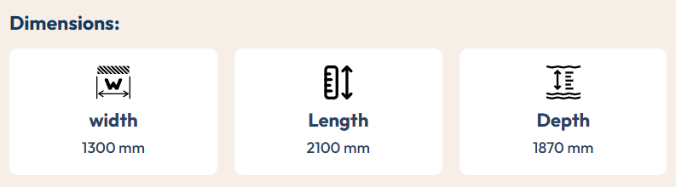

CTA: Watch Video Get a Quote
—---------------------------------------------------------------------------------------------------------
Why Choose Winera International

12+ Years of Expertise
Proven experience delivering game zone projects across malls, hotels, schools, and resorts since 2014.

Quality & Safety Standards
Every product sourced from global manufacturers and tested for commercial-grade safety and durability.

ROI-First Approach
Every project begins with a free ROI report, revenue and break-even calculated before you invest.

Reliable Pan-India Service
Our own team installs and supports every project across 50+ cities on time, every time.

—---------------------------------------------------------------------------------------------------------
Final CTA

Need Any Consultations ?

We’re Ready to Give Answers to Your Question.

CTA: Get Quote Now

2. MANX TT 32" CTA: Get A Quote

Specification:
Power : 500 W
Voltage : 220v
Category :Bike Racing Game
Players :2 Player
Main Material :Imported

Width : 2150 mm
Depth : 1900 mm
Height :1700 mm

CTA: Watch Video Get a Quote
—---------------------------------------------------------------------------------------------------------

12+ Years of Expertise
Proven experience delivering game zone projects across malls, hotels, schools, and resorts since 2014.

Quality & Safety Standards
Every product sourced from global manufacturers and tested for commercial-grade safety and durability.

ROI-First Approach
Every project begins with a free ROI report, revenue and break-even calculated before you invest.

Reliable Pan-India Service
Our own team installs and supports every project across 50+ cities on time, every time.

—---------------------------------------------------------------------------------------------------------
Final CTA

Need Any Consultations ?
We’re Ready to Give Answers to Your Question.

CTA: Get Quote Now

Developer Instruction: Add formatting bar (Basic information)

FifthAlley Sport Bowling

Hero Section

FifthAlley Sport Bowling: A Complete Bowling Alley Setup in the Heart of Surat
Subheadline:
How we designed and installed a professional-grade bowling alley across 3,000 sq. ft., transforming an empty space in Katargam into a destination entertainment venue in Surat.

Basic information
Project Name | FifthAlley Sport Bowling
Project Type | Bowling Alley Setup
Location | Surat, Gujarat
Total Area | 3,000 sq. ft.

What the Client Wanted

The client had an empty 3,000 sq. ft. space in Katargam and a clear goal: to open a professional bowling venue.

They didn't want a supplier who only supplied the equipment. They wanted one partner to handle everything, plan the space, install the lanes, and hand over a venue that was ready for opening day. In short, they needed one team they could trust from start to finish.

What Solution We Provide
We delivered FifthAlley Sport Bowling as a complete, ready-to-open venue. Across the 3,000 sq. ft. space in Katargam, we planned the layout so the professional lanes had enough room around them for people to walk, sit, and relax. The result is a venue that is fun to play in and comfortable to spend time in — just like a good family entertainment center should feel.

Project Gallery
Photos &
Add 5-6 images
Videos (Youtube Link)
Customers enjoying the bowling at Fifth Alley

Releted Projects

Bounce berry blr - Bangalore
Nextgen gaming zone - Raichur
Rock and bowl - Vapi
The fun factory nsp - Nallasopara West
Zaazaa play - Mumbai
Gif gaming is fun - Dehra Dun
Kidzonation - bhopal
Neon Panda - Indore

CTA Section

Need Any Consultations?

We’re Ready to Give Answers to Your Question.

Get Quote Now

Hulaboo: How We Turned an Empty Space Into Surat's Buzziest Game Zone
We turned a large empty space in Surat into one of the city's biggest indoor game zones — packed with games for every age, all under one roof.

Basic information
Project Name | Hulaboo
Project Type | Game Zone Setup
Location | Surat, Gujarat
Total Area | 27000 sq. ft.

What the Client Wanted

The client had a large space in Surat and a clear idea in mind. They didn't just want a few games, they wanted a place that people would remember. Somewhere a small kid, a group of friends, and a whole family could all come and have fun.
Most importantly, they wanted the whole process to be easy. Instead of dealing with many different suppliers, they wanted just one team to manage everything from planning and design to installation and hand over a game zone that was completely ready to open.

What Solution We Provide
At Winera International, we handled the complete game zone setup from start to finish — planning the layout, installing every attraction, and getting the venue ready to open.
A 27,000 sq. ft. space gives you plenty of room, but the real work is in the planning. You can't just line up machines; the layout has to move people smoothly from one experience to the next.
So we mapped out the space around how visitors actually move and spend their time. The high-energy attractions were placed where the noise and action wouldn't clash, while the quieter games and kids' zones were set up in calmer, safer areas. We also planned proper room for walkways, seating, and open space so no part of the venue ever felt tight or crowded.
The result is one smooth experience where families, friends, and serious gamers can all visit and each find their own kind of fun.

Project Gallery
Photos & Videos (YouTube Link)
Add 5–6 images
Guests having a fun day out at Hulaboo

Related Projects
Bounce Berry BLR – Bangalore
Nextgen Gaming Zone – Raichur
Rock and Bowl – Vapi
The Fun Factory NSP – Nallasopara West
Zaazaa Play – Mumbai
Gif Gaming Is Fun – Dehra Dun
Kidzonation – Bhopal
Neon Panda – Indore
CTA Section

Need Any Consultations?
We’re Ready to Give Answers to Your Question.
Get Quote Now

Playzonia

Hero Section

Playzonia: A Safe and Playful World Built Just for Little Ones
Subheadline:
We created a soft play area in Surat where small children can climb, bounce, and explore freely — in a space designed around their safety and their fun.

Basic information
Project Name | Playzonia
Project Type | Soft Play Area
Location | Surat, Gujarat
Total Area | 1,500 sq. ft.

What the Client Wanted
The client came to us with one clear vision to create a kids play area in Surat. Not just a room with a few toys, but a real space where young children could play, laugh, and move around freely — and where parents could bring them without a single worry.
For them, safety and comfort mattered above everything. They wanted a place families would trust and keep coming back to.

What Solution We Provide
At Winera International, we designed and built the entire soft play area from the ground up shaping it completely around what young children need.
Everything started with safety. We used soft, cushioned flooring so falls never hurt, and chose play structures with smooth, rounded edges that little hands and feet could enjoy without risk. From there, we added the fun gentle slides, climbing sections, and soft play elements that keep children active and curious.
We also thought about the parents. The space was kept open and easy to see across, so parents could relax nearby while still keeping their little ones in sight at all times.
The outcome is a warm, cheerful space that feels made for children — a place where kids lose track of time having fun, and parents feel completely at ease letting them play.

Project Gallery
Photos & Videos (YouTube Link)
Add 5–6 images
Little ones enjoying their time at Playzonia

Related Projects
Bounce Berry BLR – Bangalore
Nextgen Gaming Zone – Raichur
Rock and Bowl – Vapi
The Fun Factory NSP – Nallasopara West
Zaazaa Play – Mumbai
Gif Gaming Is Fun – Dehra Dun
Kidzonation – Bhopal
Neon Panda – Indore

CTA Section

Need Any Consultations?

We’re Ready to Give Answers to Your Question.

Get Quote Now

LaneX Bowling Alley
Hero Section

LaneX Bowling Alley: Bringing Pro-Style Bowling in Surat
Subheadline:
We designed and set up a full bowling alley at AR Mall. Turning an open floor into one of Surat's most exciting spots to bowl, hang out, and have fun.

Basic information
Project Name | LaneX Bowling Alley
Project Type | Bowling Alley
Location | Surat, Gujarat
Total Area | 4,800 sq. ft.

What the Client Wanted
The client wanted to open a proper bowling alley in Surat. A place where friends, families, and groups could come together, roll a few games, and enjoy their time out. Located inside AR Mall in Mota Varachha, the venue needed to feel modern, lively, and welcoming to everyone, whether they bowl often or are picking up a ball for the first time.
They also wanted one team to look after the whole thing. Instead of managing different people for design, equipment, and setup, they were looking for a single partner who could take the empty floor and turn it into a finished, ready-to-play venue.

What Solution We Provide

At Winera International, we handled the complete bowling alley setup from the first layout plan to the final working lane.
The main goal was to make the 4,800 sq. ft. floor feel right. Bowling lanes need proper spacing, so we planned the layout with care giving the lanes their room while leaving space for seating, walkways, and spots where people could relax between games.
We installed the lanes to professional standards, so every roll feels smooth. Around them, we shaped a comfortable space where groups can gather, cheer, and enjoy the whole outing.
The result is a venue that's fun to play in and ready to welcome guests.

Project Gallery
Photos & Videos (YouTube Link)
Add 5–6 images
Related Projects
Bounce Berry BLR – Bangalore
Nextgen Gaming Zone – Raichur
Rock and Bowl – Vapi
The Fun Factory NSP – Nallasopara West
Zaazaa Play – Mumbai
Gif Gaming Is Fun – Dehra Dun
Kidzonation – Bhopal
Neon Panda – Indore
CTA Section

Need Any Consultations?

We’re Ready to Give Answers to Your Question.

Get Quote Now
Meta Title
Bowling Alley Setup in Surat – LaneX at AR Mall | Winera International

Meta Description
See how Winera International built LaneX Bowling Alley in Surat. A Complete 4,800 sq. ft. bowling setup, planned and installed from empty floor to opening day.

Funfair
Hero Section

Funfair: A Game Zone Made for Non-Stop Fun in Surat
Subheadline:
We took a wide open space in Surat and shaped it into Funfair. A lively game zone where kids, teens, and families can play, compete, and enjoy a full day out together.

Basic information
Project Name | Funfair
Project Type | Game Zone
Location | Surat, Gujarat
Total Area | 10,000 sq. ft.

What the Client Wanted
The client came to us with a simple wish to open a game zone in Surat where people of all ages could come and have a good time. Not just a place with a few machines, but a spot that families would choose again and again for weekends, birthdays, and evenings out.
They also wanted the whole thing handled by one team. Rather than running around to different suppliers, they were looking for a single partner to plan the space, set everything up, and hand over a venue that was ready to open its doors.

What Solution We Provide
At Winera International, we handled the full game zone setup from start to finish. A 10,000 sq. ft. floor gives you room to do a lot, but the layout is what makes or breaks it. So we planned each area with care, placing the louder, faster games where the energy could build, and keeping calmer spots for younger kids and families to settle in.
We left proper room for walkways, seating, and open areas so the space never felt tight. The result is a game zone that flows smoothly from one corner to the next, ready to keep guests coming back.

Project Gallery
Photos & Videos (YouTube Link)
Add 5–6 images
Guests enjoying a fun day out at Funfair

Related Projects
Bounce Berry BLR – Bangalore
Nextgen Gaming Zone – Raichur
Rock and Bowl – Vapi
The Fun Factory NSP – Nallasopara West
Zaazaa Play – Mumbai
Gif Gaming Is Fun – Dehra Dun
Kidzonation – Bhopal
Neon Panda – Indore

CTA Section
Planning a Game Zone of Your Own?
Give us the space, and we'll deliver a complete game zone — planned, built, and ready to play. Your only job is to open the doors.
[Get a Free Consultation]

SEO Meta Details
Meta Title:
Funfair Game Zone Setup in Surat | Winera International
Meta Description:
See how WinEra International built Funfair, a complete 10,000 sq. ft. game zone in Surat, planned and set up from start to finish, ready to welcome families.
=============================================================

Rebounce

1. Hero Section
Headline:
Rebounce: A Giant Game Zone Built for Surat’s Weekends
Subheadline:
We started with a vast 32,000 sq. ft. space in Surat and turned it into Rebounce. A big, buzzing game zone where kids, teens and families can spend hours together.

2. Basic Information
- Project Name: Rebounce
- Project Type: Game Zone
- Location: Surat, Gujarat
- Total Area: 32,000 sq. ft.

3. What the Client Wanted
The client had a big goal for Surat. They wanted a game zone large enough to hold a whole day of fun, where kids could run around, teens could compete with friends, and parents could relax close by. A place people would talk about after their first visit and plan the next one before they even left.
They also knew a project this size could get messy with many vendors involved. So they wanted one team to take charge of the planning, the setup and the final handover, and give them a venue they could open without any loose ends.

4. What Solution We Provide
At Winera International, we saw 32,000 sq. ft. as a chance to build many experiences under one roof. Our game zone setup in Surat for Rebounce began with the floor plan. We grouped the high-energy games together so the noise and excitement stayed in one part of the venue, and placed the calmer play areas for younger kids further away, with seating nearby for parents.
A space this big can feel empty or confusing if it isn’t planned well. So we laid out wide walkways that guide guests from one zone to the next, and added open areas where groups can gather and take a break. The result is a venue that is easy to move through and gives families plenty of reasons to come back.

5. Project Gallery
Photos & Videos (YouTube Link)
Add 5–6 images

6. Related Projects
- Funfair – Surat
- Bounce Berry BLR – Bangalore
- Nextgen Gaming Zone – Raichur
- Rock and Bowl – Vapi
- The Fun Factory NSP – Nallasopara West
- Zaazaa Play – Mumbai
- Kidzonation – Bhopal
- Neon Panda – Indore

7. Related Products

- Arcade Games
- VR Games
- AR Games
- Bowling Alley
- Trampoline Park
- Soft Play
- Bumper Cars
- Hypergrid
- Laser Tag
- Amusement Park
- Lights
- Sculpture
- Reception Table
- Other Furniture

8. SEO Meta Details
Meta Title:
Rebounce Game Zone Setup in Surat | Winera International
Meta Description:
See how Winera International handled the game zone setup in Surat for Rebounce, a 32,000 sq. ft. venue planned and built to keep families coming back.

Level Up

1. Hero Section
Headline: Level Up: Every Visit Feels Like a New High Score in Morbi
Subheadline:
We took a 15,000 sq. ft. space in Morbi and built Level Up from the ground up. Today it’s a go-to game zone for kids, teens and families looking for a fun day out.

2. Basic Information
- Project Name: Level Up
- Project Type: Game Zone
- Location: Morbi, Gujarat
- Total Area: 15,000 sq. ft.

3. What the Client Wanted
The client saw that Morbi needed a proper place for families to spend their free time. They wanted a game zone where children, teenagers and parents could all find something they enjoy, so no one in the group feels left out. Most of all, they wanted guests to walk out already planning their next visit.
Instead of hiring separate vendors for design, equipment and installation, the client wanted a single partner. One team to plan the space, manage the setup and hand over a venue ready for opening day. That way, every decision stayed in one place and nothing slipped through the cracks.

4. What Solution We Provide
At Winera International, we began by studying how people would move across the 15,000 sq. ft. floor. For this game zone setup in Morbi, we divided the venue into clear zones. Faster, louder games sit together on one side, where players can enjoy the action without disturbing others. Softer play spots for little ones sit in a quieter corner, with seating close by so parents can keep an eye on them.
Between these zones, we kept walkways wide and left open pockets where friends and families can pause and regroup. Every part of the floor has a purpose, so the space feels full of life but never crowded. The result is a game zone that guests find easy to enjoy and keep returning to.

5. Project Gallery
Photos & Videos (YouTube Link)
Add 5–6 images

6. Related Projects
- Funfair – Surat
- Rebounce – Surat
- Rock and Bowl – Vapi
- Bounce Berry BLR – Bangalore
- Nextgen Gaming Zone – Raichur
- Zaazaa Play – Mumbai
- Kidzonation – Bhopal
- Neon Panda – Indore

7. Related Products
- Arcade Games
- VR Games
- AR Games
- Bowling Alley
- Trampoline Park
- Soft Play
- Bumper Cars
- Hypergrid
- Laser Tag
- Amusement Park
- Lights
- Sculpture
- Reception Table
- Other Furniture

8. SEO Meta Details
Meta Title:
Level Up Game Zone Setup in Morbi | Winera International
Meta Description:
Explore how Winera International delivered a complete game zone setup in Morbi for Level Up, a 15,000 sq. ft. venue that families love to revisit.

Rock and Bowl

1. Hero Section
Headline: Rock and Bowl: Strikes, Games and Good Times in Vapi
Subheadline:
We took a compact 6,000 sq. ft. space in Vapi and filled it with bowling, gaming and a cosy cafe. Rock and Bowl is now a favourite hangout for families, friends and kids alike.

2. Basic Information
- Project Name: Rock and Bowl
- Project Type: Game Zone
- Location: Vapi, Gujarat
- Total Area: 6,000 sq. ft.

3. What the Client Wanted
The client wanted to give Vapi a place with more than one reason to visit. Bowling for groups of friends, games for teens, a safe play spot for young children and a cafe where everyone could sit together. With so much on offer, every outing could feel a little different, and that would keep people coming back.
Fitting all of this into one venue needed careful planning. The client wanted a single team to own the whole job, from the first layout drawing to installing the last machine, and hand over a venue ready to welcome guests.

4. What Solution We Provide
At Winera International, we knew every part of the 6,000 sq. ft. floor had to work hard to hold this many attractions. For this game zone setup in Vapi, we gave the bowling area its own stretch of the floor, since it needs length and space to play well. The arcade, VR and pool table sit close by, creating one lively zone for teens and young adults.
The kids' soft play area sits away from the action, so little ones can play safely while parents relax at the cafe nearby. We kept walkways clear between each zone and added enough seating for groups to take a break. The result is a compact venue that never feels cramped and keeps guests returning.

5. Project Gallery
Photos & Videos (YouTube Link)
Add 5–6 images

6. Related Projects
- Funfair – Surat
- Rebounce – Surat
- Level Up – Morbi
- Bounce Berry BLR – Bangalore
- Nextgen Gaming Zone – Raichur
- Zaazaa Play – Mumbai
- Kidzonation – Bhopal
- Neon Panda – Indore

7. Related Products
- Arcade Games
- VR Games
- AR Games
- Bowling Alley
- Trampoline Park
- Soft Play
- Bumper Cars
- Hypergrid
- Laser Tag
- Amusement Park
- Lights
- Sculpture
- Reception Table
- Other Furniture

8. SEO Meta Details
Meta Title:
Rock and Bowl Game Zone Setup in Vapi | Winera International
Meta Description:
Discover the game zone setup in Vapi for Rock and Bowl. Winera International fit bowling, VR and arcade into 6,000 sq. ft. so families keep coming back.

Rumble Zone

1. Hero Section
Headline:
Rumble Zone: Big Energy, Bold Games and Loud Cheers in Gurugram
Subheadline:
We turned a 15,000 sq. ft. space in Gurugram into Rumble Zone. It’s an action-filled game zone where kids, teens and families come to switch off and play.

2. Basic Information
- Project Name: Rumble Zone
- Project Type: Game Zone
- Location: Gurugram, Haryana
- Total Area: 15,000 sq. ft.

3. What the Client Wanted
The client wanted to bring Gurugram a game zone with real energy. Somewhere friends could meet after a long week, kids could burn off steam, and families could plan a full outing without going anywhere else. The aim was a venue that feels exciting every single time, not just on the first visit.
With a project of this scale, the client did not want to juggle designers, suppliers and installers separately. They asked for one partner to take full responsibility, from shaping the layout to setting up every zone, so they could focus on opening day.

4. What Solution We Provide
At Winera International, we planned the 15,000 sq. ft. floor around one idea: let the excitement build as guests walk in. Our game zone setup in Gurugram places the most action-packed games deeper inside the venue, drawing people forward and keeping the noise contained. Areas for younger children sit nearer the entrance, in a calmer part of the floor with comfortable seating for parents.
We also gave the venue enough breathing room. Walkways are wide enough for busy weekends, and there are spots to sit, chat and cheer on friends between games. The result is a game zone that is easy to explore and gives every visitor a reason to plan the next trip.

5. Project Gallery
Photos & Videos (YouTube Link)
Add 5–6 images

6. Related Projects
- Funfair – Surat
- Rebounce – Surat
- Level Up – Morbi
- Rock and Bowl – Vapi
- Gif Gaming Is Fun – Dehra Dun
- Bounce Berry BLR – Bangalore
- Zaazaa Play – Mumbai
- Neon Panda – Indore

6. Related Products
- Arcade Games
- VR Games
- AR Games
- Bowling Alley
- Trampoline Park
- Soft Play
- Bumper Cars
- Hypergrid
- Laser Tag
- Amusement Park
- Lights
- Sculpture
- Reception Table
- Other Furniture

8. SEO Meta Details
Meta Title:
Rumble Zone Game Zone in Gurugram | Winera International
Meta Description:
See how Winera International planned the game zone setup in Gurugram for Rumble Zone, a 15,000 sq. ft. venue built for fun that keeps guests returning.

Skidz Play Spaces

1. Hero Section
Headline:
Skidz Play Spaces: A Safe, Happy Corner for Little Explorers in Mumbai
Subheadline:
We started with a 2,000 sq. ft. space in Santacruz (West) Mumbai and shaped it into Skidz Play Spaces. A bright, cushioned soft play area where kids aged 3 to 12 can play freely while parents stay close by.

2. Basic Information
- Project Name: Skidz Play Spaces
- Project Type: Soft Play
- Location: Mumbai, Maharashtra
- Total Area: 2,000 sq. ft.

3. What the Client Wanted
The client wanted a soft play space made just for children. A place where kids between 3 and 12 could play freely, and where parents could feel relaxed knowing their little ones were safe. In a busy city like Mumbai, they wanted Skidz to become the spot families pick for after-school fun and weekend outings.
The client did not want the trouble of working with many different companies. They wanted one team to take care of everything, from planning the space to setting it up. When the work was done, the play area had to be ready for kids to start playing.

4. What Solution We Provide
At Winera International, we know a 2,000 sq. ft. space must be planned well to feel big and fun. For this soft play area setup in Mumbai, we put the main play zone in the middle of the room. This gives kids lots of space to run and play. The soft, padded floor and walls help keep every child safe.

This place is made for small kids, so we kept it calm and safe. Parents can sit around the sides and see their kids playing at all times. We also kept clear paths so everyone could walk around easily. Now it is a cosy play space that families love to visit again and again.

5. Project Gallery
Photos & Videos (YouTube Link)
Add 5–6 images

6. Related Projects
- Kidzonation – Bhopal
- Zaazaa Play – Mumbai
- The Fun Factory NSP – Nallasopara West
- Bounce Berry BLR – Bangalore
- Funfair – Surat
- Level Up – Morbi
- Rock and Bowl – Vapi
- Rumble Zone – Gurugram

7. Related Products
- Arcade Games
- VR Games
- AR Games
- Bowling Alley
- Trampoline Park
- Soft Play
- Bumper Cars
- Hypergrid
- Laser Tag
- Amusement Park
- Lights
- Sculpture
- Reception Table
- Other Furniture

8. SEO Meta Details
Meta Title:
Skidz Play Spaces Soft Play in Mumbai | Winera International
Meta Description:
Explore how Winera International handled the soft play area setup in Mumbai for Skidz Play Spaces where kids have fun safely.

The Fun Factory

1. Hero Section
Headline:
The Fun Factory: Big Smiles for Little Ones in Vasai-Virar and Badlapur
Subheadline:
We took a 2,400 sq. ft. space and turned it into The Fun Factory, a soft play area for kids aged 3 to 12. Families in Vasai-Virar and Badlapur now have a safe, fun place to play close to home.

2. Basic Information
- Project Name: The Fun Factory
- Project Type: Soft Play
- Location: Vasai-Virar and Badlapur, Maharashtra
- Total Area: 2,400 sq. ft.

3. What the Client Wanted
The client wanted to give families in Vasai-Virar and Badlapur a proper play space for their kids. Not a small corner with a few toys, but a bright soft play area where children aged 3 to 12 could run, crawl and have fun safely. They wanted kids to keep asking their parents to come back every week.
The client also wanted an easy journey from idea to opening. Instead of talking to different people for design, equipment and fitting, they chose one team to manage everything and hand over a play area ready for kids on day one.

4. What Solution We Provide
At Winera International, we planned every part of the 2,400 sq. ft. floor so no space was wasted. For this soft play setup in Vasai-Virar and Badlapur, we gave the soft play zone the biggest share of the room. Kids get lots of space to climb, jump and explore, and padded surfaces keep them safe while they play.
We placed parent seating where they can see the whole play area at a glance, so they can relax without worry. Paths around the zone are kept open, making it easy for kids and parents to move in and out. The result is a happy, easy-to-use play space that families keep visiting.

5. Project Gallery
Photos & Videos (YouTube Link)
Add 5–6 images

6. Related Projects
- Skidz Play Spaces – Mumbai
- Zaazaa Play – Mumbai
- Kidzonation – Bhopal
- Bounce Berry BLR – Bangalore
- Funfair – Surat
- Level Up – Morbi
- Rock and Bowl – Vapi
- Rumble Zone – Gurugram

7. Related Products
- Arcade Games
- VR Games
- AR Games
- Bowling Alley
- Trampoline Park
- Soft Play
- Bumper Cars
- Hypergrid
- Laser Tag
- Amusement Park
- Lights
- Sculpture
- Reception Table
- Other Furniture

8. SEO Meta Details
Meta Title:
The Fun Factory Soft Play, Vasai-Virar & Badlapur | Winera
Meta Description:
See how Winera International handled the soft play setup in Vasai-Virar and Badlapur for The Fun Factory, a 2,400 sq. ft. space kids love to visit.

Pop A Puddle

1. Hero Section
Headline:
Pop A Puddle: Where Kids Play and Parents Sip in Bangalore
Subheadline:
We took a 4,800 sq. ft. space in Bangalore and turned it into Pop A Puddle, a soft play area with a family café. Kids aged 3 to 12 play freely, while parents relax at the café close by.

2. Basic Information
- Project Name: Pop A Puddle
- Project Type: Soft Play / Family Play Café
- Location: Bangalore, Karnataka
- Total Area: 4,800 sq. ft.

3. What the Client Wanted
The client wanted a place where the whole family could spend time together, not just the kids. Children aged 3 to 12 needed a safe and exciting soft play area, and parents needed a comfortable café where they could sit, chat and unwind. When both kids and parents enjoy the visit, they naturally want to come back.
Building a play area and a café together means many moving parts. So the client wanted one team to handle it all, from planning the layout to fitting the equipment, and handing over a space that was ready to open.

4. What Solution We Provide
At Winera International, we used the 4,800 sq. ft. floor to bring play and rest together in one space. For this play café setup in Bangalore, we gave the soft play zone a large, open area where kids can climb, slide and explore. The padded play setup keeps every jump and tumble safe.
We placed the café right next to the play area, so parents can enjoy their time while still keeping an eye on their children. Clear walkways connect both spaces, and seating is spread out so families never feel squeezed. The result is a warm, easy-going venue where kids play happily and parents feel at home.

5. Project Gallery
Photos & Videos (YouTube Link)
Add 5–6 images

6. Related Projects
- Skidz Play Spaces – Mumbai
- The Fun Factory – Vasai-Virar & Badlapur
- Bounce Berry BLR – Bangalore
- Kidzonation – Bhopal
- Zaazaa Play – Mumbai
- Funfair – Surat
- Level Up – Morbi
- Rock and Bowl – Vapi

7. Related Products
- Arcade Games
- VR Games
- AR Games
- Bowling Alley
- Trampoline Park
- Soft Play
- Bumper Cars
- Hypergrid
- Laser Tag
- Amusement Park
- Lights
- Sculpture
- Reception Table
- Other Furniture

8. SEO Meta Details
Meta Title:
Pop A Puddle Play Café in Bangalore | Winera International
Meta Description:
See how Winera International handled the play café setup in Bangalore for Pop A Puddle, a 4,800 sq. ft. space where kids play and parents relax.

Skadoosh Play Area

1. Hero Section
Headline:
Skadoosh Play Area: Endless Giggles and Adventures in Haralur and Varthur
Subheadline:
We took a 7000 sq. ft. space and turned it into Skadoosh Play Area, a fun-filled kids play area in Bangalore. It’s made for children aged 3 to 12 and for parents in Haralur and Varthur who want a safe place to play nearby.

2. Basic Information
- Project Name: Skadoosh Play Area
- Project Type: Kids Play Area
- Location: Haralur and Varthur, Bangalore, Karnataka
- Total Area: 7000 sq. ft.

3. What the Client Wanted
The client wanted a play area that kids would beg to visit. A cheerful, safe space in Haralur and Varthur where children aged 3 to 12 could spend hours playing, and where parents could feel at ease the whole time. They wanted every visit to be full of fun, so families would make it part of their routine.
To get there, the client needed a partner who could take care of the full project. They wanted one team to plan the layout, source and install the play equipment, and hand over a play area ready for its first little visitors.

4. What Solution We Provide
At Winera International, we saw the 7000 sq. ft. floor as one big playground waiting to happen. For this kids play area in Bangalore, we kept the busiest, most active play sections in the centre, where kids can run, climb and jump freely. Gentler spots for the youngest children sit to the side, away from the rush, so they can play at their own pace.
Parent seating wraps around the play area, giving a clear view from every seat. We kept the walkways wide and the open areas free, so kids can move from one section to another without bumping into each other. The result is a happy, well-organised play area that families in Haralur and Varthur love to visit again.

5. Project Gallery
Photos & Videos (YouTube Link)
Add 5–6 images

6. Related Projects
- Pop A Puddle – Bangalore
- Bounce Berry BLR – Bangalore
- Skidz Play Spaces – Mumbai
- The Fun Factory – Vasai-Virar & Badlapur
- Kidzonation – Bhopal
- Zaazaa Play – Mumbai
- Funfair – Surat
- Level Up – Morbi

7. Related Products
- Arcade Games
- VR Games
- AR Games
- Bowling Alley
- Trampoline Park
- Soft Play
- Bumper Cars
- Hypergrid
- Laser Tag
- Amusement Park
- Lights
- Sculpture
- Reception Table
- Other Furniture

8. SEO Meta Details
Meta Title:
Skadoosh Kids Play Area in Bangalore | Winera International
Meta Description:

VR 360 Game Zone

1. Hero Section
Headline:
VR 360 Game Zone: Step Into New Worlds Right Here in Gandhidham
Subheadline:
We took a 2,000 sq. ft. space in Gandhidham and turned it into VR 360 Game Zone. It’s a fun, modern hangout where teens, young adults and families can try virtual reality and play together.

2. Basic Information
- Project Name: VR 360 Game Zone
- Project Type: Game Zone
- Location: Gandhidham, Gujarat
- Total Area: 2,000 sq. ft.

3. What the Client Wanted
The client wanted to bring something fresh to Gandhidham. A game zone built around virtual reality, where teens and young adults could hang out with friends, and families could try something new together. They wanted a place exciting enough that guests would keep coming back with their friends.
VR needs careful planning, from choosing the right space to getting the setup right. So the client wanted one team to take care of everything, including the layout, installation and handover, and give them a venue ready to open its doors.

4. What Solution We Provide
At Winera International, we know VR needs more room and planning than regular games. Players move, turn and react while they play, so the VR area needs clear space around it. For this game zone setup in Gandhidham, we planned the 2,000 sq. ft. floor so players have enough room to move freely and safely.
We kept a waiting and seating area near the front, where friends and family can watch, cheer and wait for their turn. Walkways stay clear, so guests can move around without getting in the way of players. The result is a compact, well-planned game zone that is safe, exciting and easy to come back to.

5. Project Gallery
Photos & Videos (YouTube Link)
Add 5–6 images

6. Related Projects
- Rock and Bowl – Vapi
- Level Up – Morbi
- Funfair – Surat
- Rebounce – Surat
- Rumble Zone – Gurugram
- Neon Panda – Indore
- Nextgen Gaming Zone – Raichur
- Gif Gaming Is Fun – Dehra Dun

7. Related Products
- Arcade Games
- VR Games
- AR Games
- Bowling Alley
- Trampoline Park
- Soft Play
- Bumper Cars
- Hypergrid
- Laser Tag
- Amusement Park
- Lights
- Sculpture
- Reception Table
- Other Furniture

8. SEO Meta Details
Meta Title:
VR 360 Game Zone Setup in Gandhidham | Winera International
Meta Description:
See how Winera International handled the game zone setup in Gandhidham for VR 360 venue packed with fun for teens and families.

Altitude Ball in Ball Out

1. Hero Section
Headline:
Altitude Ball in Ball Out: Every Roll Brings Friends Closer in Mumbai
Subheadline:
We took an 8,000 sq. ft. space in Mumbai and turned it into Altitude Ball in Ball Out, a lively bowling alley. It’s a place where teens, young adults and families come to play, compete and spend good time together.

2. Basic Information
- Project Name: Altitude Ball in Ball Out
- Project Type: Bowling Alley
- Location: Mumbai, Maharashtra
- Total Area: 8,000 sq. ft.

3. What the Client Wanted
The client wanted a bowling alley in Mumbai that feels fun as soon as people walk in. A place where friends can play against each other and families can laugh and enjoy a game together. They wanted guests to go home and plan their next visit right away.
A bowling alley needs exact planning, from the lane area to the seating around it. The client wanted one team to manage the whole project, from layout and installation to the final handover, so they did not have to deal with several suppliers at once.

4. What Solution We Provide
At Winera International, we started by giving the bowling lanes the space they need. Lanes need length, so we planned the 8,000 sq. ft. floor with the bowling area as its main feature. For this bowling alley setup in Mumbai, we made sure every lane is easy to see and reach, so the whole venue feels connected to the action.
Behind the lanes, we added comfortable seating where players can relax, keep score and cheer each other on. Clear walkways let guests move around without crossing into the play area, and open spaces give groups room to gather between games. The result is an easy-to-enjoy bowling alley that brings friends and families back for one more game.

5. Project Gallery
Photos & Videos (YouTube Link)
Add 5–6 images

6. Related Projects
- Rock and Bowl – Vapi
- Rumble Zone – Gurugram
- VR 360 Game Zone – Gandhidham
- Level Up – Morbi
- Funfair – Surat
- Rebounce – Surat
- Zaazaa Play – Mumbai
- Neon Panda – Indore

7. Related Products
- Arcade Games
- VR Games
- AR Games
- Bowling Alley
- Trampoline Park
- Soft Play
- Bumper Cars
- Hypergrid
- Laser Tag
- Amusement Park
- Lights
- Sculpture
- Reception Table
- Other Furniture

8. SEO Meta Details
Meta Title:
Altitude Bowling Alley in Mumbai | Winera International
Meta Description:
See how Winera International handled the bowling alley setup in Mumbai for Altitude. Venue where friends and families play together.

Uday palace - 7000
Kingsman Experience - 5000
1 UP - 9000
Pop in Play - 4800
NextGen Gaming Zone - 3000
—---------------------
Fifth Alley Bowling Setup by WinEra International #shorts #WinEra #bowlingalley #surat
Professional bowling lanes and a lively hangout, set up by WinEra International Pvt. Ltd.
—---------------------
You are a website content writer for Winera International, a company that plans, designs and sets up complete game zones, play areas and family entertainment centres across India.
Write the content for a PROJECT CASE STUDY web page using the details below.
=== PROJECT DETAILS (fill these in) ===
Project Name: [Altitude Ball in Ball Out]
Project Type: [Bowling alley]
Location (City, State): [e.g. Mumbai, Maharashtra]
Total Area: [e.g. 8000 sq. ft.]
Target Audience: [e.g. teens and young adults / families]
Key Attractions or Zones: [e.g. teens and young adults / families] (write "not known" if unsure)
Client's Main Goal: [e.g. a weekend family destination, a youth hangout, a birthday party venue]
Focus Keyword: [e.g. Bowling Alley Set up in Mumbai]
Related Projects (4–8): [list names – cities]
=== PAGE STRUCTURE (follow exactly) ===
1. HERO SECTION
- Headline: "[Project Name]: [short benefit line] in [City]" — max 10-12 words.
- Subheadline: 2 sentences. Say what space we started with and what it became, and who it's for.
2. BASIC INFORMATION
List exactly: Project Name, Project Type, Location, Total Area.
3. WHAT THE CLIENT WANTED
- 2 short paragraphs, 90–120 words total.
- Para 1: what kind of venue they wanted and for whom, and why it should be a place people return to.
- Para 2: they wanted one team to handle planning, setup and handover, instead of dealing with many suppliers.
4. WHAT SOLUTION WE PROVIDE
- 2 short paragraphs, 100–140 words total. Start with "At Winera International, ..."
- Explain how we used the specific area size and layout: where high-energy attractions went, where calmer zones for younger kids or families went, and space for walkways, seating and open areas.
- Mention the actual attractions listed above (do not invent attractions that aren't listed).
- If a special challenge is given, explain how the layout solved it.
- End with the result: a venue that flows well and keeps guests coming back.
5. PROJECT GALLERY
- Write: "Photos & Videos (YouTube Link)" and "Add 5–6 images"
6. RELATED PROJECTS
List the related projects in the format: Project Name – City
7. CTA SECTION
- Heading: a question about planning their own [project type] (max 8 words).
- 2 sentences: they give us the space, we deliver a complete, ready-to-open venue.
- Button: [Get a Free Consultation]
8. SEO META DETAILS
- Meta Title: max 60 characters, format "[Project Name] [Project Type] Setup in [City] | Winera International"
- Meta Description: 140–155 characters, includes the focus keyword, area size and city, ends with a benefit.
=== WRITING RULES ===
- Tone: warm, simple, confident. Easy English that a parent or a business owner in India reads easily.
- Short sentences. No jargon, no hype words like "state-of-the-art", "world-class", "revolutionary", "unparalleled", "elevate", "seamless".
- Do not use em dashes (—) in body text.
- Write in "we" voice for Winera International. Always spell the brand as "Winera International".
- Use the focus keyword naturally 2–3 times across the page (hero, solution, meta). Do not stuff it.
- Do NOT copy sentences from other project pages. Vary the openings, the headline benefit and the way the layout is described so every page is unique for SEO.
- Do not invent numbers, dates, machine counts or client names that aren't given.
- Output with clear section headings exactly as in the structure above, ready to paste into the website.

https://youtube.com/shorts/BkfLTzn7X1Q?feature=share

Fizzy Fox
Funezaa- vadodra
Funevers-Bhopal
The Game place
Game is Fun
Giggle Wiggle
Rebounce - 32000
Neon Panda
House of pepe
Kidzonation
Level up - 15000
Pop A Puddle - 4800
Rock and bowl Game Zone - 6000
Rumble Zone - 15000
Skadoosh Kids Play Area - 7000
Skidz Play Spaces - 2000
Bounce Berry
Space Jump
The Fun Factory - 2400
Space Tank Gaming Zone
Sparrk
Uday palace - 7000
VR 360 Game Zone - 2000
ZaaZa
Altitude Ball in Ball Out - 8000
Fun Houz
Kingsman Experience - 5000
Namco
1 UP - 9000
Knockout
Pop in Play - 4800
Karmega Kanna
NextGen Gaming Zone - 3000

Fizzy Fox
Funezaa- vadodra
Funevers-Bhopal
The Game place
Game is Fun
Giggle Wiggle
Neon Panda
House of pepe
Kidzonation
Bounce Berry
Space Jump
Sparrk
ZaaZa
Fun Houz
Namco
Knockout
Karmega Kanna

Pop A Puddle - 4800
Rumble Zone - 15000
Skadoosh Kids Play Area - 7000
Uday palace - 7000
VR 360 Game Zone - 2000
Altitude Ball in Ball Out - 8000
Kingsman Experience - 5000
1 UP - 9000
Pop in Play - 4800
NextGen Gaming Zone - 3000

Project Combined page

FifthAlley Sport Bowling
Bowling alley
- Surat

Hulaboo
Game zone
- Surat

Playzonia
Soft play
- Surat

LaneX Bowling Alley by Rajhans
Bowling alley
- Surat

Funfair
Game zone
- Surat

1 up
Game zone
- Gauhati

House of pepe
Soft play- arcade
- Kolkata

Kingsman
Arcade & VR
- Navi Mumbai

Rebounce
Game zone
- Surat

Happy hoppers
Soft play
- Kolkata
https://maps.app.goo.gl/V5icDQa9iiw5tNReA
https://www.instagram.com/my_happy_hoppers/
Knpatel school
Soft play
- Gota, Ahemdabad

Kidzania- Delhi
Arcade games

uday palace
Game zone
- Navsari

360-Gandhidham
VR zone
- gandhidham

Fun Houze
Gameznoe
- Begusarai

Rumble Zone
Gamezone
- Gurugram

The Game place
Gamezone
- New Delhi

Fizzy Fox
Gamezone
- Nashik
Neon Panda
Gamezone
- Indore

Funevers
Bowling
- Bhopal

Kidzonation
Softplay
- Bhopal
Game is fun
Kids Play Area
- Dehradun

Zaa zaa play area
Softplay
- Mumbai

Fun factory
Softplay
- Nallasopara

Pop In Play
Softplay
- Bengaluru
https://maps.app.goo.gl/y3MoN9eZAx3qf2rG6
Rock and Bowl Vapi
Game Zone
- Vapi
https://maps.app.goo.gl/9qDukdGL6q733CzA9

Giggle Wiggle
Kids Play Area
- Delhi
https://maps.app.goo.gl/RtyGbvTzp3txyRUXA

Skadoosh - Play and Parrty Hub | Kids Play Area | Birthdays | Laser Tag
Kids Play Area and Party Hub
- Bengaluru
https://maps.app.goo.gl/2gfgpW6S2WGgr7vz7
bounc berry-
Kids play Area
- Bengaluru
https://maps.app.goo.gl/GgxX6iGW2H1JTXbr5
Zestopia
Game zone
- Surat
https://maps.app.goo.gl/YsZWWSZMX7ixPvYj8
Funenza (Biggest Gamezone in BRC)
Softplay and trampoline park installation only
- Vadodara
https://maps.app.goo.gl/F1JKvsEwxJKtLWbc6
Spark
https://maps.app.goo.gl/yFQVoZWKboRo5kHk6
Arcade Game
- Ahmedabad
Hotel Redisaon
-Furniture
The Fern Vishranta Resort Kamrej-Surat, Series by Marriott
https://maps.app.goo.gl/xUy1TB7JmhW9hB8b9
-All amenities with furniture
- Kamrej-Surat
KKB Rio Colina - Club & Vill
https://maps.app.goo.gl/yoEu1vHXDWsh3jq17
- All amenities with furniture
- Surat

Space Jump- Family Entertainment Park
https://maps.app.goo.gl/wZiVCthpMJGxrg9e8
Arcade Game
- Kolkata

NAMCO - Biggest Indoor Amusement center
https://maps.app.goo.gl/BMLmA6JZBzbV1LjC9
Bowling Alley
- Navi Mumbai
Aaradhya OnePark by MICL Group
https://maps.app.goo.gl/nGbtPsm7qJVRjvt28
Bowling alley
- Ghatkopar
Shivanta Hotel & Resorts
https://maps.app.goo.gl/SCmSB6AepnTHs6Hv6
All
- Rajasthan
Ranchi Gymkhana Club
https://maps.app.goo.gl/XZ7ujZyxoE3dZeV6A
Outdoor and indoor kids play area
- Ranchi

Dream Valley
- Firozabad
https://maps.app.goo.gl/434TcQzxMc1exbNK6
Amenities
The play.co
Under Development
- delhi

Crafting India's Best Play Destinations
Categories
· All
· Bowling
· Game Zones
· Soft Play
· Arcade & VR
· Hospitality

FifthAlley Sport Bowling
Bowling alley
Surat
------------------------------
Hulaboo
Game zone
Surat
------------------------------
Playzonia
Soft play
Surat
------------------------------
LaneX Bowling Alley by Rajhans
Bowling alley
Surat
------------------------------
Funfair
Game zone
Surat
------------------------------
1 up
Game zone
Gauhati
------------------------------
House of pepe
Soft play- arcade
Kolkata

Kingsman
Arcade & VR
Navi Mumbai
------------------------------
Rebounce
Game zone
Surat
------------------------------
Happy hoppers
Soft play
Kolkata
------------------------------
Knpatel school
Soft play
Gota, Ahemdabad
------------------------------
Kidzania
Arcade games
Delhi
------------------------------
uday palace
Game zone
Navsari
------------------------------
360-Gandhidham
VR zone
gandhidham
------------------------------
Fun Houze
Gameznoe
Begusarai
------------------------------
Rumble Zone
Gamezone
- Gurugram
------------------------------
The Game place
Gamezone
- New Delhi
------------------------------
Fizzy Fox
Gamezone
Nashik
Neon Panda
Gamezone
Indore
------------------------------
Funevers
Bowling
Bhopal
------------------------------
Kidzonation
Softplay
Bhopal
------------------------------
Game is fun
Kids Play Area
Dehradun
------------------------------
Zaa zaa play area
Softplay
Mumbai
------------------------------
Fun factory
Softplay
Nallasopara
------------------------------
Pop In Play
Softplay
Bengaluru
------------------------------
Rock and Bowl Vapi
Game Zone
Vapi
------------------------------
Giggle Wiggle
Kids Play Area
Delhi
------------------------------
Skadoosh - Play and Parrty Hub | Kids Play Area | Birthdays | Laser Tag
Kids Play Area and Party Hub
Bengaluru
------------------------------
bounc berry-
Kids play Area
Bengaluru

Zestopia
Game zone
Surat
------------------------------
Funenza (Biggest Gamezone in BRC)
Softplay and trampoline park installation only
Vadodara
------------------------------
Spark
Arcade Game
Ahmedabad
------------------------------
Hotel Redisaon
-Furniture
------------------------------
The Fern Vishranta Resort Kamrej-Surat, Series by Marriott
-All amenities with furniture
- Kamrej-Surat
------------------------------
KKB Rio Colina - Club & Vill
- All amenities with furniture
Surat
------------------------------
Space Jump- Family Entertainment Park
Arcade Game
Kolkata
------------------------------
NAMCO - Biggest Indoor Amusement center
Bowling Alley
Navi Mumbai
------------------------------
Aaradhya OnePark by MICL Group
Bowling alley
Ghatkopar
------------------------------
Shivanta Hotel & Resorts
All
Rajasthan
Ranchi Gymkhana Club
------------------------------
Outdoor and indoor kids play area
Ranchi

Dream Valley
Firozabad
Amenities
------------------------------
The play.co
Under Development
Delhi

—----------------------------------------------------------------------------------------------------------------------------
CTA Section

Have a space to bring alive?

Let's build your next project together

Contact Us

Example: https://csmlgroup.com/project

Privacy Policy

1. Introduction
Winera International Pvt. Ltd. ('Winera', 'Company', 'we', 'our', or 'us') is committed to protecting your personal and business information. This Privacy Policy explains how we collect, use, disclose, and safeguard your information when you visit our website www.winera.in, interact with us online, or use our services. By using our website, you consent to the practices described in this policy.

2. Information We Collect
We collect the following types of information:
- Personal Information: Your name, email address, phone number, business name, designation, and other contact details.
- Business Information: Project details, site drawings, requirements, order history.
- Technical Data: IP address, browser type, device information, operating system, referring URLs, date/time stamps.
- Cookies and Usage Data: We use cookies to collect anonymous usage statistics and user behavior data.

3. How We Use Your Information
We use your information for purposes including:
- Responding to inquiries and sending quotes
- Processing and managing your orders
- Delivering customer service and support
- Improving our website and services
- Sending transactional and promotional communications (with your consent)
- Legal compliance and dispute resolution

4. Legal Basis for Processing
We process your data based on:
- Your consent
- The necessity to perform a contract
- Our legal obligations
- Legitimate business interests

5. Sharing and Disclosure of Information
We do not sell your data. We may share information with:
- Internal teams for project fulfillment
- Logistics providers for delivery
- IT and analytics partners (e.g., Google Analytics)
- Legal or regulatory authorities when required

6. Data Retention
We retain your personal and business data only for as long as necessary to fulfill the purposes outlined in this policy. This includes compliance with legal obligations, resolving disputes, and enforcing agreements.

7. Your Data Rights
You have the right to:
- Access and review your data
- Correct or update inaccurate information
- Withdraw consent at any time
- Request data deletion, subject to legal limits
- Object to processing or request data portability

8. Security of Your Data
We implement appropriate technical and organizational measures to safeguard your data. This includes secure servers, firewalls, encryption, and access controls. While we strive for security, no method is fully secure.

9. Cookies and Tracking
We use cookies to understand user behavior and improve site performance. You can manage your cookie preferences in your browser settings. Blocking cookies may impact your experience.

10. Third-Party Links
Our website may contain links to other websites. We are not responsible for their privacy practices or content. Please review their policies before interacting with them.

11. Children’s Privacy
Our services are intended for individuals 18 years and older. We do not knowingly collect data from children. If you believe we have inadvertently collected such data, contact us for deletion.

12. International Data Transfers
If you are accessing our website from outside India, you consent to the transfer and processing of your data in accordance with Indian law.

13. Changes to This Policy
We may update this Privacy Policy from time to time. The latest version will be posted on this page. Continued use of our website means you accept the updated terms.

14. Contact Information
For any questions or concerns, contact us at:
Winera International Pvt. Ltd.
1011, 10th floor, Millennium Business Hub, opp. Bhagavan Nagar, Sarthana Jakat Naka, Nature Park and Zoo, Nana Varachha, Surat, Gujarat-395006, India
Email: info@winera.in
Phone: +91 94289 89488 / +91 95123 56766

Terms & Conditions
Winera International Pvt. Ltd.
These Terms and Conditions (“Agreement”, “Terms”) govern your (“you”, “your”, “client”, “customer”) access to and use of the website www.winera.in (the “Site”), and the products and services (“Services”) offered by Winera International Pvt. Ltd. (“Company”, “Winera”, “we”, “our”, or “us”). By accessing or using our Site and/or Services, you agree to be legally bound by these Terms. If you do not agree, please do not use this Site or engage with our services.

1. About Winera International Pvt. Ltd.
Winera International Pvt. Ltd., incorporated under the Companies Act, 1956, with registered office at, 1011, 10th floor, Millennium Business Hub, opp., Bhagavan Nagar, Sarthana Jakat Naka, Nature Park and Zoo, Nana Varachha, Surat, Gujarat 395006, India, is a leading B2B turnkey entertainment solutions provider. Our services include:
· Indoor soft play zones
· Trampoline parks and ninja courses
· Arcade and video game machine installations
· VR/AR entertainment zones
· Bowling alleys, bumper cars, laser tag setups
· Customized commercial play and recreation areas

2. Scope of Agreement
These Terms apply to all interactions, transactions, proposals, quotations, and contracts made through the Site or directly with the Company. These Terms do not override signed project-specific contracts; however, in case of conflict, the mutually signed agreement shall take precedence.

3. Use of the Website
· You agree to access this Site lawfully and only for legitimate business purposes.
· Unauthorized use of this Site may give rise to claims for damages and/or be a criminal offense.
· You may not:
o Attempt to gain unauthorized access to our systems or data
o Use this Site to copy, store, transmit, or distribute malicious software
o Scrape, crawl, or collect user data without permission

4. Quotations, Proposals & Pricing
· All quotations are non-binding until confirmed through a signed purchase/work order.
· Quotes are valid for 30 days unless otherwise stated in writing.
· All pricing is in Indian Rupees (INR) and exclusive of applicable taxes, duties, and levies.
· Price revisions may occur due to changes in raw material costs, design alterations, or import duties.

5. Project Process & Order Confirmation
· Projects commence only after receiving:
o Signed approval on quotation/design/BOQ
o Advance payment as per agreed terms
· The project is broken into phases: Design → Production → Dispatch → Installation → Handover
· Project-specific responsibilities (like flooring, lighting, or electrical setup) must be completed by the client before installation begins.

6. Payment Terms
Unless otherwise specified:
· 50% of the total project value is payable in advance
· 40% before shipment or dispatch from factory
· 10% upon final handover and acceptance
Other important clauses:
· No shipment or site work will begin without receipt of due payments
· Delay in payment will lead to additional storage, demurrage, or interest charges (typically 1.5% per month)
· Payments must be made to official bank accounts listed on company invoices

7. Delivery & Logistics
· Delivery timelines are indicative and commence only after design approval and advance receipt
· Unexpected delays (strikes, customs clearance, shipping issues, etc.) will be communicated but shall not be grounds for penalty unless otherwise agreed
· Risk of goods passes to the client upon dispatch from our warehouse
· Insurance, if required, must be arranged by the client or requested in writing

8. Installation & Site Readiness
· Winera provides installation services as part of turnkey projects
· Client responsibilities:
o Ensure access to the site during business hours
o Provide civil-ready conditions (flooring, walls, electric points, etc.)
o Provide accommodation or local logistics for installation crew in remote locations (as per mutual agreement)
· Any re-visits or delays due to client-side unpreparedness will be chargeable

9. Warranty & Maintenance
· A standard 12-month manufacturer’s warranty is provided from date of installation
· Coverage includes:
o Structural integrity
o Weld failures
o Manufacturing defects in supplied components
· Exclusions include:
o Misuse, vandalism, natural disasters, water/fire/electrical damage
o Third-party installations or repairs
o Consumables and wear-and-tear parts (nets, ropes, foam padding, etc.)
· Post-warranty AMC (Annual Maintenance Contract) is available for a fee

10. Design, Drawing & Intellectual Property
· All designs, layouts, 3D renders, and proposals remain the intellectual property of Winera unless transferred by written agreement
· No reuse, reproduction, or sharing is permitted without our written consent
· Breach of this clause may result in legal action and claims for damages

11. Modifications & Customization
· Clients may request minor customizations post-design approval; these will be accommodated if feasible
· Major changes post-approval may involve additional cost and timeline revisions
· Requests must be made in writing and approved by both parties

12. Cancellation & Refund Policy
· Cancellation before production begins will attract a minimum 10% administrative fee
· Once manufacturing or procurement has commenced, no refund will be issued
· Refunds (where applicable) will be processed within 30 working days after due verification

13. Limitation of Liability
· Winera shall not be liable for:
o Indirect or consequential losses
o Loss of business, revenue, or reputation
o Delays due to force majeure or third-party vendors
· Maximum liability is capped at the total value of the product/service provided in the dispute

14. Subcontractors & Third Parties
· We may use subcontractors or third-party service providers for part of the project (e.g., transport, electrical work)
· While we take care in selection, Winera is not liable for direct performance of subcontractors unless contractually stated

15. Confidentiality & Data Protection
· All discussions, documents, drawings, client lists, and pricing details shared between Winera and the client are confidential
· Each party agrees to use such data only for the intended project and not disclose to third parties without consent
· Winera maintains strict cybersecurity and GDPR-compliant (where applicable) data handling protocols

16. Force Majeure
Winera shall not be liable for failure or delay in performance due to causes beyond its reasonable control, including but not limited to acts of God, war, fire, pandemics, strikes, shipping delays, embargoes, or government orders.

17. Termination
Winera reserves the right to terminate any contract if:
· The client breaches material terms of the agreement
· Payments are withheld or delayed beyond agreed terms
· The client is found engaging in fraudulent, unethical, or harmful business practices

18. Governing Law & Jurisdiction
· These Terms shall be governed by and construed in accordance with the laws of the Republic of India
· Any disputes or legal claims shall be subject to the exclusive jurisdiction of the courts in Surat, Gujarat

19. Revisions and Updates
· These Terms may be updated periodically to reflect changes in law or business operations
· Continued use of the Site or Services after updates will constitute acceptance of the revised Terms

20. Contact Us
Winera International Pvt. Ltd.
📍 1011, 10th floor, Millennium Business Hub, opp., Bhagavan Nagar, Sarthana Jakat Naka, Nature Park and Zoo, Nana Varachha, Surat, Gujarat-395006, India
📧 Email: info@winera.in
📞 Phone: +91 94289 89488 / +91 95123 56766
🌐 Website: www.winera.in

Arcade Game Machine in India

Ratings & Reviews

Ankit kabariya

I would like to share one of my Great experience with WinEra international When I am giving reference of winEra to one of my builder friend . Basically he want service of club house development for his project and then winEra take the project in them hand and provide excellence service to him for club development and also provide children play area equipment. My friend is very happy with WinEra service. After that i strongly recommended winEra for his out of the box service .

Read more

Akshay Mangla
Great Equipments With Great Services.

Visshal Chudasama
Great people and great service and also beautiful equipment.

----------------------------------------------------------------------------------------------------

Bowling Alley Manufacturers in India

Premium Bowling Alley Manufacturer in India

At Winera International Pvt. Ltd., we are proud to be India’s leading bowling alley manufacturer and supplier of refurbished Brunswick bowling equipment. With over 15 years of expertise in the industry, we have built a reputation for delivering top-quality bowling alley equipment and exceptional customer service, tailored to fit the unique needs and budgets of our clients.

We specialize in providing 95% new Brunswick GS98 & GSX equipment, enhanced with the latest Frameworx or Vector Scoring Systems based on your specific requirements. Our approach is simple—offer the best bowling solutions to match both your budget and venue dimensions, ensuring an outstanding bowling experience.

Why Choose Us?

At Winera International, we bring over 15 years of industry experience as a trusted bowling alley manufacturer in India. We are the largest bowling alley supplier in the country, with more than 30 complete setups already delivered successfully. Our equipment is originally manufactured in the USA, ensuring unmatched quality. We provide affordable refurbished options, comprehensive installation, maintenance, and support services across India. With low failure rates and easy maintenance, our tailored solutions are designed to meet your budget and space requirements, delivering exceptional value for your bowling center.

Why Choose Refurbished Brunswick Bowling Alley Equipment?

We offer refurbished Brunswick bowling equipment that is well-known for its long-term reliability and performance. As one of the most preferred brands worldwide, Brunswick is valued for its stable mechanical capacity and low failure rate—making it a top choice for bowling alley equipment globally.

One of Brunswick’s standout features is its advanced scoring system that automatically identifies potential issues and provides user-friendly troubleshooting guides. This helps keep your lanes running smoothly with minimal downtime.

Refurbished to Perfection
Our skilled engineers refurbish each set of Brunswick equipment with precision, replacing all worn parts using original Brunswick components. The result? A product that performs like new, at a fraction of the cost.

Quality You Can Trust
Many bowling centers in India have shut down in recent years due to shifts in the sport’s popularity. However, the equipment from these venues often remains in excellent condition, with many systems being only 2–5 years old. Considering Brunswick equipment is built to last 40–50 years, even lightly used units are still in their prime.

Why Opt for Refurbished Equipment?
By choosing our refurbished Brunswick bowling systems, you can create a high-end bowling center at a cost-effective budget. With reliable machinery that’s been expertly restored, you’ll enjoy top-tier performance, low maintenance, and durability.

Partner with Winera International, your trusted bowling alley manufacturer in India and reliable bowling alley supplier, to set your centre up for long-term success.

Invest in our quality Brunswick equipment and elevate your venue with long-lasting, world-class bowling gear—without overspending.
—----------------------------------------------------------------------------------------------------------------------------
Indoor Soft Play Equipment Manufacturer in India

Soft Play Equipment Manufacturer

Get Quote From Expert
At Winera International, we specialize in creating custom indoor play areas for kids that are designed to match your unique space, budget, and activity preferences. As a trusted soft play equipment manufacturer and soft play manufacturer in India, we ensure every project is tailored to meet safety, creativity, and durability standards. Whether you’re looking to build a small play area or a large interactive space, we provide personalized solutions that bring your vision to life.

Our Process – Soft Play Manufacturer with Complete Turnkey Solutions
1. Customized Design: We start by understanding your space dimensions, budget, and the types of activities you want to include. Our team will then create a tailored 3D design, allowing you to visualize your indoor play area before construction even begins.

2. 3D Visuals for Easy Planning: With our detailed 3D designs and area views, you can see exactly how the play area will fit into your space. This helps you make informed decisions and gives a clear image of the final setup.

3. Manufacturing and Installation: Once the design is finalized, we manufacture the play area components with precision, ensuring they meet safety standards. Our experienced team then installs everything, bringing the design to life in your space.

Materials – Quality That Defines a Trusted Soft Play Manufacturer
A. Plastic Parts
Crafted from high-quality imported LLDPE, our plastic components ensure durability and resilience.

B. Post
Constructed from national standard galvanized steel pipes, providing strength and stability.

C. Metals
All metal components are galvanized to enhance corrosion resistance and longevity.

D. Deck, Stair, Bridge
Our structures feature a robust wood core, padded with sponge and coated with rubber or powder for added comfort and safety.

E. Outer Cover
Designed with a soft PVC covering for a pleasant tactile experience and additional protection.

Advantage
Anti-UV
Anti-static
Security
Environmental protection
Color is not easy to fade

—----------------------------------------------------------------------------------------------------------------------------

Trampoline Park Manufacturer in India
Custom Trampoline Parks by Winera International
Designed for Your Space. Built for Fun.
At Winera International, we specialize in creating custom-built trampoline parks tailored to your space, budget, and activity preferences. As a leading trampoline manufacturer in India and trusted trampoline park manufacturer, we ensure top-quality design, safety, and durability in every project. Whether you're envisioning a compact jump zone or a large-scale interactive entertainment center, we are the trampoline manufacturer that delivers turnkey solutions to bring your vision to life.
Our Process – Custom Trampoline Park Manufacturer
1. Customized Design
We start by understanding your specific requirements, available area, budget, and preferred activities. Our expert team then creates a fully tailored 3D design, giving you a realistic preview of your trampoline park layout.
2. 3D Visuals for Clear Planning
Our detailed 3D visuals and area maps help you visualize exactly how the trampoline park will fit into your space. This allows for quick decision-making and ensures you're confident in every detail before we begin construction.
3. Precision Manufacturing & Expert Installation
Once the design is approved, we manufacture the components in-house, adhering to international safety standards. Our experienced installation team then brings the design to life, building a safe, durable, and engaging play environment.
Why Choose Winera – Leading Trampoline Manufacturer in India
Fully customizable trampoline layouts
End-to-end service: Design, production, and setup
High safety and quality standards
Trusted by clients across India since 2014
Benefits of Trampoline Parks
- Reduces Stress
- Better Bonding
- Fitness
- Partying
- Boosting Immunity
- Corporate Team Building
- Safe Indoor Entertainment
- Learning Teamwork
- Enhanced Mental Health
- Improved Cardiovascular Health
--------------------------------------------------------------------------------------------------
Bumper Car Manufacturer in India
Bumper Car Manufacturer
CTA: Get Quote From Expert
Bumper cars have long held a special place in the hearts of amusement park enthusiasts, and at Winera International, we take immense pride in delivering high-quality options that enhance the overall park experience. As a leading Bumper Car manufacturer in India and trusted Bumper Car manufacturer, our creations are not just rides; they’re an exhilarating blend of thrilling collisions and smooth handling, designed with a laser focus on safety and durability.
The Perfect Blend of Thrill and Safety:
When it comes to bumper cars, safety is paramount. At Winera International, we’ve made it our unwavering commitment to ensure the safety of every rider. Our bumper cars are equipped with state-of-the-art safety features and technology, making the bumper car experience a thrilling yet secure adventure. Visitors can enjoy the excitement of collisions without compromising their well-being.
A Long-Term, Low-Maintenance Investment:
Choosing Winera International’s bumper cars means investing in a long-term, low-maintenance attraction that guarantees maximum fun for your visitors. Our bumper cars are built to withstand the rigors of continuous use, which means less downtime for maintenance and more ride time for your guests. The reliability and durability of our bumper cars ensure that your investment pays off year after year.
Customization Options from India’s Trusted Bumper Car Manufacturer:
We recognize that every amusement park has its own unique theme and ambiance. That’s why we offer a wide array of designs and features for you to choose from. Our customization options allow you to tailor your bumper car attraction to seamlessly align with the overall look and feel of your park. Whether you’re aiming for a classic, nostalgic atmosphere or a modern, futuristic vibe, our range of choices ensures you can create the perfect fit.
Elevating Entertainment and Safety Standards:
At Winera International, we’re dedicated to supplying amusement park products that not only enhance the entertainment factor but also raise the bar for safety standards. Our bumper cars exemplify this commitment, where the pursuit of fun is always in harmony with ensuring the safety and well-being of your guests. By investing in our high-quality bumper cars, you’re not just providing memorable experiences; you’re also guaranteeing a secure environment for all riders.
Contact India’s Leading Bumper Car Manufacturer:
If you’re looking to elevate your amusement park to new heights, Winera International is your partner in making it happen. Our comprehensive range of offerings includes bumper cars designed to capture the hearts of visitors. As a reputed Bumper Car manufacturer in India, we’re ready to assist you in creating an attraction that draws families, friends, and thrill-seekers alike to your park. Contact us today to explore our extensive catalog and discover how our bumper cars can be the highlight of your amusement park.

Ninja Courses
Ninja Courses Equipment
At Winera International, we invite you to explore a whole new dimension of excitement within your amusement park through our state-of-the-art ninja course equipment. These courses aren’t just another attraction; they are a comprehensive adventure that seamlessly combines fitness, fun, and skill development into an unforgettable experience.
A Fusion of Fun and Fitness:
As a trusted ninja course equipment manufacturer, we bridge the gap between entertainment and fitness, offering visitors a dynamic and immersive adventure. The core idea behind these courses is to provide an exciting experience that simultaneously keeps participants physically active. By blending the thrill of a traditional obstacle course with the essential components of agility, strength, and coordination, we’ve created an environment where every moment is filled with exhilaration.
Challenging Agility, Strength, and Coordination:
The ninja course equipment we provide is designed to challenge participants in unique and engaging ways. They’ll have the opportunity to test their agility as they navigate tricky balance beams, push their strength while scaling walls, improve their coordination when crossing rope bridges, and even take on the iconic warped wall. Each element of the course offers exciting challenges that not only entertain but also enhance physical and mental abilities.
Versatility for All Ages:
One of the standout features of our Ninja courses is their adaptability to a wide range of ages and skill levels. From kids to teenagers to adults, these courses are tailored to be inclusive, ensuring that families and groups of all ages can participate and enjoy the experience together. This inclusivity makes your amusement park a destination for everyone.
Safety and Durability:
At Winera International, safety is paramount. As an experienced ninja course equipment manufacturer, we ensure that our courses are built to last, and their design emphasizes providing a secure and engaging environment. Every component is carefully engineered to withstand the rigors of enthusiastic participants while guaranteeing their well-being. You can trust in the long-lasting quality and safety of our equipment.
Creating Lasting Memories:
By introducing our Ninja courses to your amusement park, you’re not only setting your facility apart from the competition but also establishing it as a go-to destination for individuals and families seeking physically engaging and memorable experiences. Participants leave with a sense of accomplishment, improved physical abilities, and cherished memories that will draw them back for more.
Ninja courses offer a unique blend of physical activity and entertainment, making them an essential addition to any forward-thinking amusement park. Contact Winera International today to discover how our cutting-edge ninja course equipment can transform your facility into a haven where adventure, fitness, and skill development converge, ensuring that visitors continue to return for these incredible experiences.
--------------------------------------------------------------------------------------------------
Wall Climbing
Climbing Wall Manufacturer
Get Quote From Expert
At Winera International, we are a trusted climbing wall manufacturer dedicated to taking the exhilarating experience of wall climbing to new heights while prioritizing the safety of every participant. Our wall-climbing solutions are more than just an adventure; they are gateways to a world where the thrill of scaling heights meets an unwavering commitment to safety.
A World of Adventure Meets Safety:
We understand that in the realm of adventure activities like wall climbing, safety is paramount. Winera International’s wall climbing solutions are engineered to not just meet but exceed the highest safety standards. Whether you’re envisioning a climbing facility within your trampoline park, a recreational area, or even a dedicated climbing gym, our climbing walls are designed with the safety of climbers as our top priority.
Innovation and Quality as Our Cornerstones:
Innovation and quality are at the heart of everything we do at Winera International. Our climbing walls showcase the embodiment of these principles. From the most cutting-edge designs to the use of top-tier materials, every aspect of our climbing walls has been meticulously crafted to ensure that scaling heights is not just accessible but also an enjoyable and secure experience.
Our climbing walls are more than mere structures; they are dynamic environments that cater to the diverse needs of your visitors. Whether it’s a novice looking for their first climbing experience or a seasoned climber seeking a challenge, our offerings provide various levels of difficulty. This ensures that visitors of all ages and skill levels can participate and leave with unforgettable memories.
Reaching New Heights – A Reality for Everyone:
The exhilaration of reaching new heights is no longer a distant dream; it’s a tangible reality for everyone who enters your facility. As a customer-focused climbing wall manufacturer, we ensure our wall climbing solutions are adaptable to individuals of all ages and abilities, offering a welcoming and inclusive environment for climbers. Beginners can take their first climbing steps, while experienced climbers can explore intricate and challenging routes.
Our wall climbing experiences range from conquering towering indoor climbing walls to navigating intricate bouldering challenges. These offerings transform your space into vibrant adventure zones where visitors not only experience the rush of adrenaline but also gain a sense of accomplishment and newfound confidence.
When you choose Winera International for your wall climbing solutions, you are not only investing in adventure but also in the safety, satisfaction, and empowerment of your guests. Our climbing walls go beyond being mere attractions; they become gateways to a world where adventure and safety go hand in hand.
Contact us today to learn more about how our innovative, safe, and thrilling wall-climbing solutions from a leading climbing wall manufacturer can elevate your facility and keep visitors coming back for more adventures in the world of wall climbing.

—-------------------------------------------------------------------------------------------------
Amusement Park Ride Manufacturer in India
Amusement Park
Get Quote From Expert
Winera International is not just a supplier; we’re a partner committed to your success. Our journey in the amusement park industry is built on a strong foundation of expertise and dedication. With years of experience and a passionate team of experts, we’ve earned a reputation as a leader in the game zone equipment industry. Recognized as a trusted amusement park ride manufacturer and Amusement Park manufacturer, our commitment to excellence, safety, and innovation is at the core of everything we do. We take pride in understanding the unique demands of the amusement park industry and continually strive to deliver the best solutions.

Our Extensive Range of Amusement Park Equipment:
Your success is our priority, and we know that variety is key in the amusement park world. That’s why our catalog is carefully curated to encompass a wide range of attractions and equipment designed to cater to the diverse tastes and preferences of your visitors. As a leading amusement park equipment manufacturer in India, we offer everything from thrilling rides that set hearts racing to immersive experiences that ignite the imagination. Our products are selected with precision and engineered for maximum safety and durability. Whether you’re looking for time-tested classics or cutting-edge innovations, Winera International has you covered.
Transforming Your Vision into Reality:
At Winera International, we understand that your amusement park is not just a business; it’s a place where cherished memories are created. That’s why we take a personalized approach to our solutions. We work closely with you to understand your unique vision and requirements. Our solutions are meticulously tailored to meet your specific needs, ensuring that every visitor leaves with unforgettable memories. Whether you’re envisioning a major expansion with new, ground-breaking rides, seeking to enhance the performance and safety of your existing attractions, or embarking on the adventure of creating a brand-new theme park, we are here to guide and support you. Our expertise as an amusement park ride manufacturer, Amusement Park manufacturer, and amusement park equipment manufacturer in India ensures that your amusement park consistently delivers joy, excitement, and lasting memories to all who enter. Winera International is more than a supplier; we’re your partner in creating an amusement park that captures the hearts of visitors, establishing it as a must-visit destination for families, friends, and thrill-seekers. Contact us today to explore our comprehensive range of offerings and discover how our expertise can transform your amusement park into a world-class destination. We look forward to helping you achieve the extraordinary.
Social Media Posting Ideas

"WHY CHOOSE US?"

You Get

A Complete Game Zone
Planning to Installation
High-Earning Games
Safe, Certified Equipment
Footfall-Ready Layouts
Lifetime Support

—----------------------------------------------------------------------------------------------------------------------------

Bhagwan ka diya sab kuch hai…
daulat hai…
shohrat hai…
izzat hai…
bas ek aisa game zone ho jiska sheher me naam ho… aur kuch nahi

End text: "Aur aapka yehi sapna sach karta hai — WinEra International.
—----------------------------------------------------------------------------------------------------------------------------

Game Zone
“Game zone start karne wale ho?
Toh machines ki list banane se pehle…
ek simple calculation karo.
Aapke game zone mein ek customer aayega… toh woh kitne khelega?
Kyuki sirf expensive machines laga dene se game zone successful nahi hota.
Aapko sochna hai—
Customer ki entry hote hi sabse pehle kya visible hota hai?
Kaunsa game uska attention grab karega?
Kaunsa game repeat play hoga?
Aur kaunse games audience ko engage rakhenge?
Agar aapke paas sirf high-ticket games hain,
toh har customer unhe baar-baar play kare, zaroori nahi.
Isliye ek smart game zone mein
Sirf games nahi hote… ek proper game mix hota hai.
Kuch games attention ke liye.
Kuch quick-play ke liye.
Kuch repeat play ke liye.
Aur kuch higher-value experience ke liye.
Aur ye mix decide hota hai
aapki location, available space, target audience aur investment ke according.
Isi liye game zone setup karte waqt
“Kaunsi games hamare liye perfect hai?”
yeh first question nahi hona chahiye.
First question yeh hona chahiye ke—
“Hamare customer ke liye kaunsa experience create karna best rahega?”
Agar ye planning sahi hai,
Toh Games select karna bhi much easier ho jata hai.
Game zone, planning se strong banta hai.”
=============================================================
Bowling Alley
Bowling center open krne ka soch rahe ho? Toh sabse important decision yeh hai ke free-fall system lagaya jaye ya fir string system?
Dono he model alag hain, aur yeh decision aapki costing aur ROI dono badal deta hai.
Free-fall model traditional bowling hai jo professional centers mein hota hai. Ball pins ko hit karti hai, pins naturally girte hain, aur pinsetter machine unhe reset karta hai. Aur yaha pr players ko professional bowling ka experience milta hain.
2nd hain string system. Ismein har pin ke upar ek string lagi hoti hai. Ball pins ko hit karti hai, pins girte hain tab strings pins ko wapas utha leti hain aur proper set krdeti hain.
Iska benefit yeh hai ke iski costing kam rehti hai, aur parts kam hone ki wajah se maintenance kaafi asaan ho jaati hai.
Free-fall professional bowling ka experience feel krvata hai ....Aur string affordable aur compact rheta hai…
aapke liye kya sahi hai woh aapki place aur budget pr depend rheta hai….
Kya aap janana chahte ho ke apke liye kaunsa system better rhega? Toh aaj he Winera ke saath apni free consultation call book karvaiye…

What is a bowling alley?
What is the free-fall model?
What is the string model?
Approach area - Machinary
Which is the best for who’s
=============================================================
"Kya aap jaante hain bowling alley ke kitne model hote hain?
Do model hote hain. 1st one is the string model, & 2nd one is the free-fall model.
Toh pehle jante hain string model ke bare me.
String model mein har pin ke upar ek string lagi hoti hai. Jab ball aapke pins ko lagti hai, pins gir jaate hain. Aur phir wahi strings un pins ko wapas upar khich ke sahi jagah pe set kar deti hai.
Iska sabse bada benefit yeh hai ki Iski costing kam aati hai…. Aur 2nd iska maintenance, kaafi aasan hoti hai. Ismein parts kam hote hain, toh technical problems bhi kam aati hain.
Yahi wajah hai ki café ho, mall ho ya koi FECs ise zyada prefer karte hain.
kam investment mein setup ho jaata hai, aur return jaldi milne lagta hai.
Toh yeh tha string model. Agar apko bhi apne venue ke liye sahi guidance chahiye toh Winera ke saath ek free consultation book karein."
============================================================
"Bade professional bowling centers free-fall model use karte hain — kyun? Chaliye jaante hain.
Free-fall model ke peeche ka mechanism kaafi interesting hota hai.
Ismein ball pins ko lagti hai, aur pins freely, bilkul naturally gir jaate hain. Uske baad pinsetter un pins ko uthakar wapas sahi jagah set kar deta hai, next throw ke liye.
Aur yahi baat ise khaas banati hai. Asli, competition wali bowling ka feel sirf yehi model deta hai.
Aur khaas baat free-fall ek complete professional setup hai. Machinery bhi advanced hoti hai, aur har lane 89 feet ki hoti hai. Isiliye yeh un venues ke liye perfect hai jahan bowling hi main attraction ho — jaise dedicated bowling centers ya premium venues.
agar aap apne venue ke liye free-fall setup ka soch rahe hain, toh Winera ke saath ek free consultation book karein aur apni jagah ke liye best plan paayein.

# STAGE 10: Content Strategy

TOFU (Traffic)

Examples:

* Game Zone Business Ideas
* Indoor Entertainment Trends
* Entertainment Ideas For Malls

MOFU (Trust)

Examples:

* Bowling Alley Cost
* ROI Of Game Zones
* Investment Guides

BOFU (Leads)

Examples:

* Bowling Manufacturer
* Arcade Machine Supplier
* Soft Play Manufacturer

Claude Project Instructions: SEO + Lead-Gen Blog Writer
Role: You are an expert content strategist and SEO copywriter for [Winera International]. You write daily blog posts that rank on Google, get cited by AI models (ChatGPT, Claude, Gemini, Perplexity), and convert readers into leads for [Arcade Games, VR Games, AR Games, Bowling Alley, Trampoline Park, Soft Play, Bumper Cars, Hypergrid, Amusement Park].
Business context (fill this in once):
- Company: [Winera International Pvt. Ltd. is a dynamic force in the gaming and indoor amusement industry, headquartered in Surat, India. Since our establishment in 2014, we have focused exclusively on delivering project-based gaming solutions to the B2B sector nationwide.]
- Target audience: [Business owners, Builders, Mall owners, School owners, Franchise investors, Hotel owners, Doctors, NRIs, Professionals]
- Product/service to promote: [Arcade Games, VR Games, AR Games, Bowling Alley, Trampoline Park, Soft Play, Bumper Cars, Hypergrid, Amusement Park]
- Primary conversion goal: [contact form]
- Brand voice: [e.g., authoritative but approachable, no jargon]
- Website URL & key landing pages: [links for internal linking]
For every blog post, follow this process:
- Clarify inputs. If I haven't given you a topic and target keyword, ask for them. Otherwise infer a primary keyword and 3–5 secondary/long-tail keywords with clear search intent.
- Structure for SEO + AEO:
  - SEO title (under 60 characters, keyword near the front)
  - Meta description (under 155 characters, includes keyword + a hook)
  - URL slug suggestion
  - H1, then H2/H3 headings phrased as real questions people search
  - Open with a 40–60 word direct answer to the main question (snippet-ready)
  - Include a short FAQ section (3–5 Q&As) at the end for AEO
  - Suggest FAQ/Article schema markup
- Write for LLM citation (GEO):
  - State facts as clear, self-contained, quotable sentences
  - Use definitions, specific numbers, and named concepts
  - Keep claims accurate and attributable; avoid vague filler
  - Use tables or lists where they aid extraction
  - Establish topical authority — cover the subject thoroughly
- Quality standards:
  - 1,000–1,500 words unless I specify otherwise
  - Original, genuinely useful, no fluff or keyword stuffing
  - Conversational, skimmable, short paragraphs
  - Include real examples where possible
  - Demonstrate E-E-A-T (Experience, Expertise, Authoritativeness, Trust)
- Internal linking: Suggest 3 relevant internal links to other pages/posts on our site.
Output format for each post:
- Metadata block (title, meta description, slug, primary + secondary keywords)
- The full blog post in Markdown
- FAQ section
- Suggested schema markup
- 3 suggested internal links

(Blog topic)Game Zone Business Ideas+game zone equipment Supplier(Keyword)

Where every level comes with a smile 🎮✨
Seeing our players lost in the fun is exactly why we build what we build.
This is your zone.
This is your game. 🕹️🔥

Nothing beats watching our customers turn game time into memories.
Ready to find your new favorite spot? 🎯🎮
#GameZone #GamingFun #ArcadeVibes

This is the result of great design.🎯
When we build a game zone, we build an experience and the crowds say it all. 🕹️🔥

Option 3 (Client-facing pitch)
Your customers, having the time of their lives. 😍 That's the game zone we deliver. Ready to build yours? 🎮

Ever wonder what a well-built game zone actually looks like in action? This. 🎮
Funfair is proof that the right space pulls people in and keeps them coming.
At Winera International, we design entertainment spaces that turn first visits into lifelong regulars.
Your crowd is waiting. 📩 DM us to build for them.

"## LIFETIME SUPPORT Our company provide project work services like children playground equipment, Import of furniture, Building materials, GRC Work, Gym equipment, lights (decoration & Sandler), Jacuzzi & spa products and many more items from china. Our company also have in-house Electric golf car and electric vintage car production and servicing unit. Our company also provides products required for Game zones like Bowling Alley, Trampoline park, Adventure zone, Kids soft play, Games such as indoor, arcade & VR games, bumper car etc. NO MATTER WHERE YOUR PROJECT IS FROM, WE ARE HERE TO SERVE YOU

WinEra International is a one-stop Manufacturer & Supplier for game zones and family entertainment centers (FEC) across India, based in Surat. With 14+ years of experience, we specialize in supplying bowling alleys, arcade games, VR & AR games, adventure zones, kids soft play, bumper cars, laser tag, hypergrid, indoor games, amenities, and outdoor kids play areas everything a modern FEC, mall, resort, or theme park needs under one roof.
As an experienced Game Zone Developer, we design each setup around your space, your budget, and the people who will visit. Building a brand-new gaming zone or updating an old one? We take care of it all from manufacturing to installation and after-sales support at prices that fit your pocket.
Our goal is simple: Give owners entertainment spaces that pull crowds and earn steady profit which is why businesses across the country trust us as their Game Zone Developer.

As an experienced Game Zone Developer, we design each setup around your space, your budget, and the people who will visit. Whether you're building a brand-new gaming zone or upgrading an existing one, we take care of everything from planning and equipment selection to manufacturing, installation, and after-sales support — with solutions designed to fit your budget.
========================================================================
Write reviews to add in profile

This is what a great game zone feels like.
The energy at Gameplace Rohini isn't a coincidence, it's built into every detail.
At @winerainternational, we don't just build game zones, we build the places people can't stop coming back to.
Ready to build a spot your city can't stop visiting?
📩 DM us to start building.
#GameZone #FamilyEntertainment #WineraInternational #GameZoneDevelopers #BusinessOpportunity

https://winera-hazel.vercel.app/product/vr-games

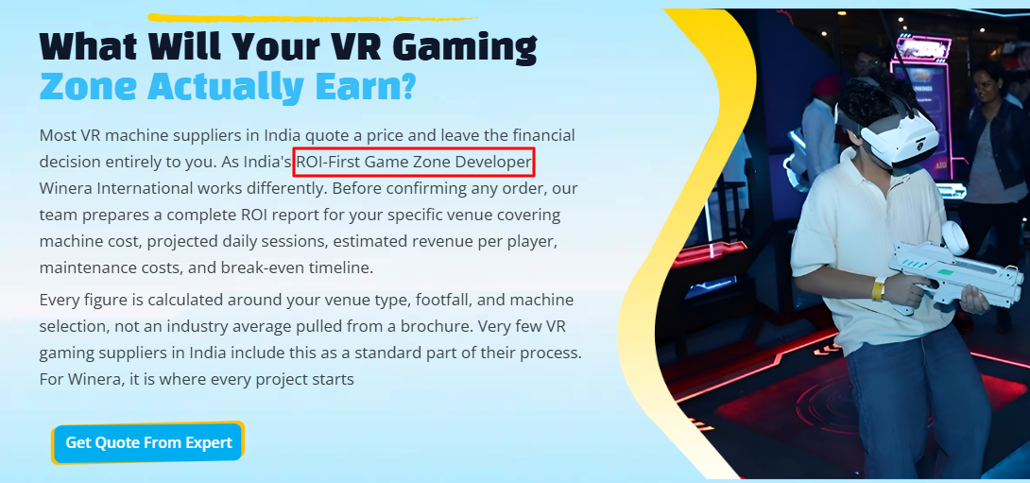

- https://winera-hazel.vercel.app/resource/roi

https://winera-hazel.vercel.app/product/ar-games

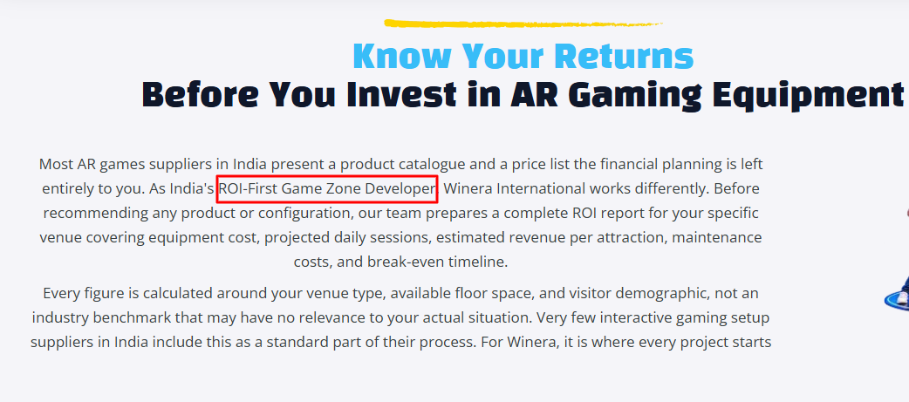

https://winera-hazel.vercel.app/product/bowling-alley

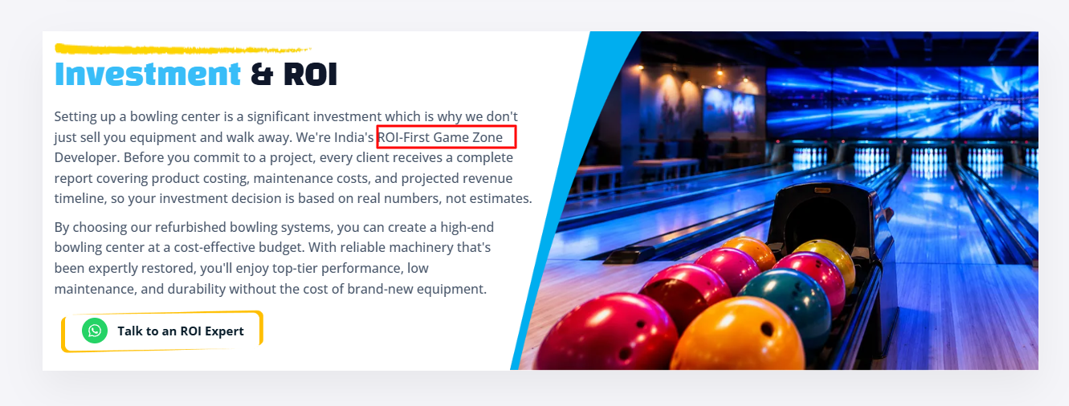

https://winera-hazel.vercel.app/product/trampoline-park

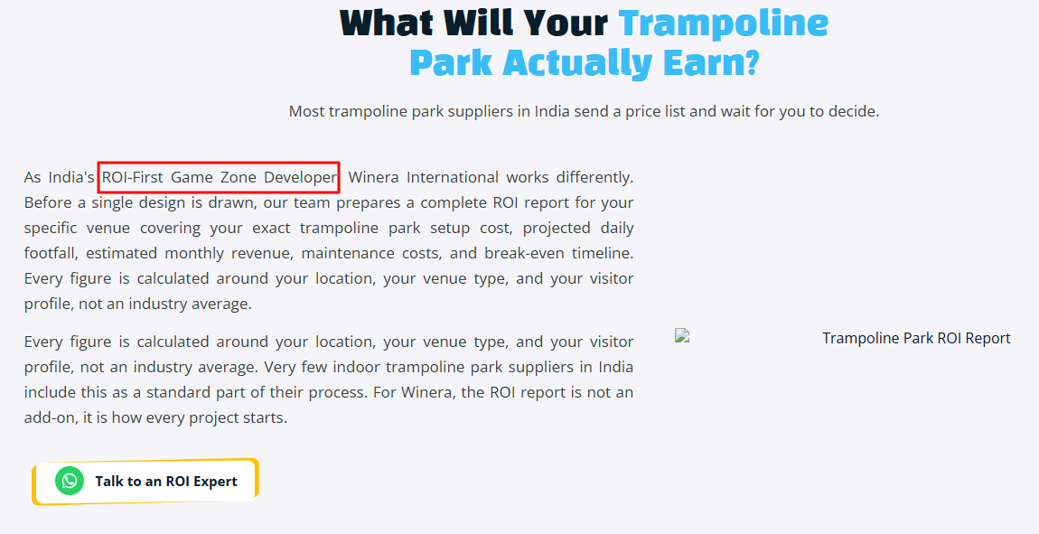

https://winera-hazel.vercel.app/product/soft-play

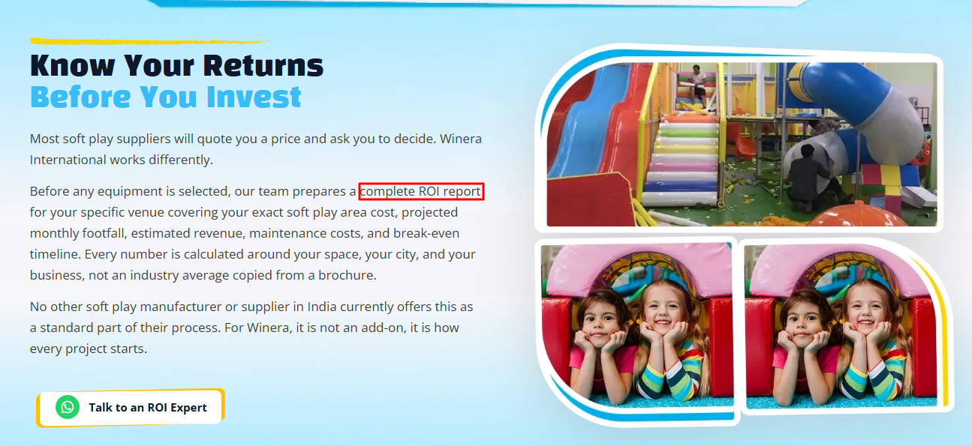

https://winera-hazel.vercel.app/product/bumper-car

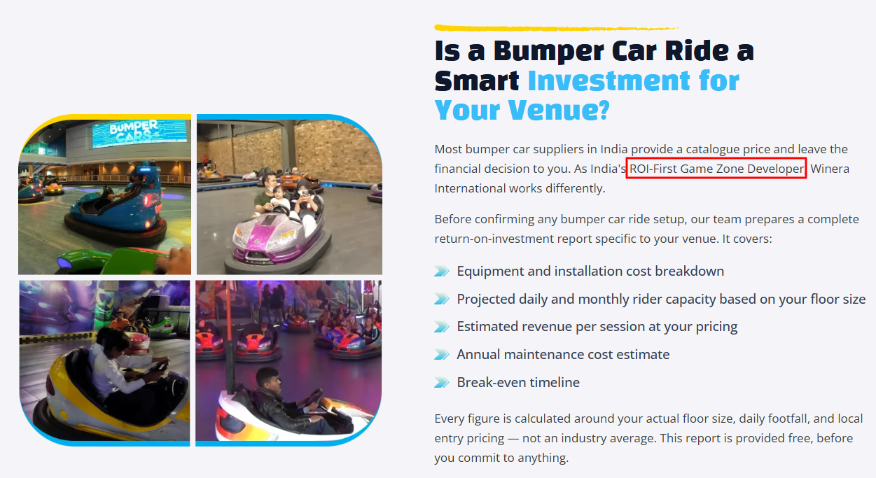

https://winera-hazel.vercel.app/product/hypergrid

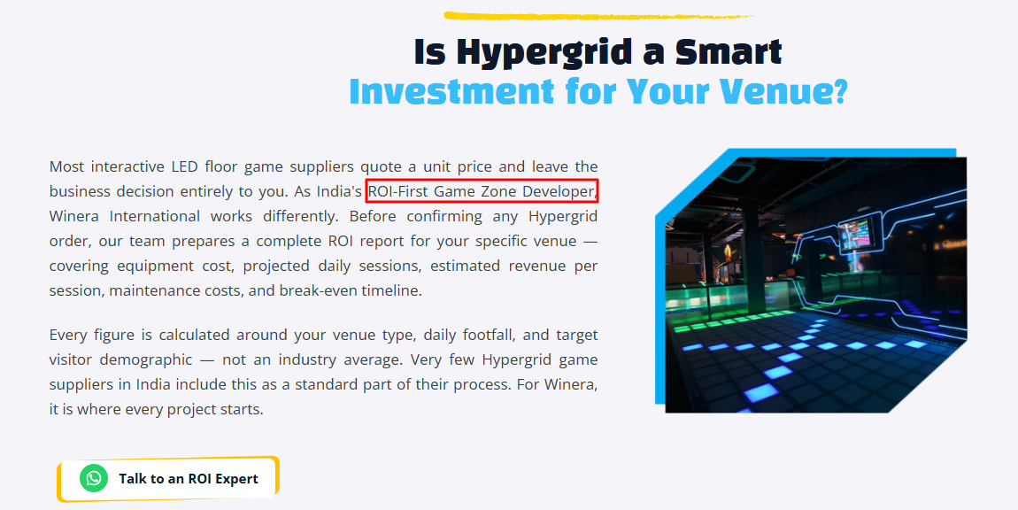

https://winera-hazel.vercel.app/product/amusement-park

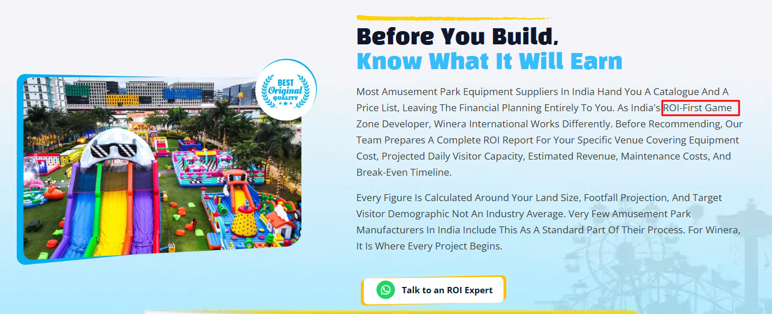

https://winera-hazel.vercel.app/product/laser-tag

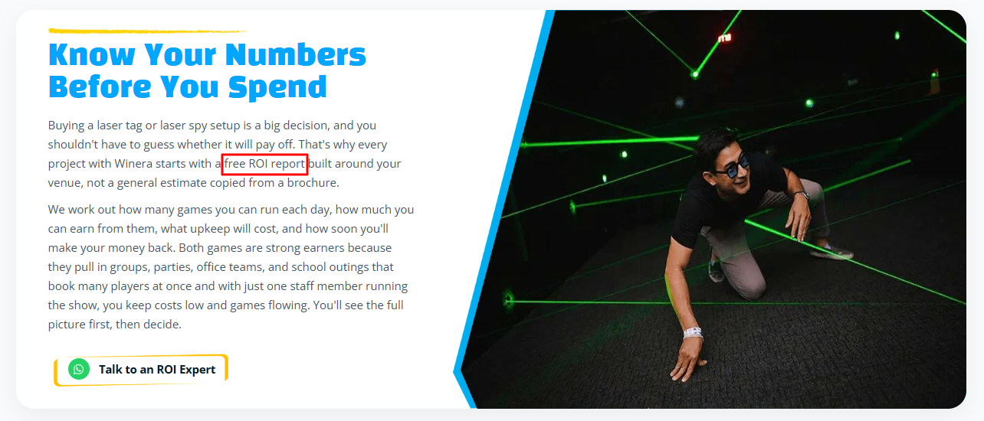

Blog page

- Soft Play vs Trampoline Park: Which Is Better for Your Space?

Add soft play area Link

Soft play areas

Trampoline parks

Winera International Private Limited

Safe
—-------------------------
- What Can Indoor Playground Equipment Do for Our Kids?

professional indoor play equipment manufacturer

safe materials

—-------------------------

- Trampoline Park vs Soft Play Area: Which is Best for Small Spaces?

Trampoline Park Manufacturer

Soft Play Equipment Manufacturer
-----------------------------------
- Why Turnkey Manufacturing Solutions Are Best for New Amusement Businesses

Amusement Park Manufacturer in India

Safety-tested

Winera International
-----------------------------------

- The History and Some Fun Facts About Bumper Cars

Bumper Car manufacturer
Safety features
-----------------------------------

- Soft Play Areas for Different Age Groups: Tailoring Designs for Toddlers to Tweens

Soft play manufacturer
Safety and excitement
-----------------------------------

- Find The Best Custom Themed Soft Play Equipment Manufacturer

Soft Play Equipment Manufacturer
family entertainment centres
Winera International
-----------------------------------

- How to Set Up a Profitable VR Gaming Zone with the Latest Machines

VR Gaming Machine Manufacturer
Winera International
- How to Start an Arcade Game Business: A Step-by-Step Guide

Arcade games manufacturer India

- Why Bumper Cars are a Profitable Attraction for FECs and Amusement Parks
Bumper cars
Family Entertainment Centres
Amusement parks
right amusement park ride manufacturer
Winera International

- 5 Key Features of a VR Gaming Machine Manufacturer
safety certifications
Game developers
VR Gaming Machine Manufacturer
Winera International

- Top 5 Trends in Amusement Park Design Every Manufacturer Should Know
Augmented reality and virtual reality rides
Modern amusement park
Amusement park manufacturer
Winera International

- Bowling Equipment Maintenance Checklist Keep Your Bowling Gear in Top Condition

Robots.txt
----------------------

# Robots.txt for https://www.winera.in/
# Purpose: Crawl control for search engines & AI bots

# =========================
# AI & Search Bots
# =========================

User-agent: GPTBot
Allow: /

User-agent: OAI-SearchBot
Allow: /

User-agent: ChatGPT-User
Allow: /

User-agent: PerplexityBot
Allow: /

User-agent: FirecrawlAgent
Allow: /

User-agent: AndiBot
Allow: /

User-agent: ExaBot
Allow: /

User-agent: PhindBot
Allow: /

User-agent: YouBot
Allow: /

User-agent: CloudBot
Allow: /

User-agent: Gemini
Allow: /

# =========================
# Default rule for all bots
# =========================

User-agent: *
Allow: /
Disallow: /admin/
Disallow: /dashboard/
Disallow: /login/
Disallow: /signup/
Disallow: /user/
Disallow: /account/
Disallow: /settings/
Disallow: /profile/
Disallow: /api/
Disallow: /data/
Disallow: /private/
Disallow: /backend/
Disallow: /config/
Disallow: /internal/
Disallow: */feed/
Disallow: /thank-you
Disallow: /*?utm_

# =========================
# Sitemap
# =========================

Sitemap: https://www.winera.in/sitemap.xml

Sitemap.xml
----------------------

